Malware Detection and Removal on Windows
Introduction

Malicious software, or malware, is a broad term which encompasses viruses, worms, Trojan horses, spyware, and adware. Malware is designed to infiltrate a victim machine without the owner’s consent, so it tends to hide its tracks and can be quite difficult to remove. You may encounter malware in the real world, and you will certainly have to deal with it at a Cyber Defense competition. In this exercise, we will look at basic ways to detect the presence of, and remove several different types of malware.

Part 1 – Basic Malware Detection and Removal

- To begin, boot your Windows VM and log in using the username “Administrator” and the password “password”. The first thing you should do on any machine you are defending (especially one with such a simple password) is change passwords. Chances are good that an attacker either already knows or can guess the password for the administrator account. Click on Start → Run and enter “lusrmgr.msc” to open the “Local Users and Groups” management console. Double-click on “Users” and you should see this:

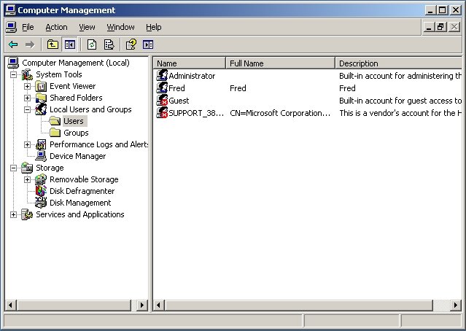
Right-click on Administrator and choose “Set Password”. Choose a password that is fairly long and complex, but that you can remember without needing to write it down. After the administrator's password has been changed, take a look at the other accounts on the system. The guest and support accounts are currently disabled, but who is Fred? Double-clicking on Fred and choosing the “Member of” tab shows that Fred is a member of the Administrators group. This is probably a rouge account left behind by an attacker. Get rid of the Fred account by right-clicking on it and selecting “Delete”.
- Next you will be using netstat, a versatile tool which comes built-in with many operating systems. Netstat, short for network statistics, is a tool which displays various network information. Open a command prompt by clicking on Start → Run and entering “cmd.exe”. In this exercise, we’re going to use netstat to look for suspicious connections or listening ports. At a command prompt, type “netstat /?” to see a brief description of what the netstat program does and what parameters it takes. Then enter “netstat -an” at the command prompt. The -a option tells netstat to print all active and listening ports on the host, and -n tells netstat to express addresses and port numbers numerically. You should see something like the following:

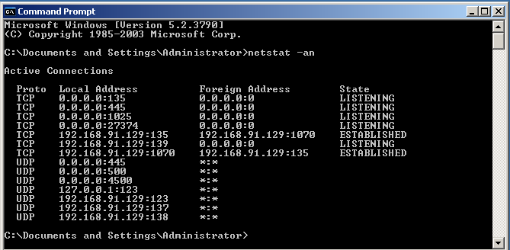
- Netstat is showing you a list of listening ports and ongoing connections to the VM. Port 135 is Windows’ DCOM Service Control Manager/Remote Procedure Call service, which is perfectly normal to see. The machine is also listening on port 445 and 139, which are used for NetBIOS. NetBIOS is used for file and printer sharing and should probably be turned off unless absolutely necessary, since it can expose your host to attackers. The portion of this netstat output that is concerning is the fact that the system is listening for a connection on port 27374, which is the well-known port for Sub7. Sub7 is a once popular Trojan horse that leaves a back door open for attackers to assume complete control of a system. It’s time to do some investigating to figure out a way to get rid of this malware.
- The next logical step is to see if there are any suspicious-looking processes running. Hopefully, whoever infected this machine with Sub7 didn’t use a rootkit, because that would make the task of detection and removal more difficult. Open the task manager by navigating to Start → Run, and then typing “taskmgr”. Click on the “User Name” tab to sort the processes and look for anything strange. In this exercise, it’s quite obvious that there is an oddly-named process running – FileZilla server.exe.
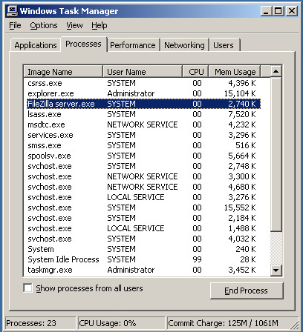
Most of the processes listed are normal for a Windows host, but not FileZilla server.exe. This process is the sub7 server listening on port 27374. Kill this process by right-clicking on it and choosing “End Process”. You will notice if you re-run “netstat -an”, the system is no longer listening on port 27374. You have successfully killed the sub7 process, but now we need to find the executable and remove it for good, otherwise the sub7 backdoor will simply restart the next the machine is rebooted.
- A good first place to check for rogue startup programs is in the Startup folder. Navigate to “C:\Documents and Settings\Administrator\Start Menu\Programs\Startup”. Note that there is a program there named “server.exe” that will run every time the Administrator logs on. It is the sub7 server so delete it. Next, you will use a Windows system configuration utility called msconfig. Click on Start → Run, then type “msconfig” and press enter. See what’s listed in the Startup tab. You will see that the executable we just identified as the sub7 server is set to execute every time the machine starts up. It is gone now, but just to be safe uncheck the box labelled “server”. You will also notice that there is a randomly-named process that the server spawns has been set to run at startup. Obviously this is not what we want, so un-check the checkbox next to the name of the file (which will be different than what is shown in the screenshot). Once this box is deselected, click the OK button.
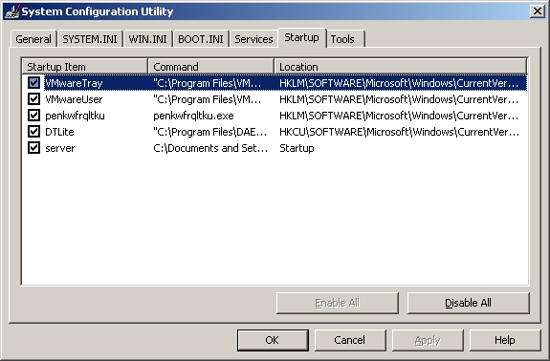
You will be prompted to restart the computer, but in this case it’s not necessary to do that yet. Select “Exit Without Restart”.
- Now we’ve killed the Sub7 process and stopped it from being executed again when the machine reboots. The next step is to find and delete the executable. In this exercise, no rootkits or special techniques were used to hide the location of the file, so we can run a simple windows search. Navigate to Start → Search. Search for the name of the file that we killed and removed from the startup list (penkwfrqltku.exe – or whatever it is called). Once you find it, delete it.
- To get rid of Sub7 for good, we'll need to remove some settings it left in the registry. Go to Start → Run, then type “regedit” and hit enter. Here you can browse and edit the Windows registry. In the Edit menu, choose “Find” and search for Sub7. (The search may take a few seconds). The registry editor will highlight the first entry it finds. Press F3 to search for the next entry. Be sure to find and remove the following registry folders:
1. HKEY_LOCAL_MACHINE\SOFTWARE\Microsoft\Shared Tools\
MSConfig\startupreg\FileZilla Server Interface
2. HKEY_LOCAL_MACHINE\SOFTWARE\SubSeven
- Restart the VM. Use netstat and the task manager to make sure that sub7 is not running on the host and that the malware was completely removed. If so, congratulations! You’ve just detected and removed a backdoor. It was not too difficult, but the attacker didn't try particularly hard to hide from you. Next, we will deal with a different attacker on your system that is using a rootkit to mask his presence.

Part 2 – Rootkit Detection and Removal

A rootkit is a piece of software that is used to hide the fact that a system has been compromised. This includes hiding files and directories from Windows Explorer, hiding running processes from view of the Task Manager, hiding services listening for connections on the network, etc. In this part of the exercise, you will learn to use an extremely effective anti-rootkit tool: IceSword.

- After having removed the sub7 backdoor, take one more look using netstat and the task manager. Things look good – there are no rogue processes running. Or are there?
- On the Desktop of your VM, there is a folder called “IceSword”. Open it. Click on the file inside called “IceSword.exe”.
- An IceSword window should open. On the left-hand side of the screen, click on the button labeled “Process”. This shows all the running processes, much like Task Manager. The difference is that IceSword’s process list contains two executables that are being hidden by the HackerDefender (hxdef) rootkit:
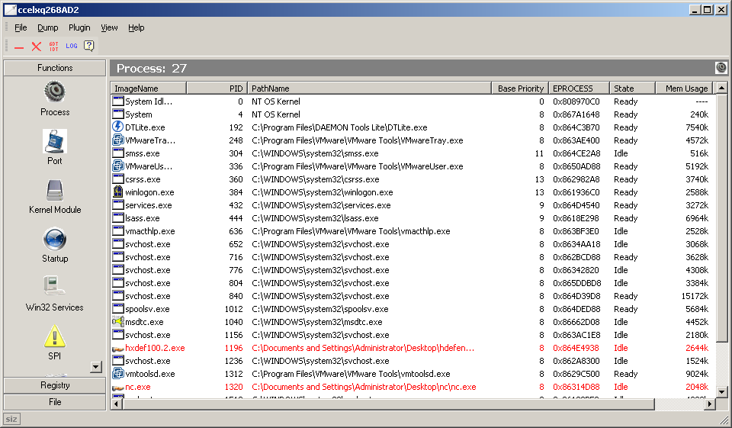
- As you can see, the two hidden processes are exposed by IceSword and are marked in red. This means that the processes are trying to do something they shouldn’t be doing; in this case they are hiding from Windows.
- If we kill the rootkit process, then whatever services that rootkit is offering are disabled. Right-click on hxdef100.2.exe in IceSword and click “Terminate Process”. Right click on the Desktop and select “Refresh”. The “hxdefender” and “nc” folders will appear, since HackerDefender is no longer running and hiding them.
- Open Task Manager. You should now be able to see the “nc.exe” program running, since its presence is no longer being hidden. Nc is short for netcat. Netcat is an extremely useful networking utility program. Among other things, it can be configured as a server (or, in this case, a back door) for other programs to work through. While it can be used as a legitimate tool, it's clearly not something that should be running without your approval. You will notice in the task manager that netcat is running with System privileges. This is because HackerDefender was configured to install itself as a service, which allows it to run as System. Each program that is launched and protected by HackerDefender is executed as the user HackerDefender is running as, so nc.exe ends up getting System privileges. This can be quite dangerous, since the System user has more power than even the system administrator. Kill the “nc.exe” program using the task manager.
- While you have the task manager open, look at the IceSword process. You will notice that there is no user associated with the IceSword process. Try to kill IceSword from Task Manager. It will not work! IceSword is in some ways more powerful than Windows. In fact, the only thing that can kill IceSword (should it hang or malfunction) is another instance of IceSword. Play around a little bit with IceSword. It can do a lot more than just handle processes. IceSword is a very powerful and useful tool.

Part 3 – Virus Scan Conclusion

To conclude your efforts, it may be worthwhile to scan your computer for known malware using a Virus Scanner. Windows Defender, a free virus scanning tool, is available from http://www.microsoft.com/en-us/download/windows-defender-details.aspx and can be deployed in only a few seconds.

After downloading WindowsDefender.msi, double-click it and install it using the wizard. Windows Defender will automatically check for updates and download the most recent set of Anti-Virus signatures. This will allow you to maximize the amount of viruses you will detect.

After you have installed the program, double-click the new icon on your desktop and run the program. Press Start Scan and check to see if your virus scanner finds any malware hiding on your computer.

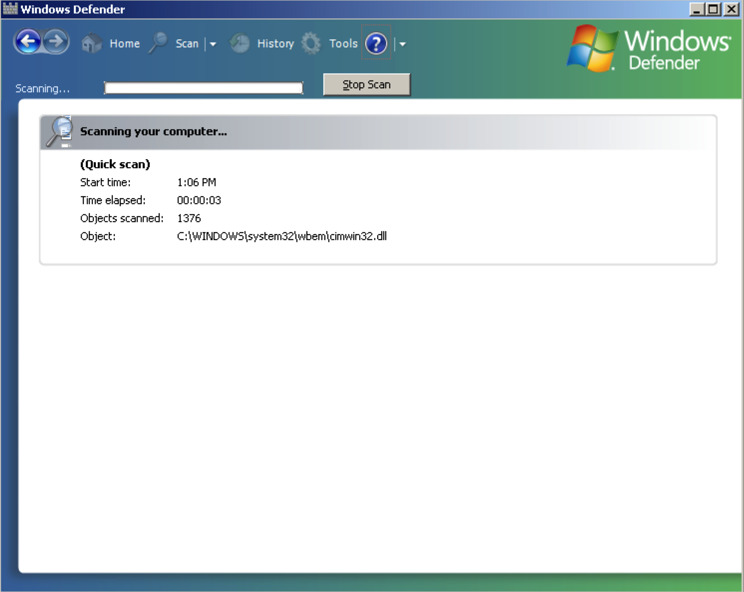

This is what a virus scan will look like with Windows Defender. It should not take that long, since pressing start scan runs a “Quick Scan”, which is less thorough than a complete scan, but a Quick Scan should find most of the if it is hidden on your computer.

Notes:

HackerDefender - http://www.f-secure.com/v-descs/hacdef.shtml
IceSword - http://www.antirootkit.com/software/IceSword.htm
Netcat - http://netcat.sourceforge.net/
Sub7 - http://www.hackpr.net/~sub7/
Sysinternals - http://technet.microsoft.com/en-us/sysinternals/default.aspx
Windows Defender - http://www.microsoft.com/en-us/download/windows-defender-details.aspx

This is what a

