Boolean expressions, String equivalence, and problem solving with if statements.

Objectives
At the end of this exercise, students will:
- Practice with evaluating Boolean expressions
- Understand how Strings are compared
- Use logical operators in decision structures
- Be prepared to do more complex coding involving decision structures

Getting ready
- All team members - record your notes on your own response sheet.
- Hand in one paper for the group (Group Response Sheet).
Part 1 – Logical operators
Logical operators take boolean operands. In other words, the logical operators are used to compare two boolean values.
In Java the logical operators are:

Logical Operator | Meaning
&& | And (and at the same time)
|| | Or (one or the other)
! | Not (negation or reversal)

Truth tables help us evaluate the logical operators. To read the table, look at the table for the && operator. If both operands are true, the result is true. If either operand is false the result is false. NOTE: Memorize the truth tables.

&& | true | false |  | || | true | false |  | ! | true | false
true | true | false |  | true | true | true |  |  | false | true
false | false | false |  | false | true | false

Examples: !true is false
true && false is false
3 > 12 || 13 == 12 is true

1. BOARD: Evaluating logical expressions. Using the variables, types, and values in the chart below, evaluate each expression and write your result as true or false. You may use a calculator.

Variable | Data type | value
blue | char | ‘b’
red | char | ‘R’
yes | boolean | true
no | boolean | false
hiVal | int | 999
loVal | int | -999
code | char | ‘@’
grade | double | 89.5
amount | double | 50.00

Expression | Result
a. (blue > red) && yes
b. (blue <= red) || no
c. (yes == no) || (code > blue)
d. yes || no
e. no && true
f. !(yes && no)
g. (yes || (no && (blue > red))) || (grade <= 100)
h. (amount <= hiVal) && (amount >= loVal)
i. (amount <= hiVal) || (amount >= loVal)
j. ((amount + 10000) <= hiVal) || (amount >= loVal)
k. (code < red) || no
Part 2 Comparing Strings – Memory models of reference types
int count;
count = 3;

String cityName;
cityName = Charleston;

- Given a model of memory after these two statements have executed:
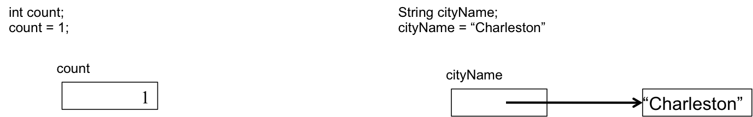
how are these two data types (int and String) fundamentally different?

- What will the model look like if we add in the declaration, String favoriteCity; and the assignment, favoriteCity = “Charleston”; (Hint, there is only one “Charleston” object since “Charleston” is a literal and will be used in both cases.) Draw the change on the model above.

- What will the model look like if we add in the declaration, int total; and the assignment, total = 1; Show your models to the instructor before moving on.
- An int is an example of a primitive type in Java. A String is an example of a reference type in Java. Provide your own definition of primitive data type and reference data type in the space below.

- The two Strings, “Charleston” and “Charles” + “ton” result in two different objects in Java. If we draw the memory model, it would look like this: 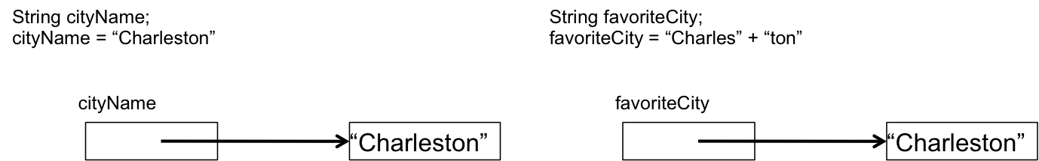
- What do you think the result of cityName == favoriteCity will be? (Hint, what do you think is being compared?)
Part 3 Comparing Strings – Correctly comparing values of reference types
The code below illustrates the correct way to compare two objects for equality.

/**
This program correctly compares two String objects using
the equals method.
*/
public class StringCompare
{
public static void main(String [] args)
{
String name1 = "Mark";

String name2 = “Ma” + “rk”;
String name3 = “Mary”;

// Compare "Mark" and "Mark"
if (name1.equals(name2))
{
System.out.println(name1 + " and " + name2 +
" are the same.");
}
else
{
System.out.println(name1 + " and " + name2 +
" are the NOT the same.");
}
// Compare "Mark" and "Mary"
if (name1.equals(name3))
{
System.out.println(name1 + " and " + name3 +
" are the same.");
}
else
{
System.out.println(name1 + " and " + name3 +
" are the NOT the same.");
}
}
}
- Reference types have a method called, equals, that lets us compare those types. For Strings, the method returns true if the two Strings contain the same characters in the same order and false otherwise. You see an example of method calls to equals in this example.
- So, when we run this code, what would you expect to be displayed by the System.out.println calls?
- If we want to compare two strings, but don’t care about the case of the letters, you can also use equalsIgnoreCase which returns true if the characters are the same regardless of case. So “abc”.equalsIgnoreCase(“ABC”) will return true.
- READ Chapter 3.6 for more information about comparing Strings.
- Do the Checkpoint 3.20 and 3.22.

3.20

3.22

- Optional (you should read about the compareTo method in this same section). Do Checkpoint 3.21.

3.21

Part 4 Problem solving using logical operators
Individually, write code to solve Programming Problem #8. Then compare your answers.

- Thought questions; be prepared to discuss in class.
  - Did everyone in the group solve the problem in the same way?
  - If not, will all correctly determine the discount?
  - Is any one solution better than another in this case?

