More Work With Arrays

Objectives
At the end of this exercise, students will:
- Be able to work with arrays of objects
- Be able to trace a problem involving objects
- Practice with object and array terminology

Getting ready
- Coordinator, get enough worksheets for each of the members of the team and keep the team on track, making sure that all team members understand the answers.
- All team members - record your notes on your own response sheet.

Part 1 - Arrays of Objects

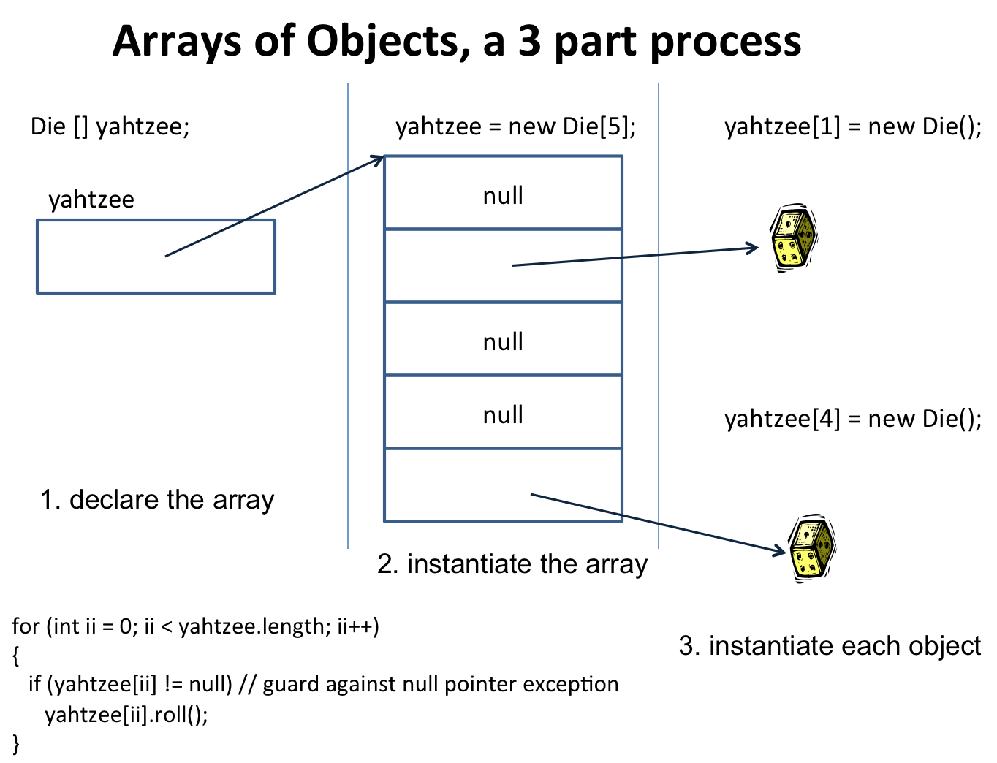

If you were to create an array of Die objects called yahtzee, the above diagram shows the three steps in the process.
- In the space below, write the code to declare an array of 5 Die objects, instantiate the array, and then instantiate each of the objects.

- After you have instantiated the array of Die objects, write a for loop to roll each of the objects. (You may use either kind of for loop). (Die has a roll() method which randomly “rolls” the Die objects.)

- The following statement executes after you have rolled all of your Die objects.

yahtzee[(int)(Math.random() * yahtzee.length]) = null;

In your own words, describe what happens on this line. Note: Math.random() returns a random number >= 0.0 and < 1.0.

- Now, write another for loop to display the face value of the Die objects in the array. Be careful, since one of the slots may not contain an object.

