CS 139 Activity – Data and data types
Content Objectives: At the conclusion of this activity students will be able to:
- Identify features of containers in a Java program
- Identify standards for our class in a Java program
- Create test data for our first programming assignment
- Write a simple program that will use a constant, literal, and variable

Roles for this activity – Choose these from among your group, not duplicating the roles from day 1.
- MANAGER: Keep the group on task. Begin the group quiz when all are finished with the individual quiz
- RECORDER: Write the group consensus
- PRESENTER: Write the group consensus on the board and be prepared to explain
- REFLECTORS: Watch the process of working through the exercise. Reflect on the Exit Pass any difficulties that your team has with the activity or with any content that may seem fuzzy.
NOTE: Please feel free to use your book for this assignment.

PART 1 – Hello World, revisited – References
The chart below, shows the Hello code that you originally wrote. When you wrote the statement System.out.println you were actually calling upon the services of another Java class, System. System in turn, called upon the PrintStream class where the code resides to carry out the println method and send the output to the moniter. In Java, individual programs are generally small because problems get broken down into many classes each serving a specific role. In this case, Hello formed the output line and System and PrintStream carried out the display action. This is an example of what we have called reference before…The Hello program is referencing the System class which in turn is referencing the PrintStream class.
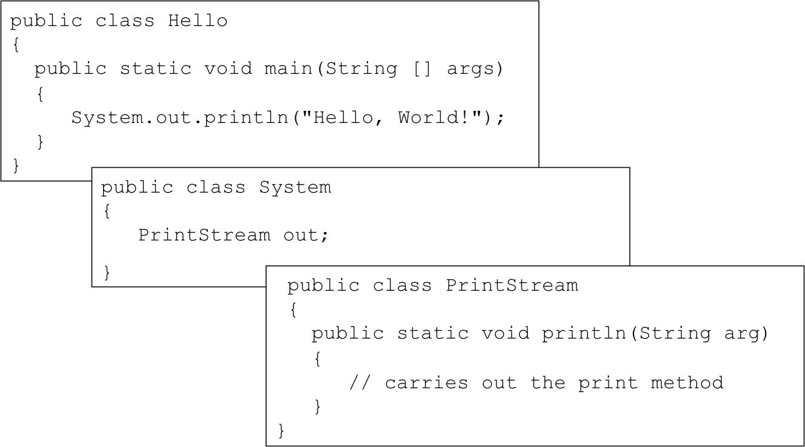
The following is a model for the revised Hello world program.
/***********************************************
* Prints a message, Hello World.
*
* @author - Nancy Harris, model solution
* @version - V1 - 09/09/2010
************************************************/
/* References and Acknowledgements: I have neither given nor
* received help on this assignment
*************************************************/
public class Hello
{
/********************************************
* entry point into the application
*
* @param args command line arguments - unused
*********************************************/
public static void main(String [] args)
{
// declarations
String message;
String message2;
// initialization
message = "Hello, World!\n");
message2 = "I'm happy to be a programmer.");
// output
System.out.print(message);
System.out.println(message2);
}
}

1. This program conforms to the style guide for this course. Using the Style Guide for CS 139 sheet, identify as many of the conventions that are followed in this program as you can. Put a check mark beside the CS 139 Program Evaluation Sheet for items that you find in the program that conform to the style guide. When referring to “methods”, main is a method or sub program within the Hello class.

2. BOARD – How many different style guide items do you have checked off? Have your PRESENTER be prepared to identify where each one is in the program.

Example programs
1 // This program has variables of several of the java data types.
2
3 public class Variables
4 {
5 public static void main(String[] args)
6 {
7 int checking;
8 byte miles;
9 short minutes;
10 long days;
11 float total;
12 double sum;
13 boolean flag;
14 char letter;
15 String message;
16
17 checking = -20;
18 miles = 105;
19 minutes = 120;
20 days = 185000;
21 total = 7.98F;
22 sum = 5628.335;
23 flag = true;
24 letter = '9';
25 message = "Now why is my type in capital letters?";
26
27 System.out.println("We have made a journey of " + miles +
28 " miles.");
29 System.out.println("It took us " + minutes + " minutes.");
30 System.out.println("Our account balance is $" + checking);
31 System.out.println("About " + days + " days ago Columbus " +
32 "stood on this spot.");
33 System.out.println("Your total bill is " + total);
34 System.out.println("The sum of the scores is " + sum);
35 System.out.println("The flag is " + flag);
36 System.out.println("The letter is " + letter);
37 System.out.println(message);
38 }
39 }
Part 2 – Containers in Java
- The example program Variables, has a number of variables declared, initialized and used. Which lines numbers contain declarations of variables? (You will see Variables on the back of page 1.)

- In your own words, what is a declaration?

- Which line numbers are giving values to the variables?

- BOARD - There are a couple of things you need to know about Java and containers and values.
  - Java is strongly typed. That means you cannot put a value into the container that is of a different type.
  - Java will “widen” a value of a type that can be expanded to another type. For example, an integer can be made into a double by making the value the integer with a decimal point 0 at the end.
  - Java will not “narrow” a value of a type that cannot fit into that type. For example, if we tried to put a decimal number into an integer container, the Java compiler will not let us do so. * There is a way to explicitly narrow the value, but we’ll deal with that later.
  - A literal number without a decimal point is considered to be of int type. A decimal number is considered to be of double type.

Given these “rules” which of the following statements are valid given the declarations and values provided in Variables. Feel free to use your book as an aid. The chart of sizes is shown on page 45 of the purple book.

OK or NO
checking = 56000;
total = 0;
sum = total:
total = sum;
checking = miles;
sum = checking;
sum = days;

- In your books, chapter #2 in the Predict the Output section, do question numbers 1 – 4. We have not talked about operations (other than the + as part of output), so use common sense when it comes to the operation in question 2.

MANAGER – Have your group put their response sheets in the team folder, place the Exit Pass in the folder and clear the board.

