Transactions

Terms

Recovery – restoring the database to a correct state after failure.
Concurrency control – allows simultaneous use of the db without having users interfere with one another.
Transaction – A logical unit of work in the database. Takes the db from one consistent state to the next.
Transactions have two outcomes – success and commit or failure and abort.
Aborted transactions must be rolled back if they changed the database in an intermediate step.
Concurrency – Many processes occurring on the same db at the same time.
Serially – Processes can only occur one at a time.

Problems
DBMS must ensure that we do not get:
- Lost updates (one update occurs while another update to that same item is occurring)
- Uncommitted updates (an update occurs, a second process uses that data and the first update is rolled back).
- inconsistent analysis problems (read several values, but some of the values are being updated during the process)
- non-repeatable read (read a value, something updates it, read now gets a different value)
- Phantom data problem (read a set of rows, something adds a row, read now gets a different set of rows)

See book example of a simultaneous update. Plane flights
Issue of two related transactions that could cause a problem. Bank account example.

Transactions support the notion of serializability, by forcing a single transaction to occur for the steps where concurrency could cause an inconsistent update.

Locking of the resources is often used to prevent inconsistency.

Example from the student database: We want to update the number of credits for a student.
- Locate student (block)
- Bring student into the buffer
- Changing the value of the credit field
- Write the updated block back to the db.

More complex – A batch update to update all of the student statuses based on current registration data.

A transaction then is the sum total of the work to take the database from one consistent state to the next.
A transaction is atomic. Atomic – All or nothing. It cannot be subdivided.

It is the responsibility of the programmer to identify transaction blocks. Begin transaction, end transaction, commit and rollback and abort are some commands available to identify transaction blocks.

START TRANSACTION or BEGIN in MySQL. Commit and Rollback are supported.

During the transaction process, the DBMS is constantly checking to see that we can carry out the transaction to completion. Concurrency control, security, etc can all play a roll in whether or not the transactions can be carried out. If a failure occurs, the DBMS will rollback the partially committed transaction.

The DBMS keeps a log of the individual actions and will use it to rollback to the consistent state.

ACID – Atomicity, consistency, isolation, and durability

Consistency – user is responsible to ensure that the transaction leaves the database in a consistent form. The DBMS must ensure consistency between transactions.

Isolation – Each transaction should be treated as if it is isolated from every other one (even though they may be executing in an interleaved fashion).

Durability – If a transaction is committed, the DBMS must make sure that its effects are permanent.

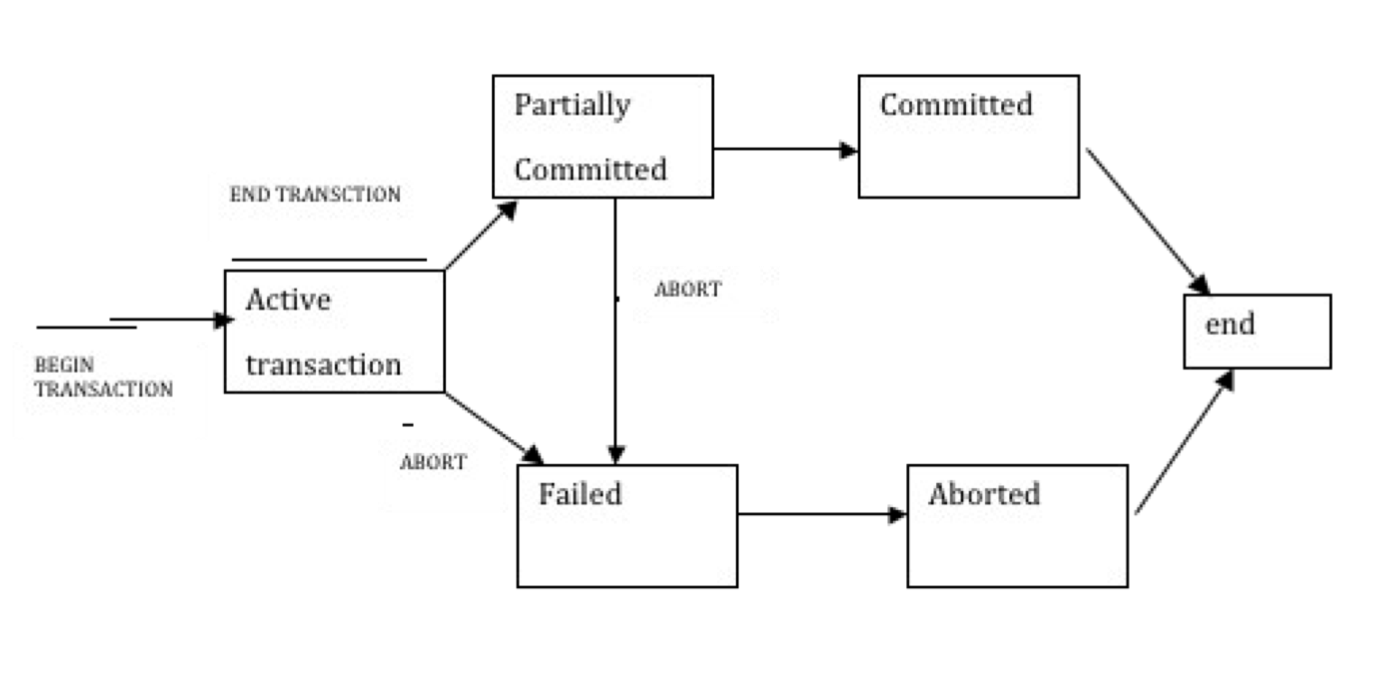
From Databases Illuminated

Return to plane flights. We could allow both users to see that the seat is available. But when the first user commits to choosing the seat, we lock (through transactions) any further action on that seat. The second person can attempt to select, but until the first user’s transaction has gone through the second persons transaction will pend. After the choice of the first seat, the second user should get a message that the seat is not available. It is up to the programmer to decide what is appropriate, at what point we create the transaction and how we will handle potential errors caused by the timing of these actions.

Important to differentiate between read and update uses of the db.

SET TRANSACTION READ ONLY; before a BEGIN and the system knows that the transaction will not cause db changes.

It is up to the programmer to decide which transactions should be serial and which can be concurrent.

No conflicts if
- Two transactions are reading data.
- Two transactions operate on separate data items.
- If one reads and the other writes (updates) then order is important for consistency.

Locking
Locking of resources is a way to enforce serial transactions. Locks can be shared (read) or exclusive (write).
Deadlock
The state in which Process A needs a resource locked by Process B and Process B needs a resource locked by Process A.
Deadlock prevention – Look ahead and see what resources are required, do not begin the transaction until all resources can be locked.
Deadlock detection and recovery – Once deadlock has occurred, system breaks the deadlock by “failing” one transaction and allowing the other to complete.

Book answers to 6.6.7
6.6.1
(a)

EXEC SQL BEGIN DECLARE SECTION;
int modelNo;
int pcPrice;
int pcRAM;
float pcSpeed;
EXEC SQL END DECLARE SECTION;

void lookupPC(int iSpeed,int fRAM) {
EXEC SQL SET TRANSACTION READ ONLY ISOLATION READ COMMITTED;
EXEC SQL DECLARE pcCursor CURSOR FOR
SELECT model,price
FROM PC
WHERE speed=:pcSpeed
AND ram=:pcRAM;

pcSpeed = iSpeed;
pcRAM = fRAM;

EXEC SQL OPEN pcCursor;

EXEC SQL FETCH pcCursor
INTO :modelNo, :pcPrice;
while (SQLCODE == 0)
{
printf(“Model No: %d Price: %d”, modelNo, pcPrice );
EXEC SQL FETCH pcCursor
INTO :modelNo, :pcPrice;

}
EXEC SQL CLOSE pcCursor;
EXEC SQL COMMIT;
}

This is a READ ONLY transaction and READ COMMITTED provides the optimum ISOLATION LEVEL for concurrency while not allowing dirty reads.

(b)

EXEC SQL BEGIN DECLARE SECTION;
int modelNo;
EXEC SQL END DECLARE SECTION;

void deleteModel(int iModel) {
EXEC SQL SET TRANSACTION ISOLATION LEVEL SERIALIZABLE;
modelNo = iModel;

EXEC SQL DELETE FROM Product
WHERE model = :modelNo;

EXEC SQL DELETE FROM PC
WHERE model = :modelNo;

EXEC SQL COMMIT;
}

The ISOLATION LEVEL is set to SERIALIZABLE but it could be anything since there is no risk of dirty read (no select statement).

(c)
EXEC SQL BEGIN DECLARE SECTION;
int modelNo;
EXEC SQL END DECLARE SECTION;

void updatePCPrice(int iModel) {
EXEC SQL SET TRANSACTION ISOLATION LEVEL SERIALIZABLE;
modelNo = iModel;

EXEC SQL UPDATE PC
SET price = price - 100
WHERE model = :modelNo;

EXEC SQL COMMIT;
}

For reason same as in (b) above, the isolation level is set to SERIALIZABLE.

(d)
EXEC SQL BEGIN DECLARE SECTION;
char maker[1];
int exists = 0;
int modelNo;
int pcPrice;
int pcRAM;
int pcHDD;
float pcSpeed;
EXEC SQL END DECLARE SECTION;

void insertPC(char cMaker[1],int iModel,int iSpeed,float fRAM,int iHDD, int iPrice) {
EXEC SQL SET TRANSACTION ISOLATION READ COMMITTED;
EXEC SQL DECLARE newCursor CURSOR FOR
SELECT 1
FROM Product R
WHERE R.model=:modelNo;

maker = cMaker;
modelNo = iModel;
pcSpeed = iSpeed;
pcRAM = fRAM;
pcHDD = iHDD;
pcPrice = iPrice;

EXEC SQL OPEN newCursor;

EXEC SQL FETCH newCursor
INTO :exists;
if (exists == 1)
{
printf(“ERROR:Model No: %d already exists in database”, modelNo);

}
else /* Add model into database */
{
EXEC SQL INSERT INTO Product
VALUES(:maker,:modelNo,'pc') ;
EXEC SQL INSERT INTO PC
VALUES(:modelNo,:pcSpeed,:pcRAM,:pcHDD,:pcPrice) ;

}
EXEC SQL CLOSE newCursor;
EXEC SQL COMMIT;
}

6.6.2
(a) It is a READ ONLY transaction. Thus there is no write or update atomicity problem. However, a system crash can cause truncated result and application may need to rerun on system restart.

(b) If the system crash occurs after the model was deleted from Product but before deletion from PC, an atomicity problem occurs. Databases keep a log of activities and use the log with some kind of recovery strategy to bring the database to a consistent state on system restart.

(c) There is no atomicity problem here since there is only one sql statement and each sql statement is atomic by nature. However, the application may need to call updatePCPrice again if the system crashed before update completed.

(d) Similar to (b). If system crashed between inserts, atomicity problem occurs and database is left in inconsistent state.

6.6.3
(a)
T is the READ ONLY transaction from 6.6.1 (a). Another READ ONLY transaction can run concurrently without any difference (i.e. As if all transactions ran in SERIALIZABLE isolation).
If deleteModel from 6.6.1 (b) was running concurrently with T, T may not return a PC model which had been deleted from Product and then deleteModel rolled back. With SERIALIZABLE isolation, T would return the PC model unless the delete transaction committed.
If updatePCPrice from 6.6.1 (c) was running concurrently with T, the reduced PC price(dirty read) could be returned by T even if updatePCPrice later rolled back.
Similarly, T could return the inserted PC model by insertPC (phantom read) even if insertPC later rolled back.

(b)
T is the deleteModel from 6.6.1 (b). If running insertPC concurrently with T, insertPC checked that the model does not exist since T just deleted the model, but then T rolled back. Thus insertPC attempts to insert a model that already exists.

(c)
T is updatePCPrice from 6.6.1 (c). When running concurrently with another updatePCPrice for same model, T could read the updated price (dirty data) and decrement model price by $100. But then first updatePCPrice rolled back. However, the pc price for the model was reduced by $200 though only one updatePCPrice completed.

(d)
T is insertPC from 6.6.1 (d).
When running concurrently with another insertPC, both could check that there is no product with the model, and then try to insert the model.

6.6.4

Serializable: T will never see changes to the database and keep printing the same list of PCs. This does not serve any useful purpose. Application may need to periodically stop T and then restart it to see data committed in the meantime.

Repeatable Read: T will continue to see the list of PCs it saw once. However, T will also see any new PCs that are inserted in the database. Locking issues can occur if another transaction such as 6.6.1 (b) or (c) tries to update/delete the rows read by T. 6.6.1 (d) inserts a new row and thus can run concurrently with T.

Read Committed: Perhaps the best option. T can see new or updated rows after other transactions such as 6.6.1 (c) or (d) commit. However, if T reads the same table twice, the results are not consistent because some rows may have been updated (6.6.1 (c) or deleted(6.6.1 (b)) by other transaction. Moreover, if T reads a row and based on the result then tries to read/update/delete the row; the state of row may have changed in the meantime.

Read Uncommitted: T will not cause any locking (high concurrency) but uncommitted PC data might be printed out due to insert/update by other transaction e.g. 6.6.1 (c) or (d). However, the other transaction might rollback resulting in wrong reports.

