More Work With Arrays

Objectives
At the end of this exercise, students will:
- Be able to work with arrays of objects
- Be able to trace a problem involving objects
- Practice with object and array terminology

Getting ready
- Coordinator, get enough worksheets for each of the members of the team and keep the team on track, making sure that all team members understand the answers.
- All team members - record your notes on your own response sheet.

Part 1 - Arrays of Objects

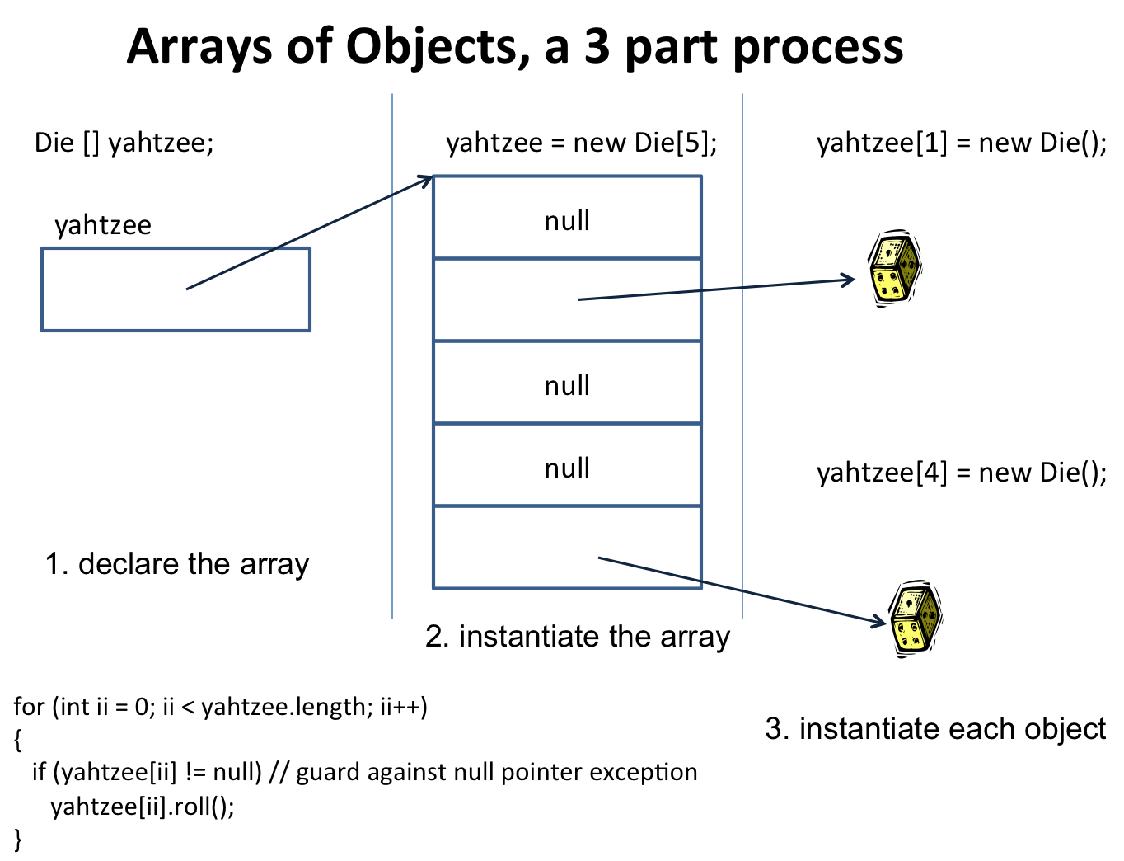

If you were to create an array of Die objects called yahtzee, the above diagram shows the three steps in the process.
- In the space below, write the code to declare an array of 5 Die objects, instantiate the array, and then to instantiate each of the objects.

- After you have instantiated the array of Die objects, write a for loop to roll each of the objects. (You may use either kind of for loop). (Die has a roll() method which randomly “rolls” the Die objects.)

- The following statement executes after you have rolled all of your Die objects.

yahtzee[(int)(Math.random() * yahtzee.length]) = null;

In your own words, describe what happens on this line. Note: Math.random() returns a random number >= 0.0 and < 1.0.

- Now, write another for loop to display the face value of the Die objects in the array. Be careful, since one of the slots may not contain an object.

Part 2 – Terminology

Using PFGrade.java ONLY answer the following questions.

What is the line number of the constructor header?

What are the line numbers of all return types?

What is one of those return types?

Which method(s) is(are) available to outside classes?

Which line numbers contain overloaded method headers?

Using PFGrade.java and UsePFGrade answer the following questions.

 | Which line(s) in UsePFGrade instantiate object(s)?
 | Which line(s) in UsePFGrade declare an array?
 | Which line(s) in UsePFGrade instantiate an array?
 | Which line(s) in UsePFGrade invoke (call) a mutator method?  -----------------------------------  What is one of those method(s)? | ------------------------------
Which line(s) in UsePFGrade invoke (call) an accessor method?

What is one of those methods?

Part 3 – Tracing with Objects

Using PFGrade.java and UsePFGrade.java, trace the code. At each break point, indicate the value of each of the variables listed. Use the provided grid paper or back of another page for keeping track of your values.

Part A: Execute UsePFGrade through line B-9
A1. How many “containers” exist in memory for the following PFGrade attributes?

grade ___________ passCounter ______________ PASS_____________

A2. How many PFGrade objects currently exist? ________________

A3. What is the value of grade for myGrade and yourGrade?

myGrade.grade ___________ yourGrade.grade _____________

Part B: Continue to execute UsePFGrade through line B-14
B1. What is the value of grade for myGrade and yourGrade?

myGrade.grade ___________ yourGrade.grade _____________

B2. What would be returned by the method call, myGrade.getPasses() _______________

Part C: Continue to execute UsePFGrade through line B-22
C1. What is the value of cs139.length ___________

C2. What are the values of: cs139[0].grade ___________

cs139[1].grade ___________

cs139[2].grade ___________

C3. What is the value of myGrade.getPasses() __________________

Part D: Continue to execute UsePFGrade through line B-28
D1. What are the values of: cs139[0].grade ___________

cs139[1].grade ___________

cs139[2].grade ___________

D2. What is the value of myGrade.getPasses() __________________

public class PFGrade
{
private double grade;
private static int passCounter;
private final static double PASS = 65.0;
public PFGrade(double incoming)
{
grade = 0;
changeGrade(incoming);
}
private void changeGrade(double newValue)
{
if (newValue < 0 || newValue > 100)
grade = 0;
else
{
if (newValue >= PASS && grade < PASS)
passCounter++;
else if (newValue < PASS && grade >= PASS)
passCounter--;
grade = newValue;
}
}
public void setGrade(double grade)
{
changeGrade(grade);
}
public void setGrade(int numRight, int totalNum)
{
double newGrade;
newGrade = (double) numRight / totalNum;
newGrade = newGrade * 100;
changeGrade(newGrade);
}
public double getGrade()
{
return grade;
}
public char getLetter()
{
char alpha;
if (grade < PASS)
alpha = 'F';
else
alpha = 'P';
return alpha;
}
public static int getPasses()
{
return passCounter;
}
}

public class UsePFGrade
{
public static void main(String args[])
{
PFGrade myGrade, yourGrade;
PFGrade [] cs139;
myGrade = new PFGrade(95);
yourGrade = new PFGrade(55.5);
// A. STOP HERE AND ANSWER THE QUESTIONS FOR PART A
myGrade.setGrade(65);
yourGrade.setGrade(50);
// B. STOP HERE AND ANSWER THE QUESTIONS FOR PART B
cs139 = new PFGrade[3];
cs139[0] = myGrade;
cs139[1] = yourGrade;
cs139[2] = new PFGrade(60.0);
// C. STOP HERE AND ANSWER THE QUESTIONS FOR PART C
cs139[0].setGrade(-5);
cs139[1].setGrade(57);
cs139[2].setGrade(75);
// D. STOP HERE AND ANSWER THE QUESTIONS FOR PART D
for (int ii = 0; ii < cs139.length; ii++)
System.out.printf("Grade: %.2f letter: %s\n",
cs139[ii].getGrade(), cs139[ii].getLetter());
System.out.printf("Passes: %d\n", myGrade.getPasses());
}
}

