Exploring Arrays

Objectives
At the end of this exercise, students will:
- Understand a mapping algorithm to map values into array indices (Followup from lab)
- Describe the difference between a “deep copy” and a “shallow copy” (Followup from lab)
- Identify all of the elements of the main method header
- Implement a sequential search algorithm over an array
- Write an algorithm to instantiate an array of objects and use those objects

Getting ready
- Coordinator, get enough worksheets for each of the members of the team and keep the team on track, making sure that all team members understand the answers.
- All team members - record your notes on your own response sheet. Turn all of the sheets into your team folder.

Part 1 – Followup from the lab – Gaddis 8.1, 8.2

1 public class ArrayPlay
2 {
3 public static void main(String [] args)
4 {
5 int [] arrayA;
6 int [] arrayB;
7 int index;
8 Die die;
9
10 arrayA = new int[6];
11 die = new Die();
12
13 for (int ii = 0; ii < 100; ii++)
14 {
15 index = die.roll() - 1;
16 arrayA[index]++;
17 }
18
19 // on to copies
20 arrayB = arrayA;
21
22 arrayB = new int[arrayA.length];
23 for (int ii = 0; ii < arrayA.length; ii++)
24 {
25 arrayB[ii] = arrayA[ii];
26 }
27 }
28 }

The code above is an example of part of the lab from yesterday. Using this code and what you learned in the lab, answer the following questions.
- Which line declares an array?

- Which line instantiates the first array?

- Describe in your own words, why we don’t need an if statement for lines 13-17 (where we are incrementing the specific cell based on the dice role.)

- Thinking about the example of the array of month days, how could we use the month number as a natural array index?

- Draw a model of what arrayA looks like at the end of statement 10. (Remember that arrays are reference types.)

- Ignoring specific values in the arrayA, draw a model of what happens at line 20. How many array objects do you have?

- Now, how would the model be different after line 22? Alter the model above to show how this is different.

- Line 20 is an example of a shallow copy and lines 22 – 26 is an example of a deep copy. In your own words, describe the difference between a shallow copy and a deep copy.

Part 2 – Command line arguments – Gaddis 8.12

20 public static void main(String args[])
21 {
22 long seed; // seed value to start random generator
23 WordGuess game;
24
25 // This code gets a seed value to use to control words displayed
26 if (args.length == 0)
27 seed = 123456789;
28 else
29 seed = Integer.parseInt(args[0]);
30
31 game = new WordGuess(seed);
32 game.playGame();
33
34 System.out.println("Game over. Play again soon.");
35 } // END main method

This is an example of the main method from WordGuessDriver.java from PA4. Take a good look at the method header on line 20.
- What does the word “public” mean?

- What does the word “static” mean?

- What is “void”?

- What is “main”?

- What is the data type of the parameter to the main method, (String args[])?

- What are lines 26 – 29 doing?

- The program can be called from the command line in two different ways:

java WordGuessDriver

OR

Java WordGuessDriver 223344

Which one of these method calls will use the default value 123456789?

Part 3 – Sequential search algorithm Gaddis 8.8

In the space below, write the method to search a String array, list, passed as a parameter for a specific value, value. You need to take into account that the item may be found anywhere within the array or may not exist at all. If it is found, return the index number of the element. If it is not found, return a -1.

public static int searchArray(String [] list, String value)

{

}

Part 4 - Arrays of Objects

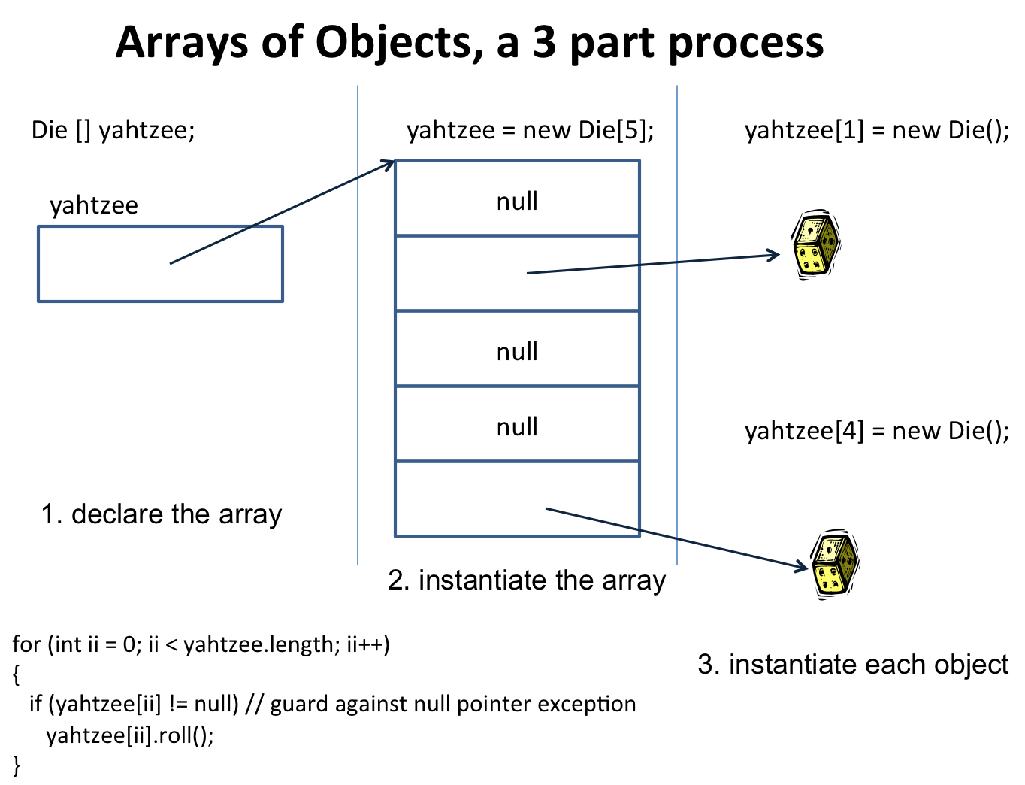

If you were to create an array of Die objects, the above diagram shows the three steps in the process.
- In the space below, write the code to declare an array of 5 Die objects, instantiate the array, and then to instantiate each of the objects.

