Exploring Objects

Objectives
At the end of this exercise, students will:
- Introduce the use of the terms, object, class, instantiation, immutable method, accessor method, mutator method, public, private and this.
- Provide a framework for reading Chapter 6.1-6.3 prior to lab on Thursday.

Getting ready
- All team members - record your notes on your own response sheet. Reporter, turn in one sheet per team. Manager – make sure that all team members are contributing to the discussion.

Let’s look at a class designed to make new objects

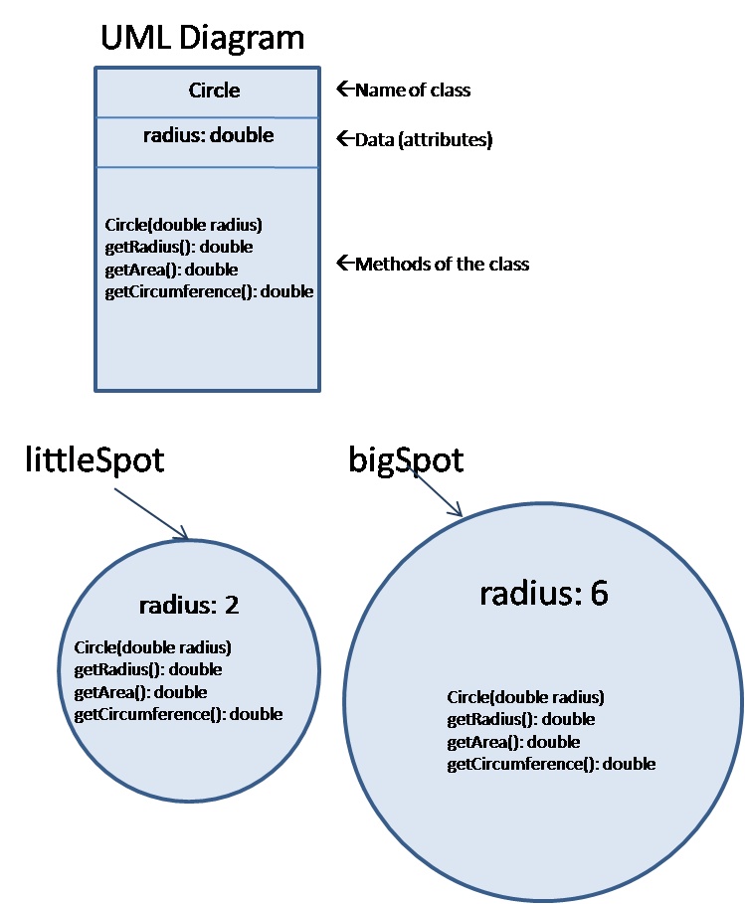

Take a look at the diagram of the Circle class on the prior page. You should also reference the code that you find in the reference pages.
- Looking at Circle.java, what is the data that is contained within this class? In other words, what are the class field(s)? (These are also called class attributes.) Class attributes define the object state.

- What visibility modifier do you see on the line(s) that declares the class field(s)? This modifier means that the data of this class is available only to members (data and methods) within the class. No class outside of this class may access this field directly.

- What visibility modifier do you see on the lines where you find method headers? What do you think this means?

- Looking at MakingCircles.java, on what line do you see a call to a constructor for a Circle object? What is the name of the constructor method?

- In the call to the Constructor, what do you need to pass to the Constructor method? Why?

- Look at Circle.java again. The constructor method header is missing something that all other methods have. What is it?

- The constructor is named the same as the class name. What normal rule about naming methods does this violate?

- Constructors always return the address of the location where the object has been created. In MakingCircles, into which variables are the addresses going?

- What do we call such variables?

Extending the notion of classes
- BOARD For a class such as Circle, why do we need to make an object to use the methods of the class?

- Inside of Circle, all references to radius (except for the declaration) are prefaced with “this.” Within a class, “this” refers to the calling object’s fields or methods. If I call the getArea() method in MakingCircles using the littleSpot object, what is the value of this.radius in getArea()?

- Which method (if any) allows you to change the radius of the Circle after the Circle object has been created?

- We call this class an immutable class because it cannot be changed once created. In your own words, how would you describe an immutable class? How would you describe a mutable class?

- Non-constructor methods can be categorized as mutator, accessor, or utility methods. Mutator methods change class field data, accessor methods access or read class field data without changing it, and service or utility support other methods and do not directly access data. Looking at the non-constructor methods in Circle, which kind(s) do you see? Why do you characterize them in this way.

REFERENCE PAGES FOR UNDERSTANDING OBJECTS
/***********************************************
MakingCircles exercises each of the Circle methods
@author Nancy Harris
@version V1 09/26/07
***********************************************/
import java.util.Scanner;
public class MakingCircles
{
/** main method - Drives the action
@param args command line arguments - unused
*/
public static void main(String args[])
{
// declare variables
Scanner kb;
Circle bigSpot;
Circle littleSpot;
double radius;
double outRadius;
double area;
double circumference;
// instantiate and initialize where necessary
kb = new Scanner(System.in);
// prompt for and read in a radius
System.out.print("Enter a small radius value: ");
radius = kb.nextDouble();
System.out.print("\n");
// instantiate a new Circle called spot
littleSpot = new Circle(radius); // test the constructor
// prompt for and read in a second radius
System.out.print("Enter a large radius value: ");
radius = kb.nextDouble();
System.out.print("\n");
// instantiate a new Circle called spot
bigSpot = new Circle(radius); // test the constructor
// test Circle methods
outRadius = littleSpot.getRadius();
System.out.println("The radius of the small circle is: " + outRadius);
outRadius = bigSpot.getRadius();
System.out.println("The radius of the large circle is: " + outRadius);
// test your other methods here using the variables above
area = littleSpot.getArea();
System.out.printf("The area of the small circle is: %.2f\n", area);
area = bigSpot.getArea();
System.out.printf("The area of the large circle is: %.2f\n", area);
// circumference
circumference = littleSpot.getCircumference();
System.out.printf("The circumference of the small circle is: %.2f\n",
circumference);
circumference = bigSpot.getCircumference();
System.out.printf("The circumference of the large circle is: %.2f\n",
circumference);
System.out.println(littleSpot.toString());
System.out.println(bigSpot.toString());
}
}

/********************************************
Circle is a class representing circle-like
shapes.
@author Nancy Harris, James Madison Univ
@version V1 09/26/2007
*******************************************/
public class Circle
{
// Circles are defined by their radius
private double radius;
/****************************************
Constructor Builds a Circle of radius
inRadius. If the radius is negative, sets
it to 0.
@param inRadius The radius of this Circle
*****************************************/
public Circle(double inRadius)
{
this.radius = inRadius;
if (inRadius < 0) //invalid data
this.radius = 0;
}
/*****************************************
getRadius is an accessor method which
returns the radius of this Circle
@return radius of this Circle
*****************************************/
public double getRadius()
{
return this.radius;
}
/****************************************
getCircumference is an accessor method
which calculates and returns the circumference
of this circle: cirumference = PI * d where d
is the diameter.
@return The circumference of this Circle object
*****************************************/
public double getCircumference()
{
double circum;
circum = 2 * this.radius * Math.PI;
return circum;
}
/*****************************************
getAreaCircle calculates and returns the
area of this Circle object using the formula
area = PI * r * r
@return the area of this Circle
*****************************************/
public double getArea()
{
double area;
area = this.radius * this.radius * Math.PI;
return area;
}
/*****************************************
toString provides a representation of this
Circle. Your String should read:
A circle of radius, XXXXXX, and area, YYYYY.
XXXXXX is replaced by the radius and YYYYY
is replaced by the area.
@return String representation of this Circle
*****************************************/
public String toString()
{
return String.format("A circle of radius, %.2f, and area, %.2f.",
this.radius, getArea());
}
}

