Exploring relational and logical operations.

Objectives
At the end of this exercise, students will:
- Be able to create simple relational expressions
- Understand the role of decisions in algorithms
- Be able to use simple relational expressions in decision structures in Java

Getting ready
- Coordinator, get one copy of the response sheet for each team member and one Exit Pass for the team.
- All team members - record your notes on your own response sheet.

Initial Activity
Review of relational operators from prior math classes. Relational operators ask questions like, “Is a greater than b?” or “Is a equal to b?”. The relational operators in Java are:

Relational Operator | Meaning
> | is greater than
< | is less than
>= | is greater than or equal to
<= | is less than or equal to
== | is equal to
!= | is not equal to

Examples:
13 > 22 is false
13 < 22 is true
13 == 22 is false
13 == 13.0 is true (widen the integer to a double, then apply the is equal to operator)

ADDITIONAL PRACTICE IF YOUR TEAM FINISHES EARLY
Algorithm workbench (end of Chapter 3) 1, 2, 3, 4
Problem solving with relational operators. Given the variables and the values in the chart below, evaluate each expression and write your result as true or false.

Variable | Type | Value
bluebird | int | 25
monkey | double | 25.33
alligator | int | 88
petunia | int | 92
rose | double | 125.00
pheasant | char | ‘X’
mushroom | char | ‘Z’

Expression Answer
a. 98 == petunia
b. bluebird >= monkey
c. (petunia + rose) < (alligator * 3)
d. bluebird == monkey
e. (alligator % 3)!= (rose / 40)
f. bluebird == ((rose * 2) – 225)
g. mushroom >= pheasant
h. 16 + ((25 / 5) % 2) > 17
i. ((alligator % 5) / 3) < 0

The Model – Decision structures in Algorithms

Your favorite band is coming to town and you want to get tickets to the concert. Here is the algorithm you might use to buy the tickets.
 | If I have the money for tickets | 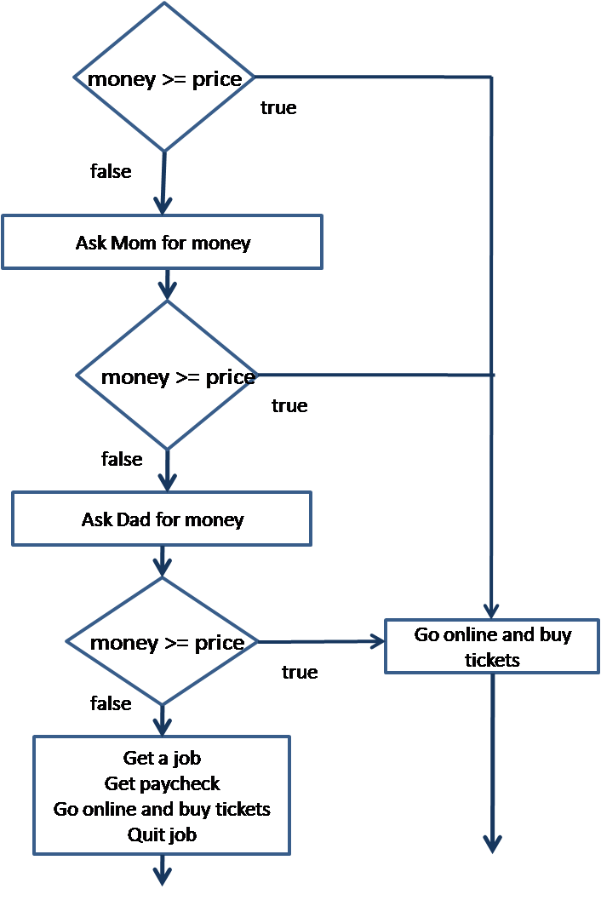
 | go online and buy the tickets
 | otherwise
 | ask Mom for the money
 | If mom gives me enough money
 | go online and buy the tickets
 | otherwise
 | ask Dad for the money
 | If dad gives me enough money
 | go online and buy the tickets
 | otherwise
 | get a job
 | get paycheck
 | go online and buy the tickets
 | quit job

Exploring the model
What do the diamond shapes represent?

What do the rectangles represent?

There are two arrows coming from the diamonds. What do they mean?
At each decision point, you have how many choices?

If you take a “branch”, do you execute the code in the other branch?

In your own words, what are decisions in algorithms allowing you to do?

Extending the model to code
See the example of decisions in the code below.
public class TestResults
{
public static void main(String[] args)
{
int testScore; // Numeric test score
String input; // To hold the user's input
Scanner kb; // Keyboard Scanner
kb = new Scanner(System.in); // get the Scanner ready
// Get the numeric test score.
System.out.print("Enter your numeric " +
"test score and I will tell you the grade: ");
testScore = kb.nextInt();
System.out.print("\n\n");
// Display the grade.
if (testScore >= 70)
System.out.println("Your grade is CR.");
else
System.out.println("Your grade is NC.");
}
}
What is this code doing?

How many decision points are in this code?

What kind of expression is used to represent a decision?

What will the result of the expression be (in general terms)?

If the user enters 70 what will be the result of running this program?

Try it! Download the code from here. Now test a different value that will take the other branch and write the value here _____.

What will happen if a user enters an invalid grade (like -456)?

What will happen if the user enters something at the keyboard like “A”?

