Lab
Using a Database: Tables and Queries
Name:
Vocabulary
All key vocabulary used in this lab are listed below, with closely related words listed together:
relationship
entity-relationship (ER) diagram
redundancy
table
entity
record
field, attribute, column
data type
key, primary key
row, tuple, record
query
result set
selection criteria
You will be looking at an existing database and then performing a series of queries on that database. Be sure to answer the questions as they appear in the lab, and ask questions as you are going along. You will receive this booklet back prior to the exam for studying. Feel free to take notes on your processes as you are working.
Preparation
Download a copy of the Movies.mdb and the Movies.xls files from Blackboard to your local machine (either a memory stick or your local C: \temp drive).
Discussion and Procedure
Throughout this lab, you will be working with a sample database that stores information about movies and movie directors. Before we actually work with the movie database in Access, however, we will spend some time discussing why this information is better suited for storing in a relational database, in contrast to a spreadsheet.
Submission for Credit
As you are working, use the full lab document as your guide and fill in the answers to the thought questions on the worksheet provided. When you have completed the lab, upload the Movies.mdb database to the Blackboard submission site. Make sure that it has all of the queries in it. Also, be sure you are out of the database before you upload. Check with the instructor to insure that it loaded properly. Submit your worksheet in hardcopy form, no later than the beginning of class on Tuesday.
Lab is due BEFORE class on Tuesday. We will continue with more advanced database topics then.
- Recognizing Relationships in Information
The information stored in the sample database includes movie titles, movie release dates, movie directors, directors’ names, directors’ year of birth, etc. What is it about this information that makes it better suited for storage in a database, rather than the simpler spreadsheet, which we studied in the previous lab?
First, let’s consider what the information describes: movies and directors. Movies and directors are separate things in real life, but they are also related. This “separate but related” property suggests that a database would be good for storing information about these things. The relationship between movies and directors can be represented in an “entity-relationship” diagram, or ER diagram, like this:
Movie
Director
Directed

Why not a spreadsheet? Let’s return to considering the movie and director information, keeping in mind the organizational structure represented in our ER diagram. The sample database stores this information in two tables, but unless we consider what it would be like to store this information in a spreadsheet, it might not be clear to you how a database is advantageous. Each movie has some information that we want to store about it, e.g., title, year of release, director. Each director also has some information, like their name and year of birth. The most natural way of storing all of this information in a spreadsheet might look like this (See the Spreadsheet that you downloaded):
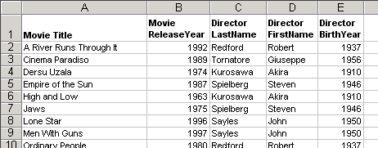

Storing information this way, however, has some potential problems related to redundancy.
- Consider adding or editing information in the spreadsheet above and briefly describe how redundancy might lead to problems or inconveniences. Try it with your spreadsheet. Add a new Spielberg movie. What happens if you misspell his name. What information is duplicated?
These redundancy problems are directly related to the fact that a single spreadsheet is being used to store two distinct groups of information: information about movies and information about directors. The more appropriate storage solution is to have a database with separate tables for movie information and director information. In the rest of this lab, we will examine a database that has this design and see how it simplifies viewing, modifying, and adding information.
- Viewing Information in Tables
- Open the sample database. Open movies.mdb. This should start Microsoft Access, and the main window should look like this:
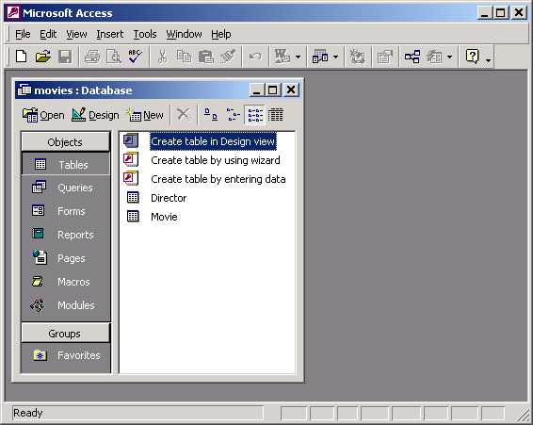
(Note that the Access window has a subwindow titled “movies : Database.” As we will begin to see in this lab, databases have many parts, so Access displays them in separate subwindows, all within the main window titled “Microsoft Access.”)
This sample database already has some information stored in it, so we will start by seeing how it is organized into tables.
Among other things, a database contains tables, where all of the information is stored in tuples(or rows); queries, which do not hold data themselves but are ways of building new tables out of the existing tables; and forms and reports, which are specialized ways of viewing the information. (Note that queries are somewhat similar to programs in that they describe processes and actions, rather than describe information.) The Database subwindow lists these categories of parts on the left side, under the heading, “Objects.”
Notice that this database contains two tables: Director and Movie. (Select Tables under Objects to see the table list, if it is not already shown in the Database subwindow.) There is one table for each of the kinds of “separate but related” things the database is designed to store information about.
- Open the Movie table to see the tuples(rows) stored inside. Double-click the Movie table to open it in what Access calls “Datasheet View,” which appears in a new subwindow. Before we start clicking around to work with this table, write down some similarities between this view of the information and a spreadsheet?

Along the top of the table, you see field names. (Another word for field is “attribute,” which is commonly used when discussing databases. We will try to consistently use “field,” which is the term Microsoft Access uses.) The fields specify the information that the table stores for each movie. Each field has a name, shown in the gray buttons at the top of the columns in Datasheet View.
- Identify the field names in the Movie table. Write the names of the fields below.
Information about each movie is stored as a set of field values and displayed as a row in Datasheet View. We call this set of field values a tuple or row in database terminology.
- Examine the tuples for fields with unique values. Are there any tuples for which the values for the Title field are the same? Which field’s values are unique across all of the tuples in the Movie table?

Based on this, which field do you expect is the primary key for this table?

Examining a table’s structure. Datasheet View shows you both the information stored in the table, as well as a little bit about the structure of the information, i.e., how many fields there are for each tuple, and what the field names are. Access provides another view of a table called “Design View,” which is specialized for working with the structure of the information.
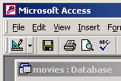
- Switch the Movie table to Design View. There are many ways of switching between Datasheet and Design View. You can use the menus in the main Access window by selecting View \ Design View. You can also click the toolbar View button, whose icon changes when you switch between views. While you are in Datasheet View, it should look as shown at the right.
Design View is used to view and modify table structure, rather than table contents (which is what Datasheet View is primarily for). Again this view has rows and columns, but this time, each row contains information about an field. In this lab, we’ll just look at the table design, but in a later lab, we’ll revisit Design View and make changes to this table.
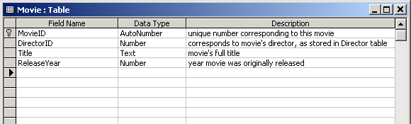
In this view, it is clear that in addition to a name, each field has a data type, which specifies what kind of information the field’s value must be (e.g., a number, some text, a currency amount, etc.). The database designer can also provide a brief description of what the field is for in the rightmost column.
Access identifies the primary key with a small key icon to the left of the field name. The data type for this field is a special kind of number data type that guarantees that no two tuples ever have the same value for the field.
The DirectorID field allows each tuple in the Movie table to be associated with a tuple in the Director table. Just like the Movie table, the Director table has a primary key field called DirectorID that uniquely identifies each director. Next, we will see more about how the primary keys in these tables are used to represent the relationship between movies and directors.
- Close the Movie table.
- Open the Relationships subwindow. You can do this via menus by selecting Tools \ Relationships… or by clicking the toolbar Relationships button ( ).
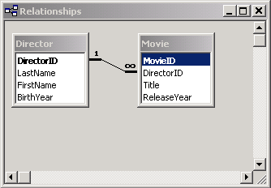
The new subwindow should resemble the ER diagram from the beginning of this lab.
- Judging from their titles and contents, what does each small window represent?

- Each small window shows a list of fields. How is the primary key distinguished from the others in these lists?
- Which fields from which tables are connected by the black line?
Just as in the ER diagram, the black line between the two smaller windows represents the relationship between movies and directors. The 1 and the infinity (∞) symbols are used to indicate that directors and movies have a “one-to-many” relationship, i.e., each director can be related to many movies. (Note that the reverse is not true, with the usually valid assumption that each movie has only one director. This is why we say the relationship is “one-to-many,” rather than “many-to-many.”) (Instructor note: Even though we may have two rows with the same movie title, you will notice that the movie dates are different representing different movies. It would be possible to make a many-to-many relationship between movies and directors – see shaded box.)
What about many-to-many? In the world of movies, there are a variety of relationships that are many-to-many, instead of one-to-many. Consider actors and movies, for example. Most movies feature more than one actor, and most (successful) actors star in more than one movie. Relational databases are also capable of storing many-to-many relationships, but the way you represent them is considerably more complicated than adding an ID field to a table. If you want to set up a many-to-many relationship between two tables, it requires that you add a third table, called a “junction” or “link” table. This third table stores pairs of IDs, and rows from the original two tables are related if their IDs appear together in a row of the link table. To keep things simple, we’ll stick with one-to-many relationships in these labs, but once we cover creating tables in Lab 3.4, you can give many-to-many relationships a try yourself.
- Queries on One Table
Now that we see what kind of information is stored in this database and how it is organized with tables and relationships, let’s see how to use queries to retrieve the information in different ways and answer questions using the information.
As discussed in the text, you can think of a query as instructions for building a new table based on other tables. (“Other tables” includes tables generated by queries, in addition to the tables actually stored in the database. This means that queries can be built on top of existing queries, although we will not practice this in this particular lab.)
We begin with queries that are based on only one table. Here are some examples of potentially useful questions that you can answer with one-table queries:
- Which movies were released before 1980, ordered by year of release?
- When were each of the Psycho movies released?
- Which movies have titles that start with the letter R?
Examining an existing query. Before we write any new queries from scratch, let’s look at the results of running a prewritten query. Queries, like tables, can be viewed in Datasheet or Design View.
- Open the Query list. In the Database subwindow, under Objects, select Queries.
- Open a query in Datasheet View. Open the “MoviesBefore1980” query by double-clicking it or clicking the Open button (in the Database subwindow’s toolbar) with the query selected. Describe the tuples you see in the resulting subwindow: What fields are shown in the columns?
a. What is true of all of the ReleaseYear values?

b. In what order, if any, do the tuples seem to be in?
In Datasheet View, the subwindow showing query results should look just like a table subwindow, because it is, in fact, a table. In contrast to the tables Movie and Director, however, query tables are not stored in the database. Instead, they are generated from one or more of the stored tables (in this case, just the Movie table). Next, we’ll look at the query’s Design View to see how it is set up to construct the tuples you see in Datasheet View.
- Switch to Design View for this query. You can switch views with queries in the same way as with tables. Use the menus in the main Access window by selecting View \ Design View. You can also click the toolbar View button.
The Design View subwindow for a query is divided horizontally into two panes. The top pane shows the tables from which the query results are generate, and the bottom pane (the “design grid”) shows the fields (from the tables above) that the query assembles.
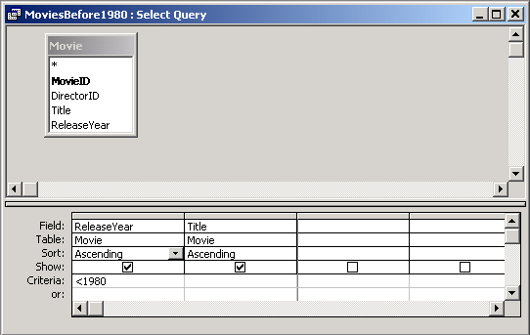
- Examine the fields in the design grid. What are the two fields in the grid, and which table are they from?
- Which of the fields have criteria specified for them, and what are they?

Modifying a query. To better understand how changes in the design grid affect the results of the query, we will try changing this query (MoviesBefore1980), switching back to Datasheet View after each change to observe the effects on the query results.
- Change sorting order. Two factors affect the order of tuples in a query result. First, for each field, you can specify whether the field is used for sorting, and, if so, whether the tuples are sorted in ascending or descending order by that field value. To select how an field should be treated for sorting purposes, in the design grid, click the cell in the Sort row in the field’s column. At the right end of the cell, a drop down list button should appear, and you can click it to select either “Ascending,” “Descending,” or “(not sorted).” The last option specifies that the field should not be used for sorting.
a. Try to modify query MoviesBefore1980 to sort the results in order by ReleaseYear, starting with the most recent movie. What change(s) do you have to make to the query?

You might want to sort results by more than one field. For instance, in the MoviesBefore1980 query, the tuples are sorted first by the ReleaseYear field first, then the Title field. If any movies have the same value for the ReleaseYear field, ties are broken by sorting by Title. Fields are considered in the order in which they appear in the columns of the design grid. To move a column to a new location, start by clicking the narrow, unlabelled, gray button at the top of the column. (When you move the mouse pointer over one of these column selector buttons, it should change to a thick, black down-arrow. Once the column is selected, with your pointer on the column selector button, drag to the new location.
b. Try to modify the query to sort by Title, then ReleaseYear. What change(s) do you have to make to the query?

- Change selection criteria. Change the criteria for the ReleaseYear field to =1980. Switch to Datasheet View and which row(s) appear.
- Remove/add a field. In addition to changing the order of the result tuples, you can change the fields included in the tuples. To remove a field, select its column in the design grid and press Delete or use the menus and select Edit \ Delete.
To add a field, drag it from its table (in the upper pane of the design view window) to the design grid below. Try removing the ReleaseDate field, and switch to Datasheet View to see the result. Then, add the ReleaseDate field back to the query, again verifying your change using Datasheet View.
Creating a new query. In the next steps, you will create a new one-table query for viewing information about directors. Your goal is a query to show just the names (first and last) of all directors whose last names begin with the letter S.
- Open a new query in Design View. Double-click “Create query in Design View.” Access should open a new subwindow for a new query, giving it the preliminary name “Query1”, which you should replace with a more descriptive and meaningful name when you save the query.
- Select the table whose fields you want in this query. A Show Table dialog box should appear with the new query subwindow. Double-click the table(s) from which you want to take field values and close the dialog box when you are done. In this case, we are interested in fields from just the Director table. (You can add more tables later using the Show Table toolbar button. You can remove them by right-clicking them and selecting Remove Table.)
- Construct the query. Using the table modification methods you learned above, construct a query that shows the names of directors (last name before first name) whose last names begin with the letter S, sorted by last name, then first name. (The criterion for beginning with the letter S is Like "s*", where the asterisk indicates that anything can come after the S.)

What tuples are in the query results?

- Construct other single-table queries to answer the remaining two questions introduced at the beginning of this part of the lab.
- When were each of the Psycho movies released? Be sure to save this query.
- Which movies have titles that start with the letter? Be sure to save this query.
- Submission Checklist
At the end of this lab, you should have a query to answer each of the following questions:
- Which movies were released before 1980, ordered by year of release?
- When were each of the Psycho movies released?
- Which movies have titles that start with the letter R?
- Which directors have last names that start with the letter S?
Whose software do the big databases use? As of 2003, the most commonly used database systems included Oracle, IBM DB/2, and Microsoft’s SQLServer. Large, international businesses and organizations rely on these systems to keep track of their operations, records, etc.
Further Reading
- The idea of relational databases isn’t really that old. Find out when relational databases were invented, as well as when ER diagrams were introduced as a tool for designing and thinking about databases on these pages or do a web search on “history of databases”.
http://math.hws.edu/vaughn/cpsc/343/2003/history.html
http://wwwdb.web.cern.ch/wwwdb/aboutdbs/history/

