
Computer Science at JMU
Nancy Harris
Lecturer and Freshman Advisor

Take a Peek Day April, 2011

What is Computer Science?
Computer science is the study of computers and computational systems including their theory, design, development, and application. It’s about solving real world problems with the aid of appropriate technologies. Our program begins with 2 programming courses.

What is programming?

A computer program is like a script that tells the computer what to do. Just like in a play, the actors perform actions and speak their lines based on what the script tells them to do. Unlike actors in a play, a computer cannot make up its own lines or actions, and must be directed to do every thing by its human directors.

Alice is a programming language that is like creating a play. The actors are the objects within a “world”, and the script (or program) tells those actors what to do and the order in which to do them. Each actor has certain actions (called methods) that it can do. And each actor has certain traits, like appearance, size, color, etc (called attributes).

Alice is a freely available download for Mac or PC from Alice.org. Developed by Carnegie Melon University as a way to teach beginners programming techniques, it is designed specifically for students in middle, high school, and beginning college students.

Opportunities for you to explore more

Computer Programming 1 – 4
Technical and Career Education

Introduction to Object Oriented Programming in Alice

- An object is a people, place, or thing that we manipulate.
- Objects have properties (size, shape, color, location)
- Objects have behaviors (move, raise, turn, say)

- We can control the properties and behaviors of our objects.
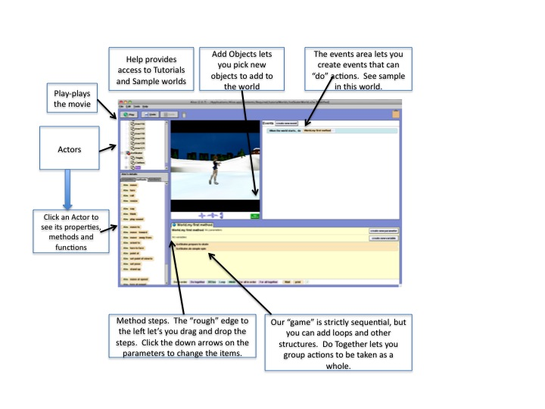
- Create an object:
  - Click Add Objects:
  - Choose Animals/Bunny and drag him to your “world”.
- Change its properties
  - Click on the properties tab in the lower left hand box.
  - You can change things like the color of the bunny or the “opaqueness”. Feel free to change your bunny’s color.
  - You can also change the size of the bunny by clicking on the resize button in the upper right.
- Add some behaviors
  - Close the gallery by clicking on the Done button. 
  - The method window lets you control the actions of the Bunny by writing a script.
  - Click on methods in the lower right window.
  - Drag bunny.play sound to the method window by grapping the “handle”.
  - Choose the sound ( I like the chicken sound).
  - Test your work by clicking on the Play button.
  - Click on the bunny foot.
  - The methods change to show “bunny.foot” methods.
  - Choose “foot.move at speed” action and drag to the method window.
  - A box opens where you can choose “up/speed .5 meters per second”.
  - Choose “foot.move at speed” action again and drag it to the method window below the last move action.
  - Play: You will see the foot levitate. Not quite what we want.
  - Change the parameters:
    - click more on the up action.
    - Change the “duration” to .25 seconds.
    - Do the same on the down.
    - Now play. It should look the the bunny is tapping its foot once.
  - Repetition
    - At the bottom of the method screen are some buttons to control actions.
    - We would like the bunny to look like it is tapping its foot. We can do that with a loop.
    - Grab the loop and pull it into the method window at the end.
    - Grab the two move statements and move them into the loop.
    - Change the loops to repeat 5 times.
    - Test by Playing.
  - Together actions
    - We can have the bunny cluck like a chicken while tapping its foot.
    - Pull up the “do together” button and pull the make sound and loop statements into it.
    - Test by Playing.
- You’ve created (or instantiated) and object, changed its properties and created a program which used sequence and repetition to perform an action.

