

Department of Computer Science

First Lego League 2011 – Game Programming with Alice

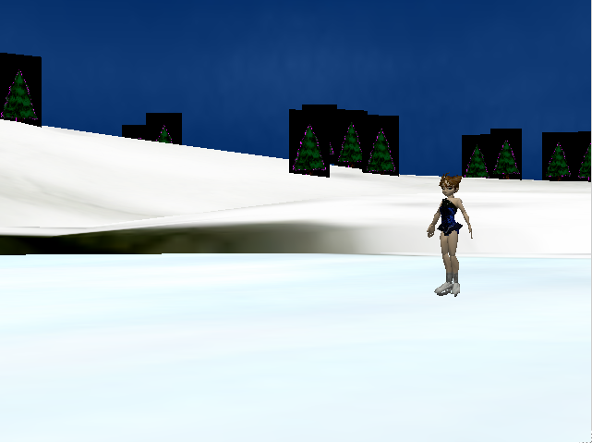
Activity 1 – Binary Codes
From Computer Science Unplugged
Background
Computers can do many amazing things. You have probably used them to play games and do schoolwork. You see pictures on the computer and you see text. But, everything in the computer is stored as a series of 1’s and 0’s (ons and offs). How does this code work to make up everything that you see on the computer?
We will use the example of text.
How many different code words, can you make from 2 binary digits (or bits in computer terms)?
Each one can be either 0 or 1. So,
00 01 10 and 11.
How many with three bits?
000 001 010 011 100 101 110 111
So to represent letters, we would need more bits.
ASCII or American Standard Code for Information Interchange is a coding scheme for text that not only represents the letters of the alphabet, but all kinds of other symbols as well. (Think of other languages that don’t use the same letters as the English language does.)
So think of ASCII as a secret code that computers can understand. But you can understand that code too. This code is made up of 8 bits also known as a byte.
This is a small part of the ASCII code which represents capital letters.
A 0100 0001 J 0100 1010 S 0101 0011
B 0100 0010 K 0100 1011 T 0101 0100
C 0100 0011 L 0100 1100 U 0101 0101
D 0100 0100 M 0100 1101 V 0101 0110
E 0100 0101 N 0100 1110 W 0101 0111
F 0100 0110 O 0100 1111 X 0101 1000
G 0100 0111 P 0101 0000 Y 0101 1001
H 0100 1000 Q 0101 0001 Z 0101 1010
I 0100 1001 R 0101 0010
Worksheet
Can you decode this message?
_____________ _____________ _____________ _____________ _____________
0100 0011 0100 1111 0100 1101 0101 0000 0101 0101

_____________ _____________ _____________ _____________
0101 0100 0100 0101 0101 0010 0101 0011

_____________ _____________ _____________ _____________ _____________
0100 0100 0100 1111 0100 1110 0100 1111 0101 0100

_____________ _____________ _____________ _____________
0100 0010 0101 1001 0101 0100 0100 0101

Can you put this message into the ACII code: THEY WENT DATA WAY
_____________ _____________ _____________ _____________

_____________ _____________ _____________ _____________

_____________ _____________ _____________ _____________

_____________ _____________ _____________

Now, write a message to a friend for them to decode.

Message:

Code:

Activity 2 – PIXELS
From Computer Science Unplugged
Background
So, computers use binary codes to represent letters and numbers. But what about pictures? Yes, pictures are binary codes also.
When you look at a picture on a computer screen, it looks like a photograph or a video. But while those are continuous images, a computer screen represents a picture as a series of “pixels” each of which has a color. A pixel is a tiny dot of light on the computer screen. The colors of the dots depends on binary codes. When you put a bunch of the tiny dots together, they make a picture. Look closely at the screen and you can see the pixels.
In this exercise, you will simulate making a picture like the computer does.
Materials – You need a marking pens and the grid on the following page.
Color the following “pixels” using your marking pen.

 | A | B | C | D | E | F | G | H | I | J | K | L | Row C – 24, 23, 22, 21, 20, 18, 12, 9, 3  Row D – 21, 18, 17, 13, 12, 9, 3  Row E – 21, 18, 16, 14, 12, 9, 3  Row F – 21, 18, 15, 12, 9, 3  Row G – 21, 18, 12, 9, 3  Row H – 21, 18, 12, 9, 3  Row I – 24, 21, 18, 12, 8, 3  Row J – 23, 22, 18, 12, 7, 6, 5  What is your picture of?
1
2
3
4
5
6
7
8
9
10
11
12
13
14
15
16
17
18
19
20
21
22
23
24
25
26

Activity 3 – Video Games with ALICE

A computer program is like a script tells the computer what to do. Just like in a play, the actors perform actions and speak their lines based on what the script tells them to do. Unlike actors in a play, a computer cannot make up its own lines or actions, and must be directed to do everything by its human directors.

Alice is a programming language that is like creating a play. The actors are the objects within a “world”, and the script (or program) tells those actors what to do and the order in which to do them. Each actor has certain actions (called methods) that it can do. And each actor has certain traits, like appearance, size, color, etc (called attributes).

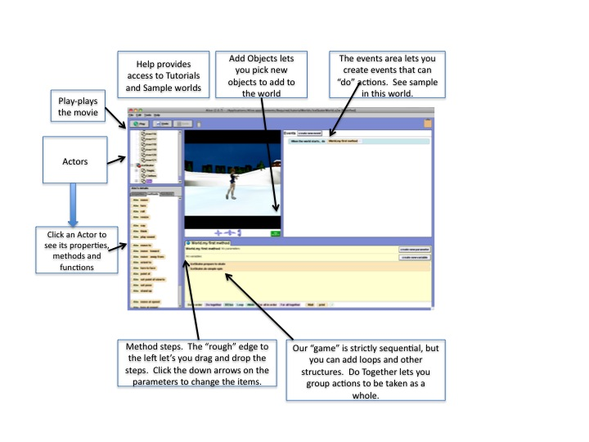
In the middle of the screen is a series of steps. The first step says IceSkater.prepareToSkate. This is an action of the IceSkater object and gets her ready to skate.
The actor name is always to the left of each step and the action follows. So IceSkater.prepareToSkate says that the actor, IceSkater, should prepareToSkate. Sometimes actions have parameters…these are what allows an action, such as sayDelay, to say something in one case (like “Yes”) and something different the next time it is used (like “No”).
For today’s lab, you will program a simple game, consisting of “actors”, methods, and events. After the demo, you can start with the ice skater example and add in some additional actors and or actions, you can use one of the other worlds, or you can create your own.
If you use any of the other worlds, be sure to save a copy to your desktop with your name in the file name. See the instructors for help.
NOTE: Alice is available for free from www.alice.org. There are two versions, one is Storytelling Alice geared for younger audiences and the other is the version we are working with today which lets you do more sophisticated programming.

