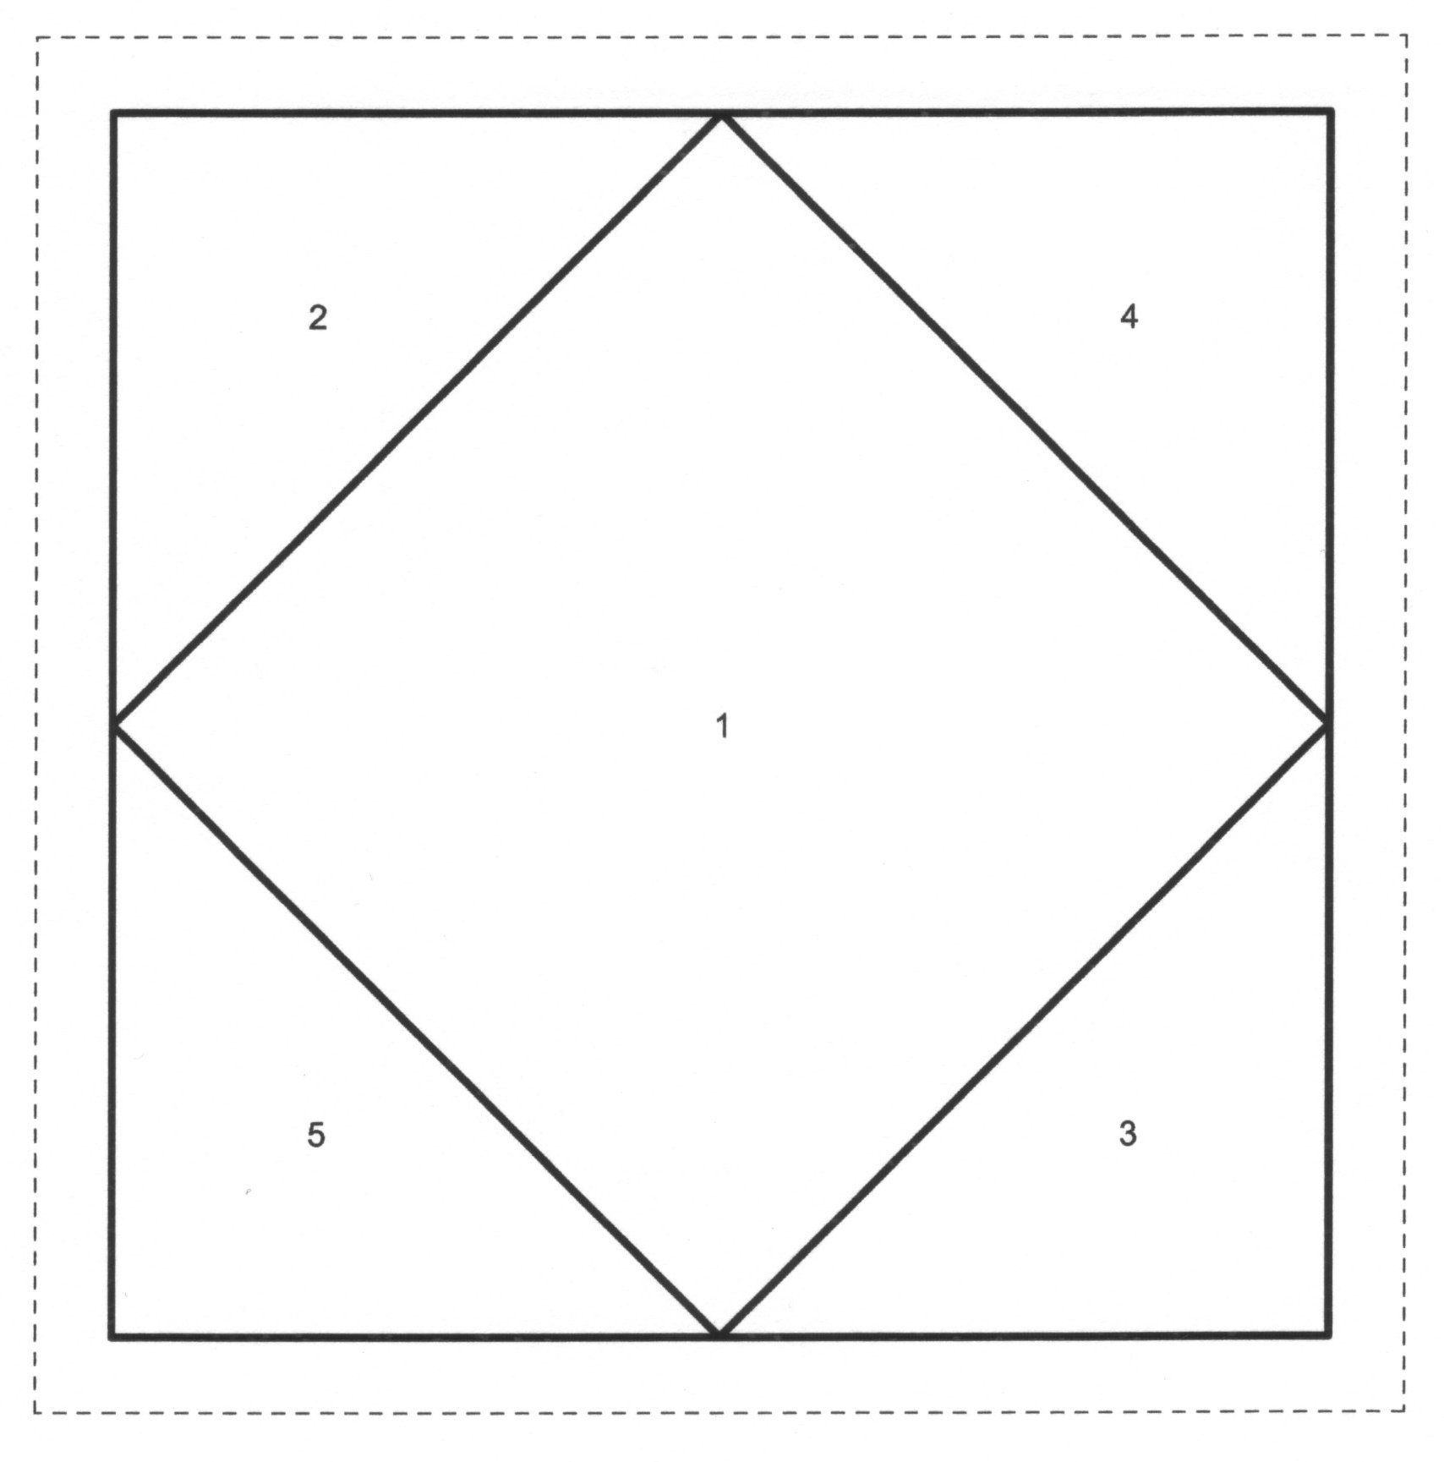

Canal Street Tile #1 Paper Piecing Pattern. Please check size after printing for accuracy. The finished size (dark solid line) should be 4”.

