The REQUIRED textbook for this course is:

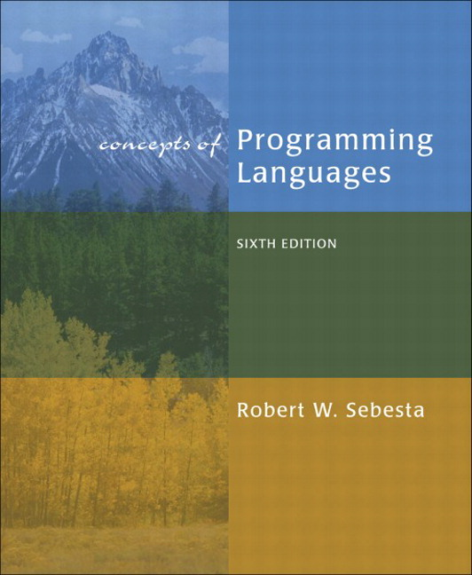

Sebesta
Concepts of Programming Languages

Programming Languages

Professor
Elizabeth Adams

Why you NEED this text:

- You will be TESTED from this textbook

- Homework assignments

- Reading assignments

