Quiz # 5 – Section 2 – CS 474
Name ______________________________
1. Define semantic object.

- Give an example of each of the following in a semantic object named APARTMENT:
  - a simple, single-value attribute:
  - a simple, multivalue attribute
  - a group, multivalue attribute
  - a simple object attribute

- What type of object is shown below?



4. Show to represent this object by means of relations.

5. Identify any necessary referential integrity constraints
6.. What is minimum cardinality?

- Which types of attributes have minimum cardinality?

- What type of object is shown below?

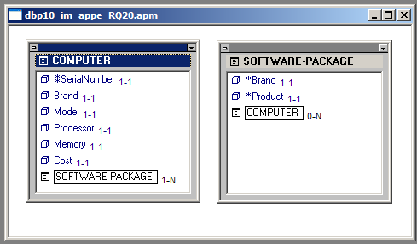

- Show how to represent the above object by means of relations

- Identify any necesary referential integrity constraints:

