Quiz # 5 – Section 2 KEY - – CS 474
Name ________________30 points______________
2 points
1. Define semantic object.
A semantic object is a named collection of properties that sufficiently describes a distinct entity.

- Point each just for red answers = 4
Give an example of each of the following in a semantic object named APARTMENT:
- a simple, single-value attribute: | NumberOfBedrooms
- a group, single-value attribute | ApartmentName as (BuildingName, ApartmentNumber)
- a simple, multivalue attribute | Phone jack location (one value for each phone jack in the apartment)
- a group, multivalue attribute | Occupant (FirstName, LastName), where more than one person can live in an apartment.
- a simple object attribute | BUILDING
- a multivalue object attribute | REPAIR

- What type of object is shown below? composite object E-16 2 POINTS

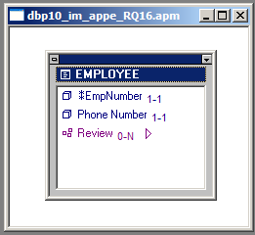

5. Show to represent this object by means of relations. 6 points
1 POINT FOR EACH ENTITY = 2
1 POINT FOR two attributes in EMPLOYEE = 2
1 point for primary key in EMPLOYEE = 1
1 point for foreign key in REVIEW = 1
EMPLOYEE (EmpNumber, Phone)
REVIEW (EmpNumber, ReviewDate, ReviewComments) need some additional attribute

- Identify any necessary referential integrity constraints 2 points
EmpNumber in REVIEW must exist in EmpNumber in EMPLOYEE

2 points What is minimum cardinality the number of values of an attribute that are required

2 points- What objects have minimum cardinality? All objects have minimum cardinality

- What type of object is shown below? M:N compound object 2 points

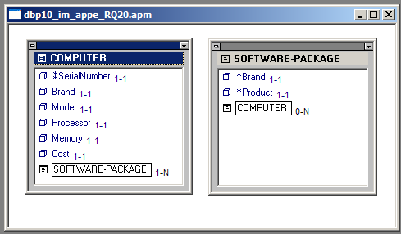

- Show how to represent the above object by means of relations 6 points

1 point per relation (entity) = 3
1 point for all the correct attributes per relation = 3

COMPUTER (SerialNumber, Brand, Model, Processor, Memory, Cost)
SOFTWARE-PACKAGE (Brand, Product)
COMPUTER-SOFTWARE-PACKAGE-INT (SerialNumber, Brand, Product)

- Identify any necesary referential integrity constraints: 2 points – 1 point each

Referential Integrity Constraints:

SerialNumber in COMPUTER-SOFTWARE-PACKAGE-INT must exist in
SerialNumber in COMPUTER
(Brand, Product) in COMPUTER-SOFTWARE-PACKAGE-INT must exist in
(Brand, Product) in COMPUTER

