Quiz # 5 – Section 1 – CS 474
Name ______________________________
- What is a semantic object view?

- Given the example of an APARTMENTobject with the following attributes (BuildingName, ApartmentNumber, RentAmount, LastOccupiedDate ) provide two views

- What type of object is shown below?

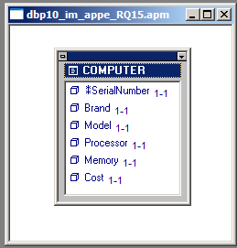
- Show how to represent the above object by means of relations.

- Indicate any referential integrity constraints

- List the three types of attributes.

- What is maximum cardinality?

- Which types of attributes have maximum cardinality?

- What type of object is shown below?
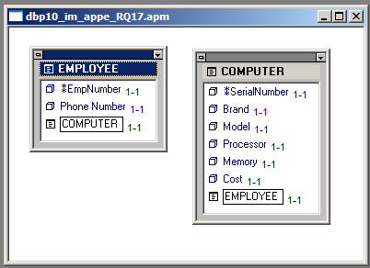

- Show how to represent the above object by means of relations.

- Indicate any referential integrity constraints

