Quiz # 5 – Section 1 key – CS 474
Name ______31________________________
2 points What is a semantic object view?
A semantic object view is a subset of a semantic object
2 points Given the example of an APARTMENTobject with the following attributes (BuildingName, ApartmentNumber, RentAmount, LastOccupiedDate ) provide two views
One view might have the first three attributes and another might have all four attributes.
3 points List the three types of attributes.
Simple attributes, group attributes, and semantic object attributes.
2 pointsWhat is maximum cardinality?
The maximum number of values an attribute can have in a semantic object. No object will be allowed to exist that has more than this number. .
2 points Which types of attributes have maximum cardinality?
All types have maximum cardinality

2 points What type of object is shown below? simple object
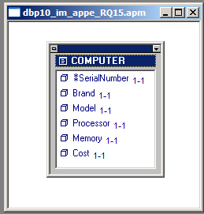
7 points Show how to represent the above object by means of relations.
COMPUTER (SerialNumber, Brand, Model, Processor, Memory, Cost)
1 for entity (COMPUTER) 1 for each attribute = 5
1 for indicating that SerialNumber is the primary key
2 points Indicate any referential integrity constraints

none

2 points What type of object is shown below? 1:1 compound object (1 each)

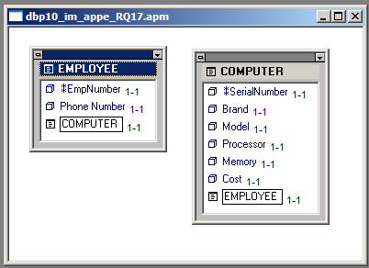

7 points Show how to represent the above object by means of relations.
EMPLOYEE (EmpNumber, Phone, SerialNumber)
COMPUTER (SerialNumber, Brand, Model, Processor, Memory, Cost)

OR just want one of the other
EMPLOYEE (EmpNumber, Phone)
COMPUTER (SerialNumber, Brand, Model, Processor, Memory, Cost, EmpNumber)
1 point per entity = 2
1 point for all attributes per entity = 2
1 point for indicating primary key for each relation = 2
1 point for indicating foreign key for 1 relation = 1

2 points Indicate any referential integrity constraints
Referential Integrity Constraints:
SerialNumber in EMPLOYEE must exist in SerialNumber in COMPUTER
OR only need one of these
Referential Integrity Constraints:
EmpNumber in COMPUTER must exist in EmplNumber in EMPLOYEE

