MUSIC SEMANTIC OBJECT MODEL (design phase)

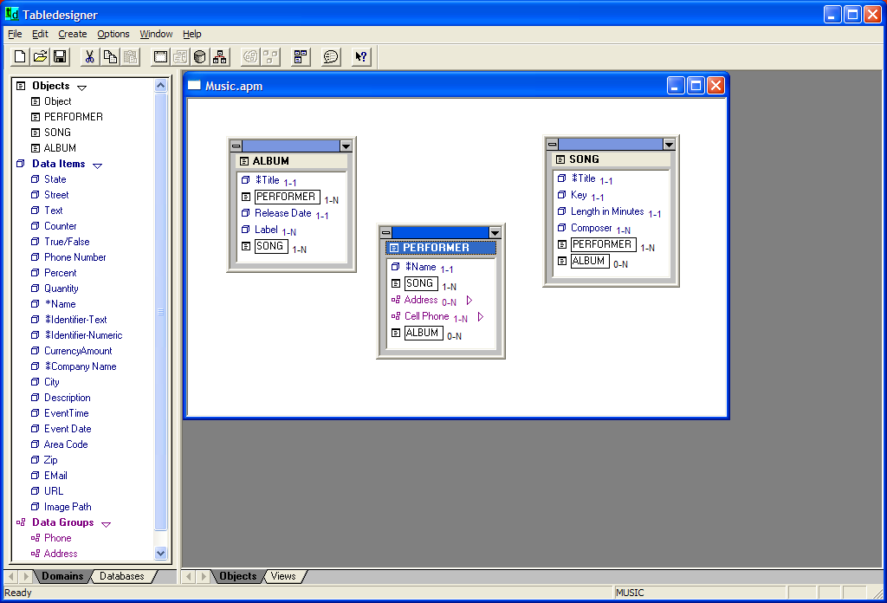

MUSIC SQL SERVER TABLES (created from above model)

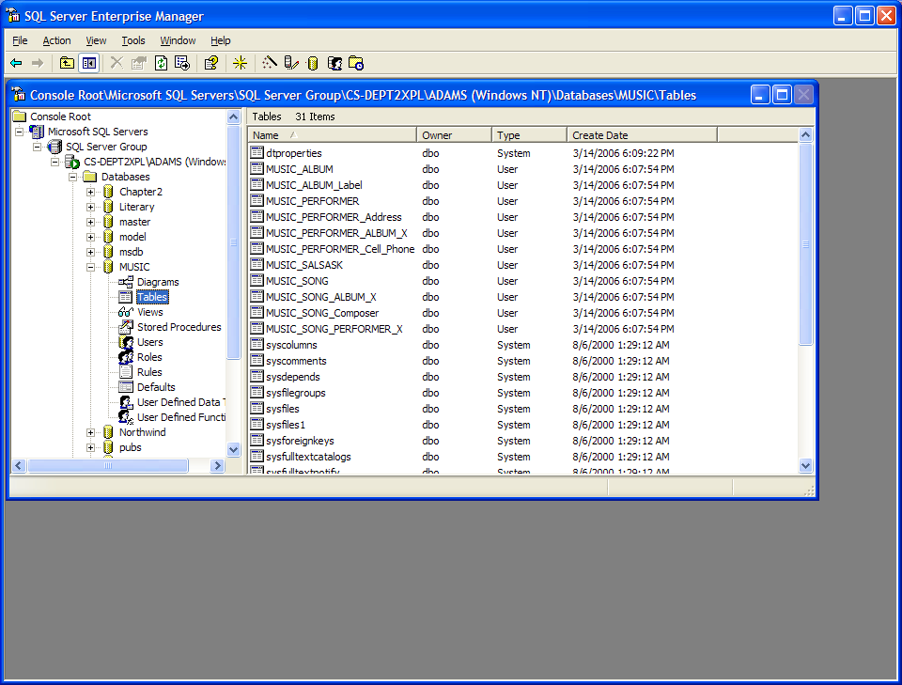
MUSIC RELATIONSHIP DIAGRAM (created by SQL Server from tables in database)

