Lab 4 – Due Tuesday February 21st

NOTE: Note the change in part III. This was done to differentiate between III and IV

Must be done in groups of two or three (bigger is better) . Group must include at least one person that one of you has not worked with before.

Below you will find a description of a non-profit organization known as the Metropolitan Housing agency (MHA). They are in need of a database design to hold their data. they have heard that the most important part of a database is its design. therefore, they have decided to hold a design competition to see who can come up with the best design.

Your assignment is to create a design which is in four parts.
- Make a list of all of the entities
- Indicate all of the attributes of each of the entities
- Indicate the relationships between the entitites – cardinalities, identifying relationships,
- (Bonus) not required: Create an entity relationship diagram of the entire project based on I, II, and III using ERwin

If you include an entity, attribute, or relationship which members of thee group differed on, you should include a statement or two about the rationale for the decision you came to.

Fill out the form which follows the description.

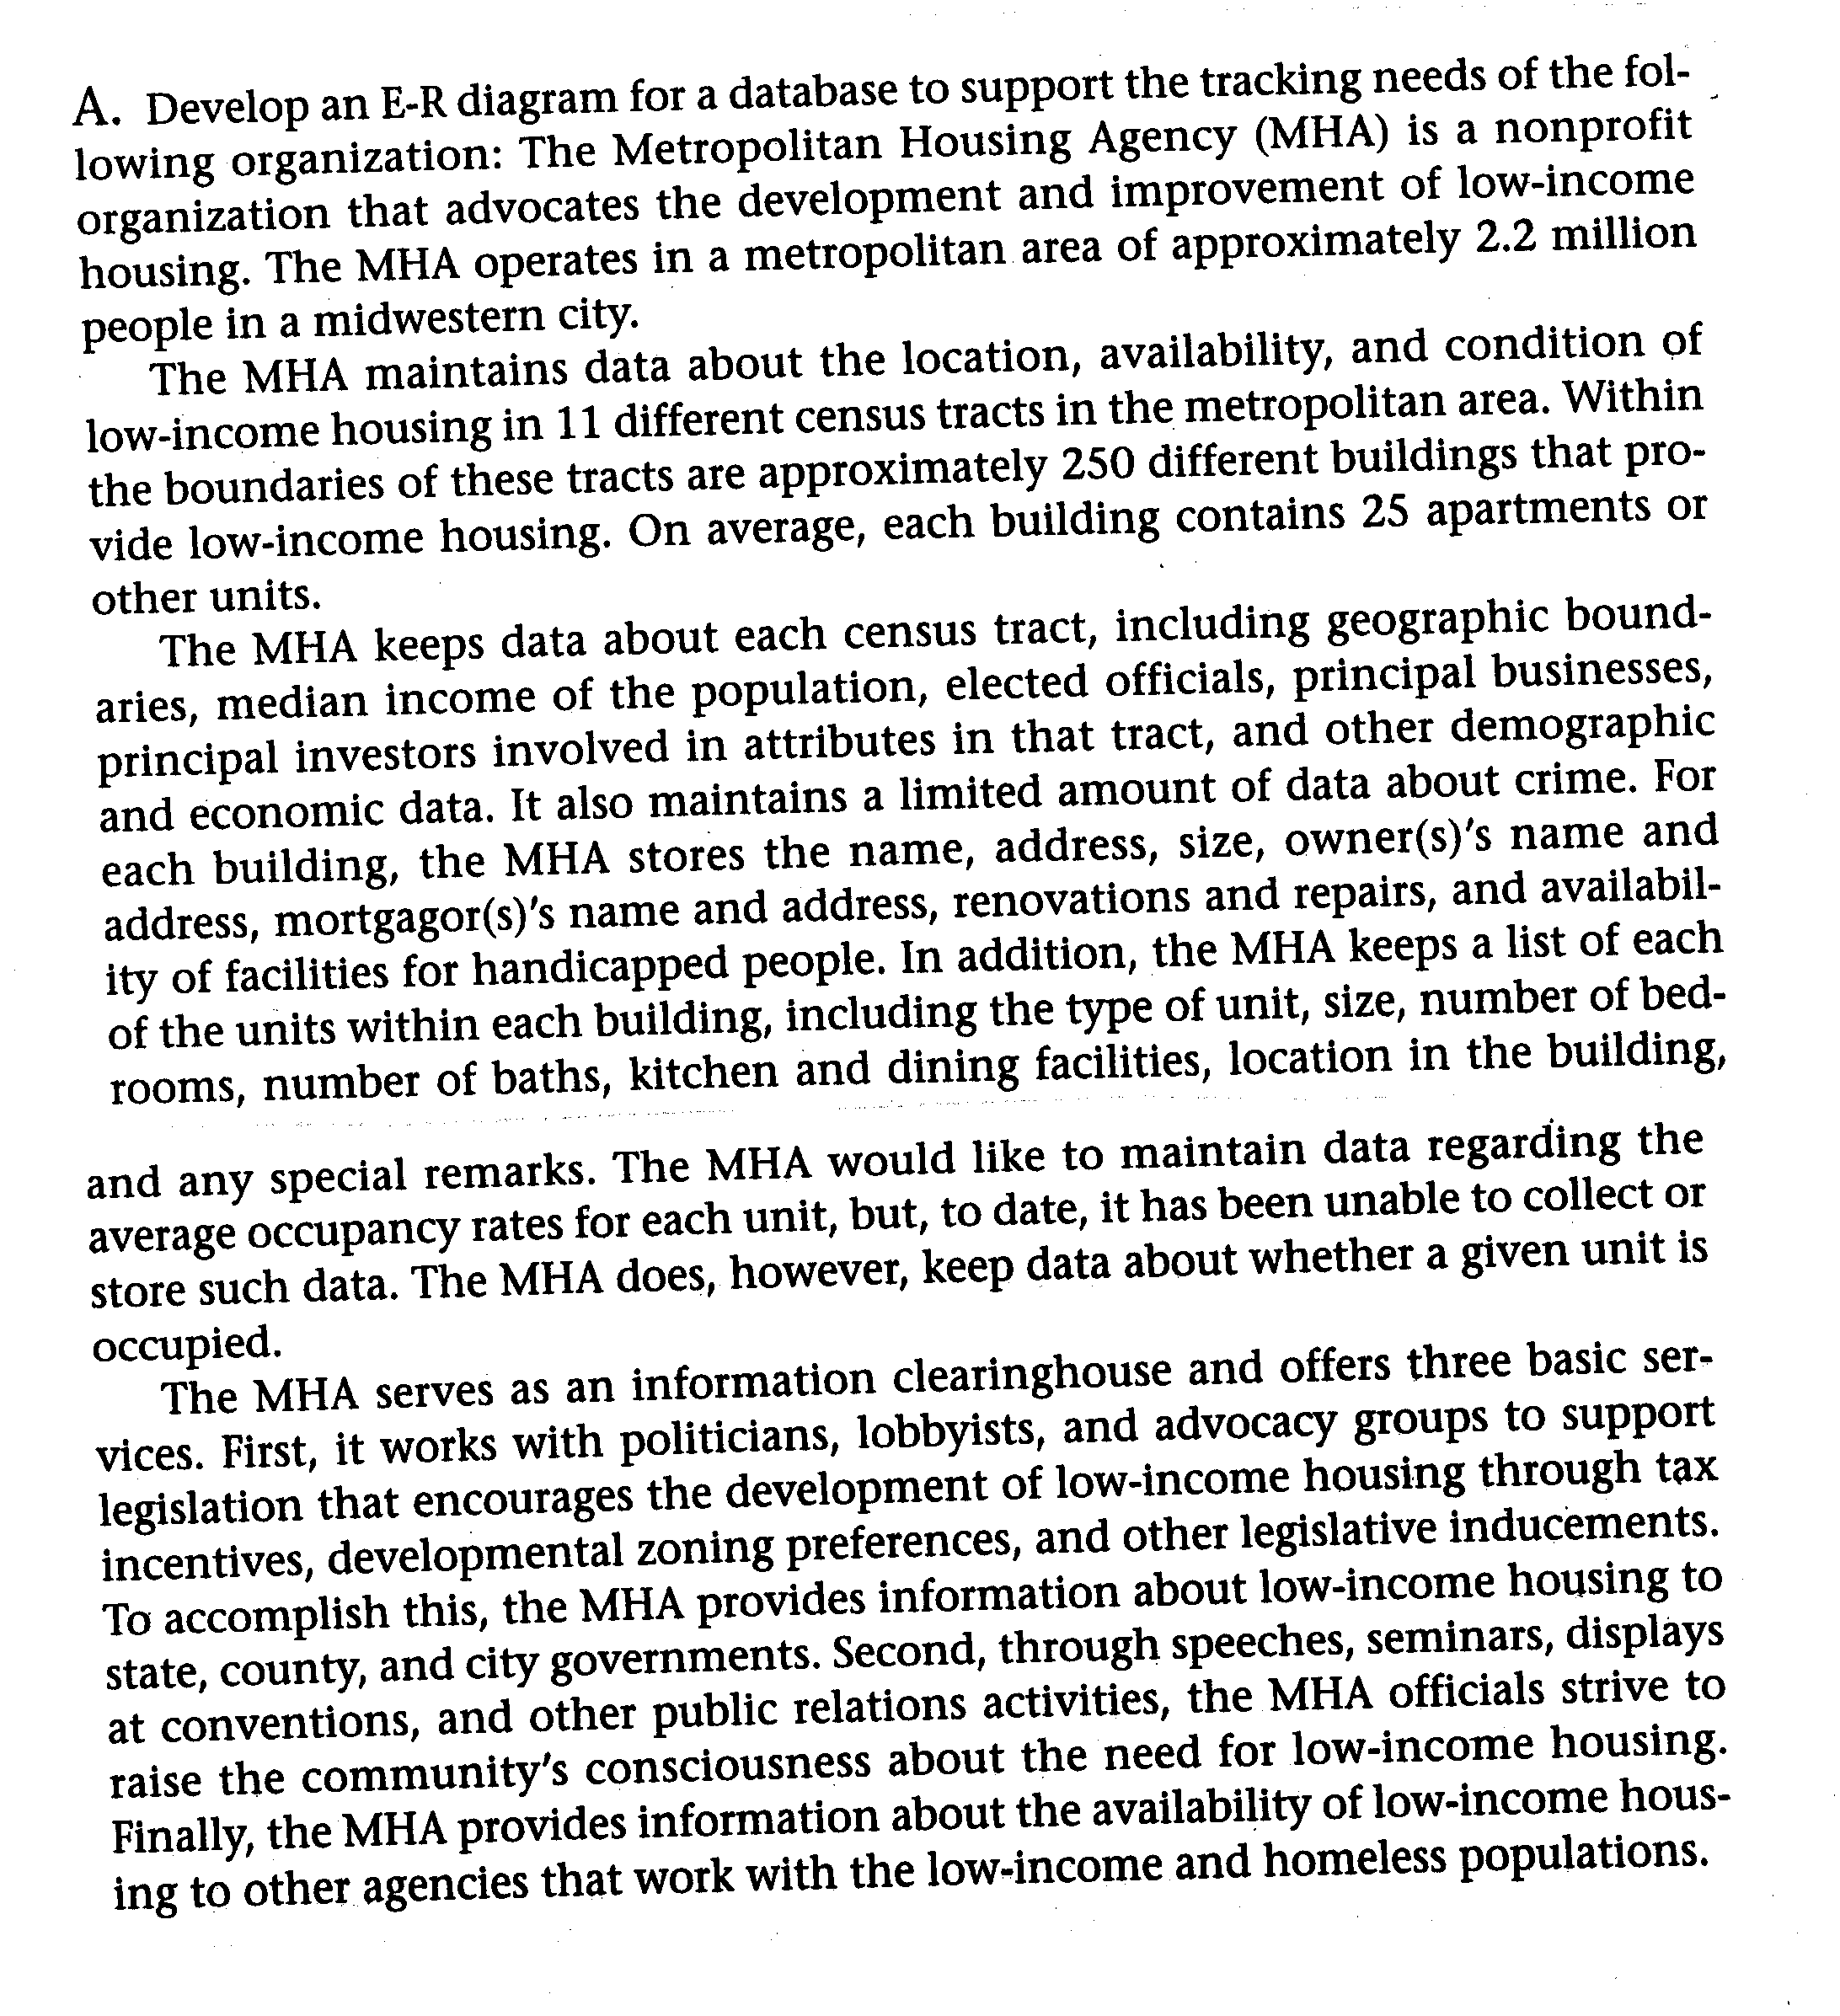

Group members first and last names:
____________________
____________________
____________________

Number of meetings: __________

For each meeting:
Date of Meeting | Length of Meeting | Part worked on (I,II, III, or IV | Group Members Present (last names only)

Part I – List of entitites

Part II Entities showing their attributes

Part III Relationships between entities indicating cardinalities

Part IV Relationship diagram for project

