Lab 4 – Due Tuesday February 21st

NOTE: Note the change in part III. This was done to differentiate between III and IV
Must be done in groups of two or three (bigger is better) . Group must include at least one person that one of you has not worked with before.

Below you will find a description of a non-profit organization known as the Metropolitan Housing agency (MHA). They are in need of a database design to hold their data. they have heard that the most important part of a database is its design. therefore, they have decided to hold a design competition to see who can come up with the best design.

Your assignment is to create a design which is in four parts.
- Make a list of all of the entities
- Indicate all of the attributes of each of the entities
- Indicate the relationships between the entitites – cardinalities, identifying relationships,
- (Bonus) not required: Create an entity relationship diagram of the entire project based on I, II, and III using ERwin
If you include an entity, attribute, or relationship which members of thee group differed on, you should include a statement or two about the rationale for the decision you came to.
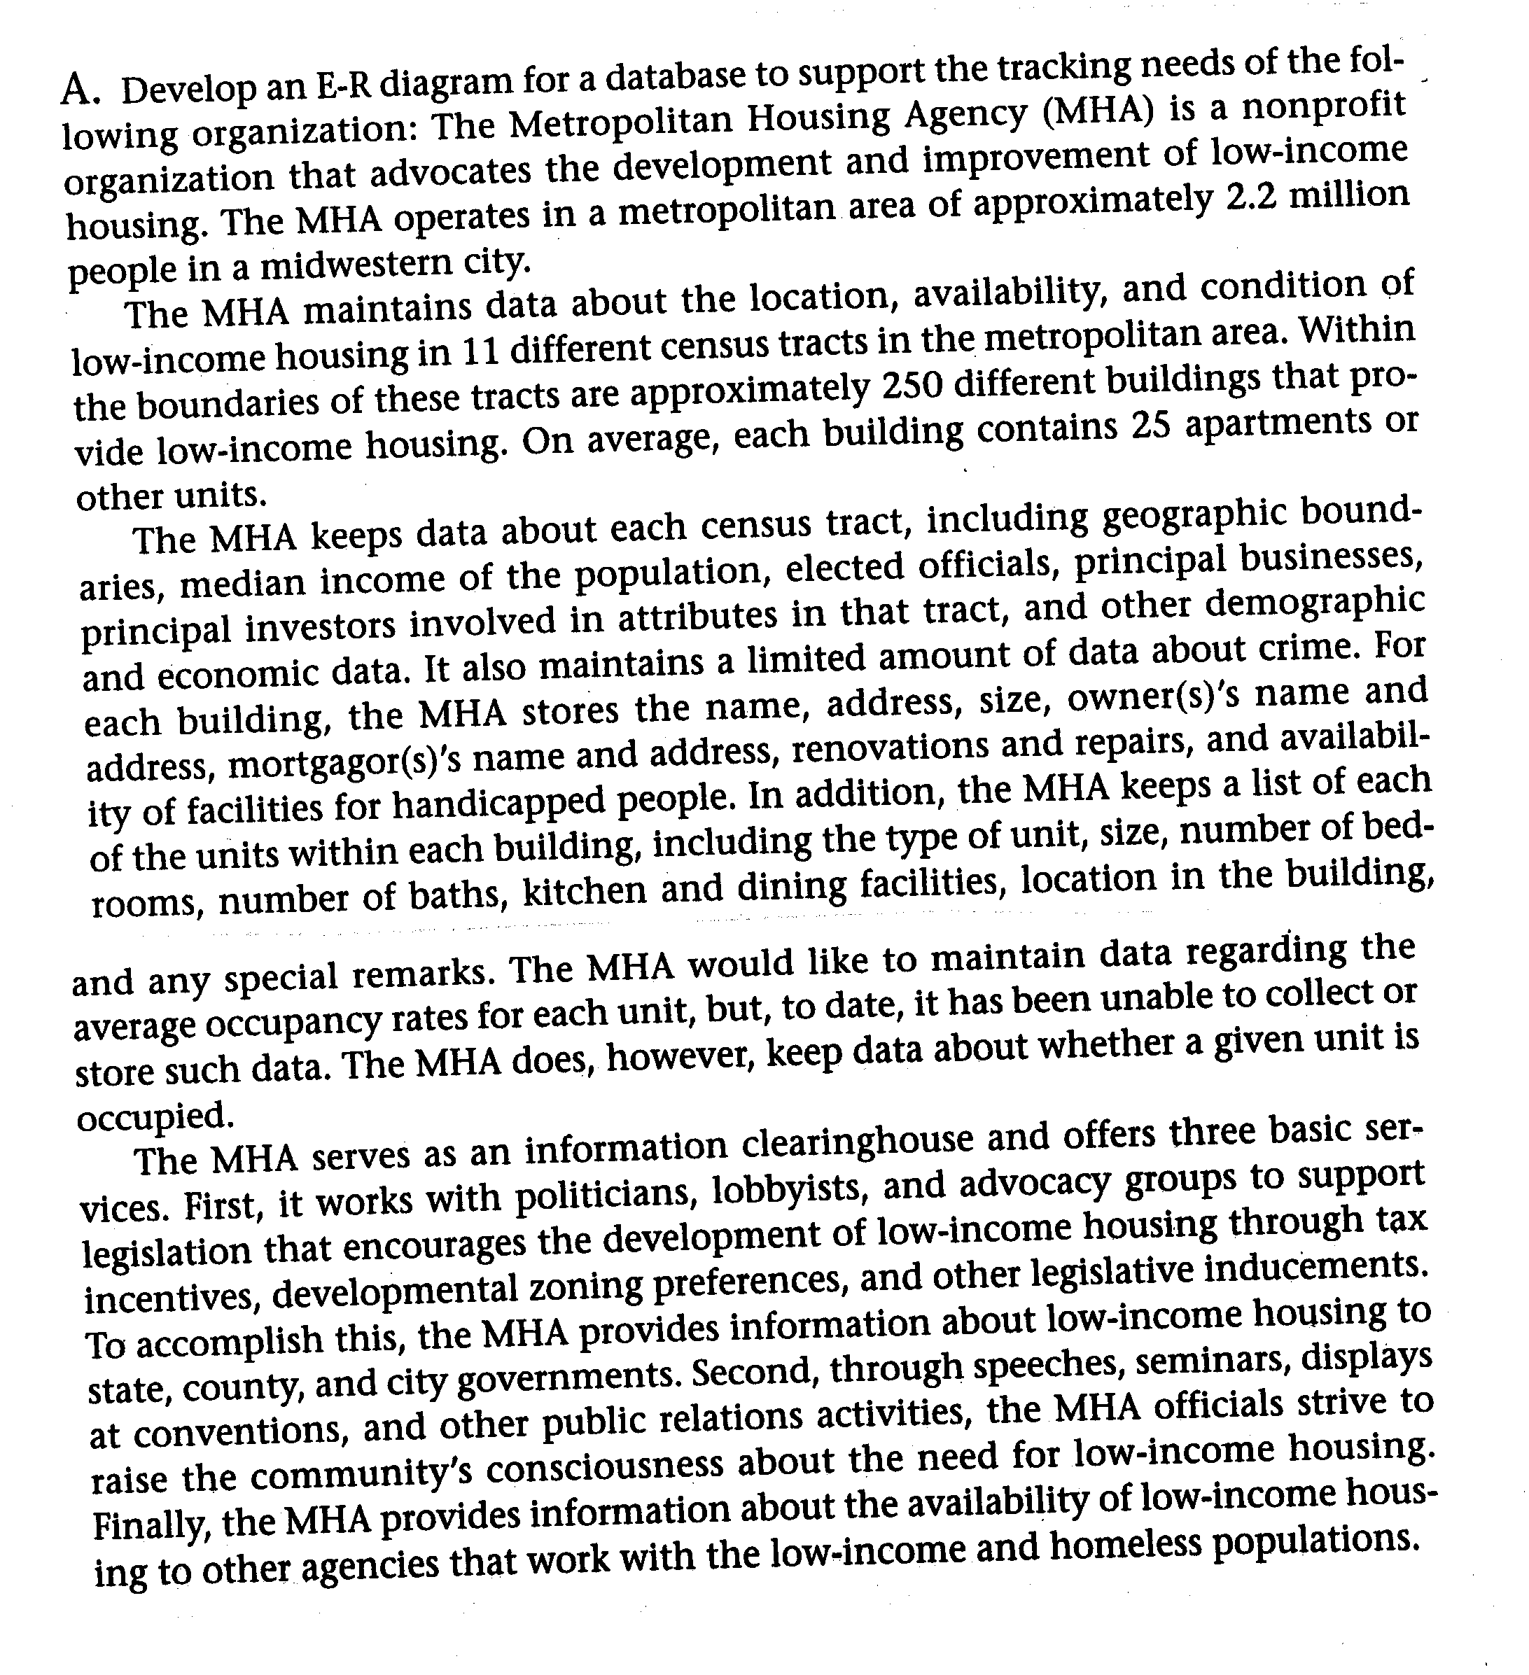
Fill out the form which follows the description.
44 points maximum score
Group members first and last names: 1 point for filling this in
____________________
____________________
____________________

Number of meetings: __________ 1 point for filling this in

For each meeting: 4 points total (1 point for each column filled in)
Note: does not require multiple rows flled in
Date of Meeting | Length of Meeting | Part worked on (I,II, III, or IV | Group Members Present (last names only)

Part I – List of entitities – 8 points (1 each) – no deduction for additional entities
Note: minor name variants okay
Census Tract
Elected Official
(Principal) Business
Investor
Building
Owner
Mortgagor
Unit

Part II Entities showing their attributes – 11 points – 1/2 point each
these are the minimum required - no deduction for additional attributes
Note: you can accept ID instead of name
Census Tract | name, geographic_boundaries, median_income, crime_data | 4
Elected Official | name | 1
(Principal) Business | name | 1
Investor | name | 1
Building | name, address (street, city, state, zip), size, renovations, repairs, handicapped facilities | 6
Owner | name | 1
Mortgagor | name | 1
Unit | size, #bedrooms, # baths, kitchen/dining_facilities, location, remarks, occupied | 7

Part III Relationships between entities indicating cardinalities
14 points (7 relationships - 7 cardinalities ) may be shown with diagrams or as below
note 3 possibilities for each 1:1 (one to 1), 1:n (1 to many), n:m (many to many)
building to unit  census tract to building  building to owners  mortgagor to building  census tract to elected official  principal business to census tract  investor to building | 1:n  1:n  n:m  n:m  n:m or 1:n  n:m  n:m

Part IV Relationship diagram for project 5 points for a diagram being present – don’t evaluate correctness

