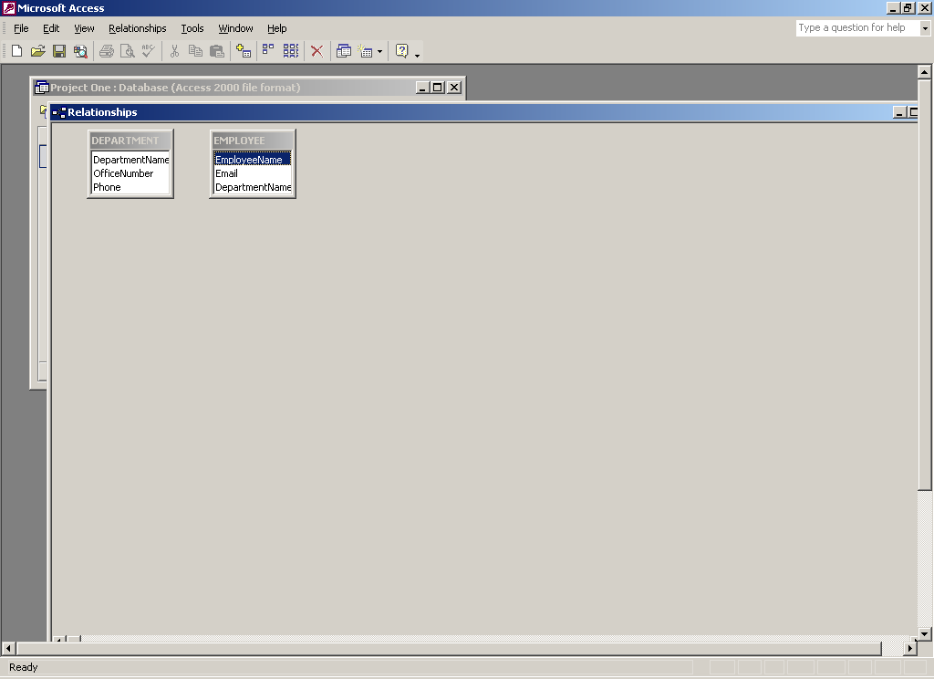

Tables created without relationships (no primary or foreign keys)

