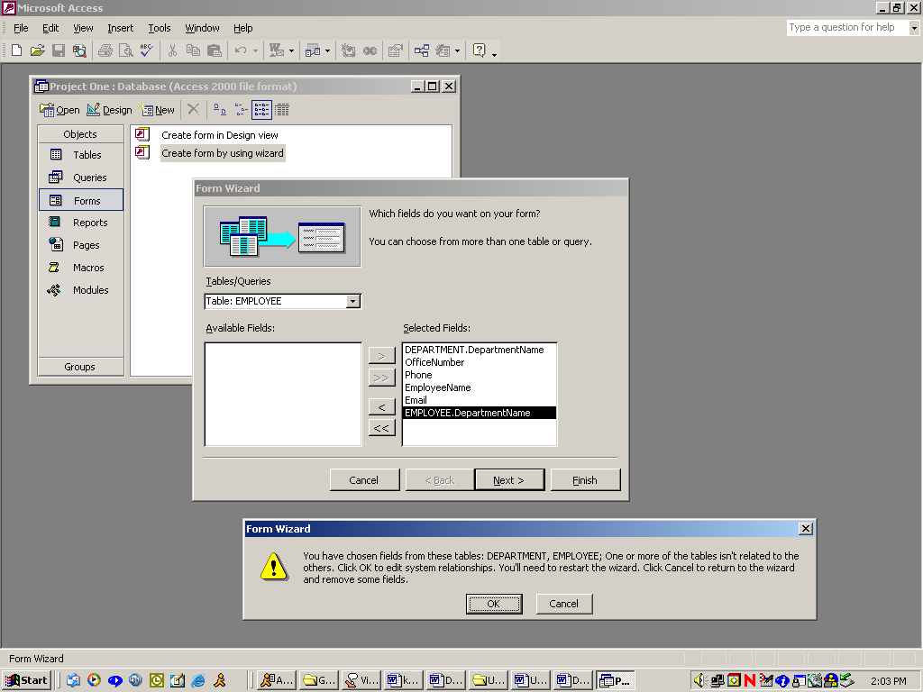

Page showing problem that occurs when you haven’t related the tables!

