Ji Kwon Lim
CS430
Professor Adams
9-6-07

Programming Assignment #2

Input Screen Capture:

PA2A
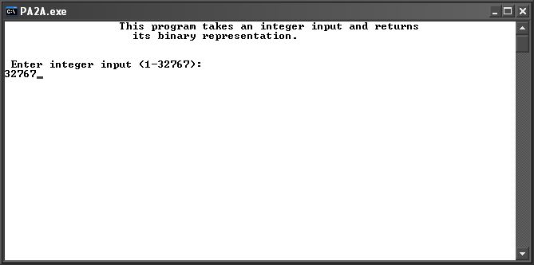

PA2B
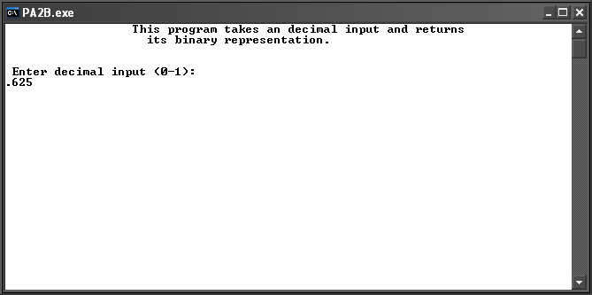

Output Screen Capture:

PA2A
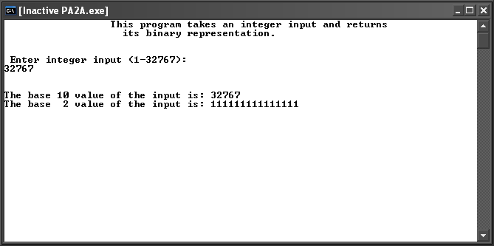

PA2B
