Part A: Base 10 Integer → Base 2 Integer
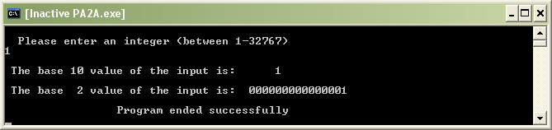

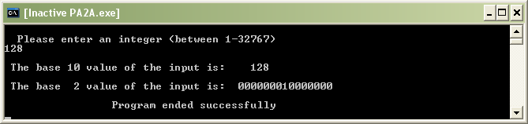

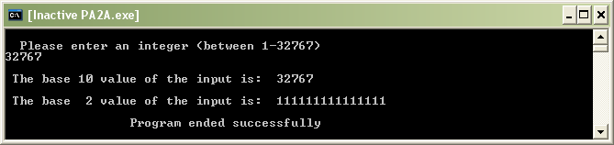

Part B: Base 10 Decimal Number → Base 2 Number
