Ji Kwon Lim
CS-430-002
Adams

Input:

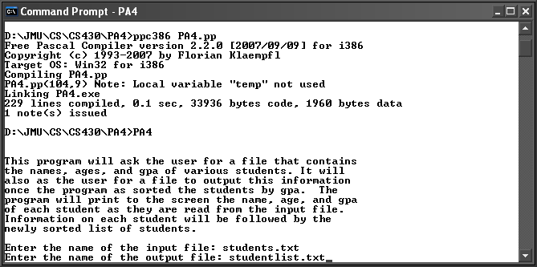

Output:

Last pause before it spirals out of control.

