- Download the Ada Core GNAT Ada compiler and install it. (Look in the preface of text OR follow this link http://www.adaic.org/ to find it).
  - If you use the link, click Downloads which you will find along the left hand side.
  - Choose the GNAT GPL Edition
  - create a new account and follow the instructions.
- If you don’t have JGrasp on your home computer, install it. If you do, you MAY have to re-install it AFTER you install the Ada compiler
- Compile and run a test program (so you know the installations worked)
  - get a test program from one of the tutorials or from the slides or use the following:

with Ada.Text_io;
Procedure Example1 is
begin
Ada.text_io.put ("Hello, Jonathan, how are you? ");
end example1;

JGrasp may have trouble finding your Ada compiler. It sometimes has trouble finding where the compiler is. If it does, you can
compile your Ada program from the command line.

If you want to compile your Ada program from the command line:
compile: gcc -c –g Example1.adb
*.adb, Ada body
link and bind: gnatmake -g Example1.adb
performs: gnatbind -x exampl1.ali
*.ali, implementation
gnatlink -x example1.ali -g

To run a file while at the command line, type the name of the file.

***************************************************************

IF the above doesn't work you can try the following:

click on following link
ftp://ftp.cs.kuleuven.ac.be/pub/Ada-Belgium/mirrors/gnu-ada/gps/

it will bring up following screen

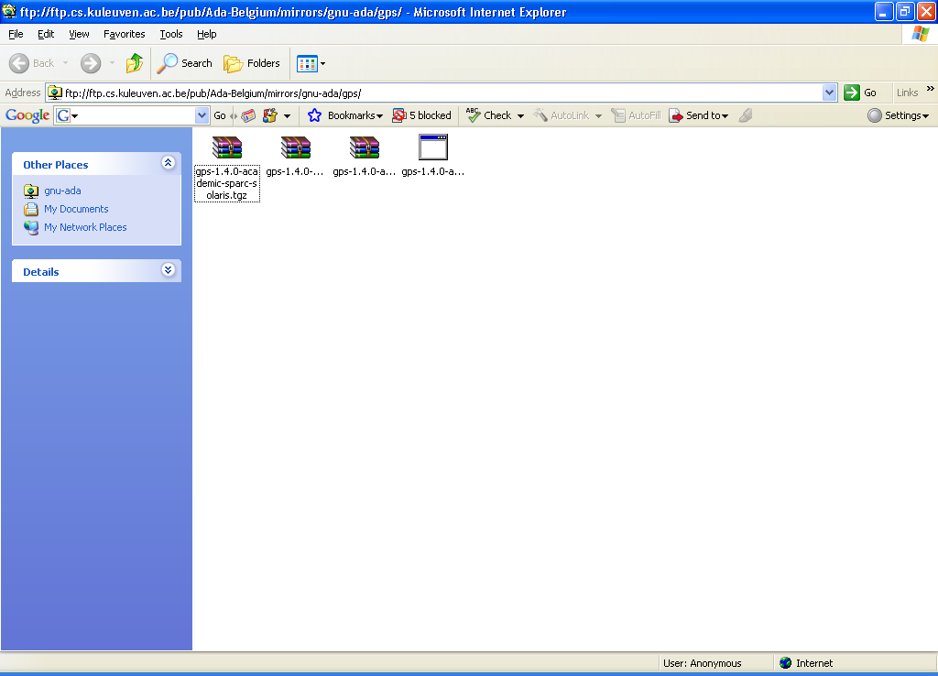

click on the rightmost icon which will bring up the File Download - Security Warning

click on save

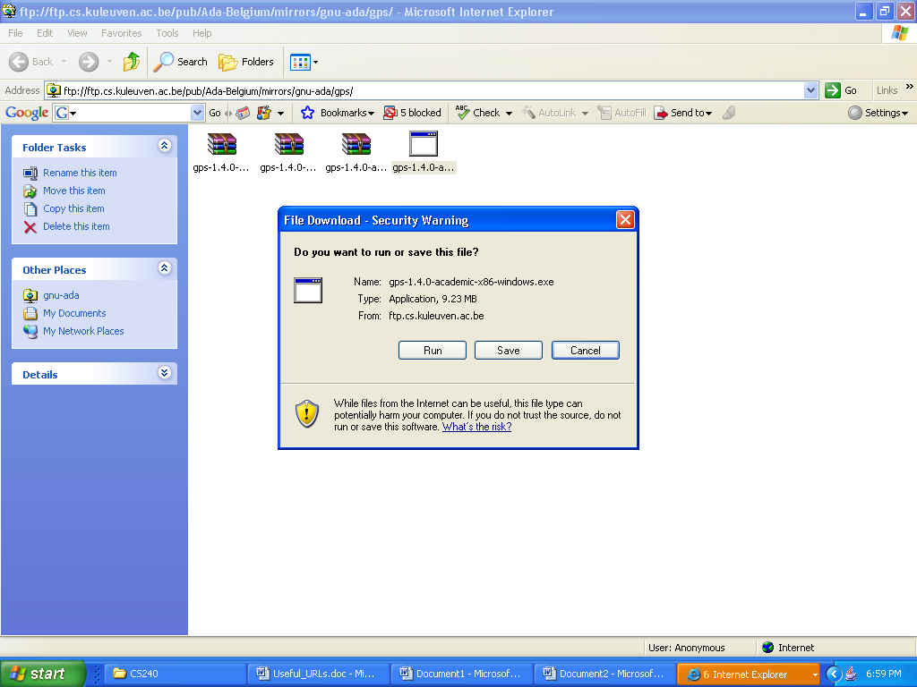

make sure that what is saved has the .exe extension.

Click on it. It should install the Ada compiler

Finally, you should make sure that the code you save has the extension .adb or .ads and not .ada

