Name _Jeremy Halterman________________________ Lab 8 Worksheet

  - Show the result of the compilation
«Ï ----jGRASP exec: javac -g F:\Eclipse07\workspace\CS239Lab8\Lab8\Circle.java
ÏÏ§Ï
ÏÏ§Ï
ÏÏ©Ï ----jGRASP: operation complete.

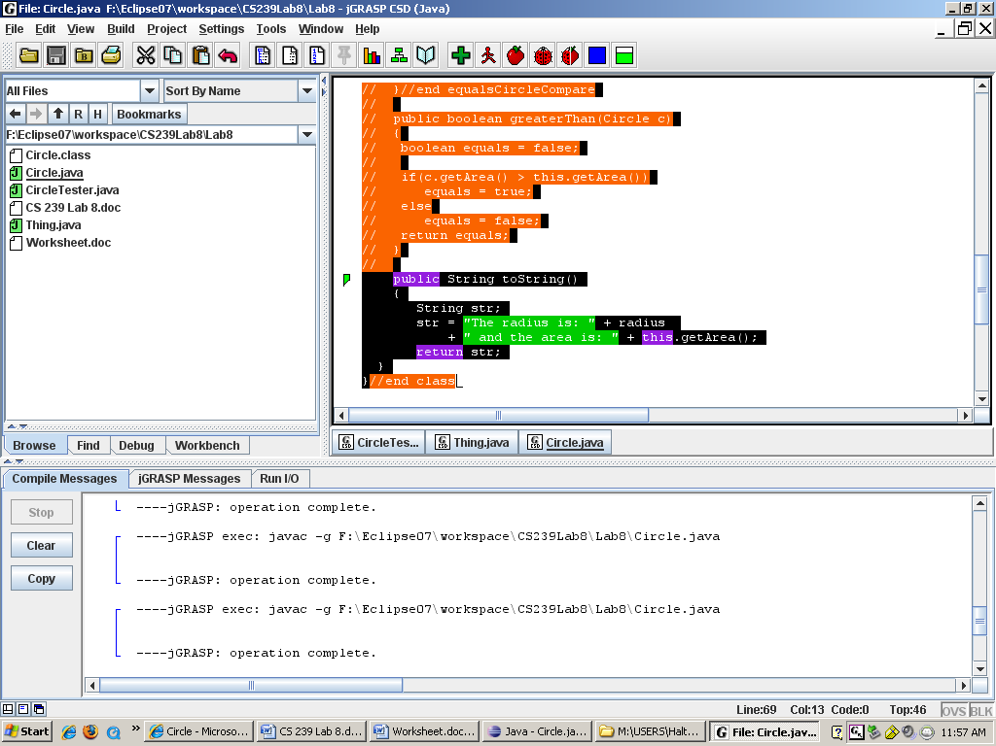

3.9 Show the result of the compilation
----jGRASP exec: javac -g F:\Eclipse07\workspace\CS239Lab8\Lab8\Circle.java
ÏÏ§Ï
ÏÏ§Ï
ÏÏ©Ï ----jGRASP: operation complete.

3.12 Show the result of the compilation
----jGRASP exec: javac -g F:\Eclipse07\workspace\CS239Lab8\Lab8\Circle.java
ÏÏ§Ï
ÏÏ§Ï
ÏÏ©Ï ----jGRASP: operation complete.

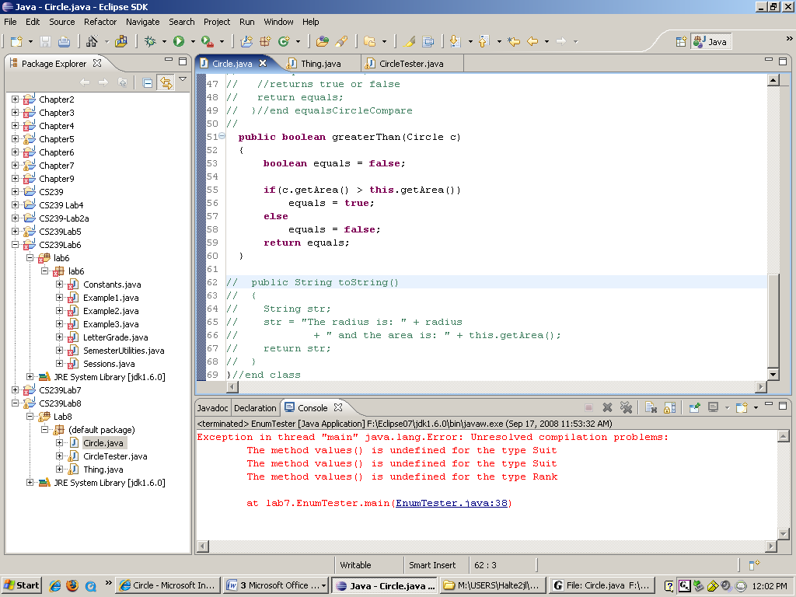

  - Call the toString method and print the result
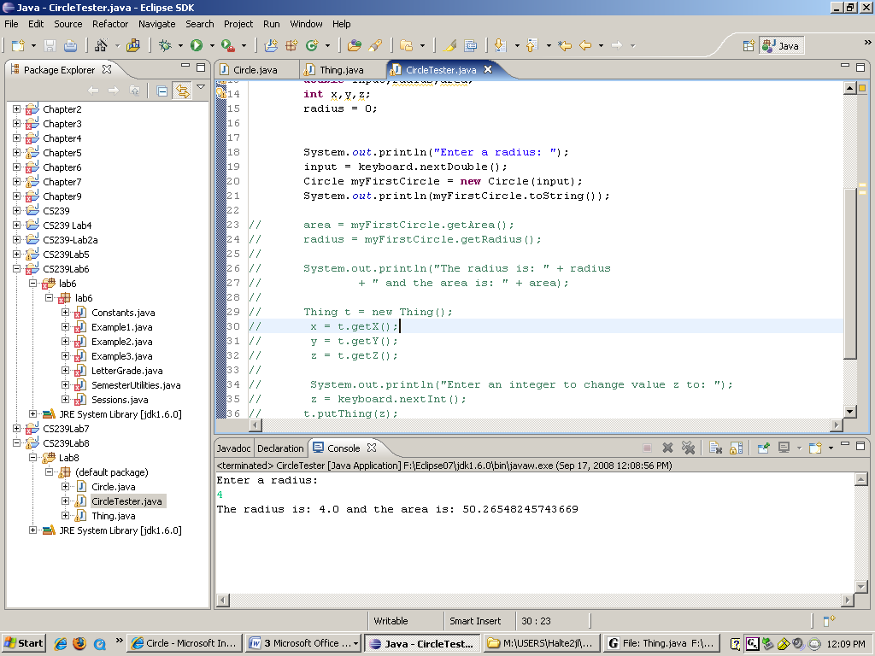

3.17 Call the toString method and print the result
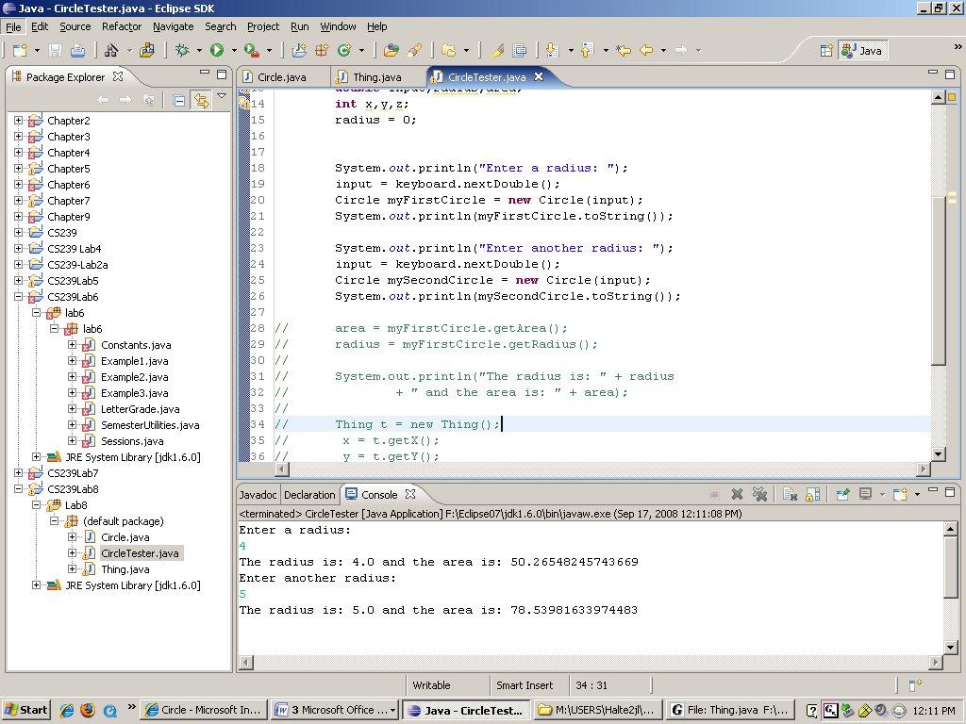

  - Determine whether the two objects are equal and print the result.
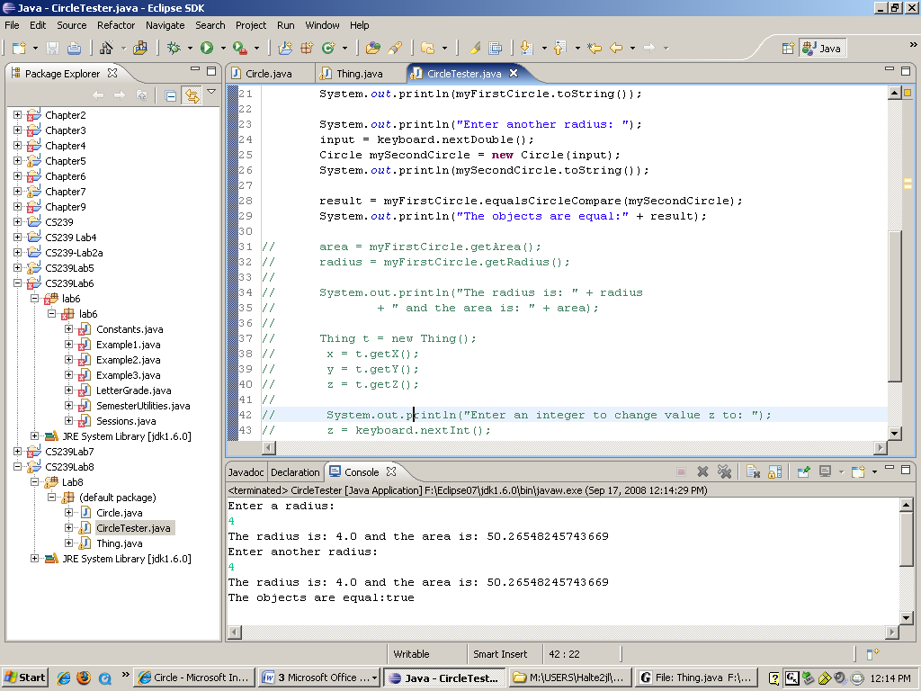

  - Determine whether the second object is greater than the first and print the result
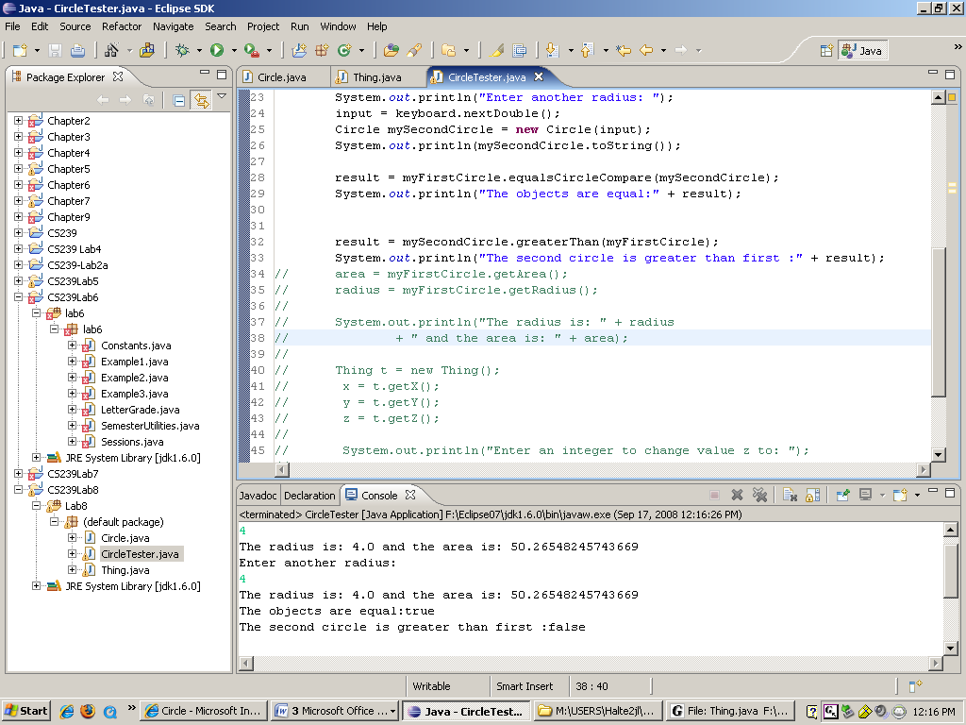

  - What did you write?
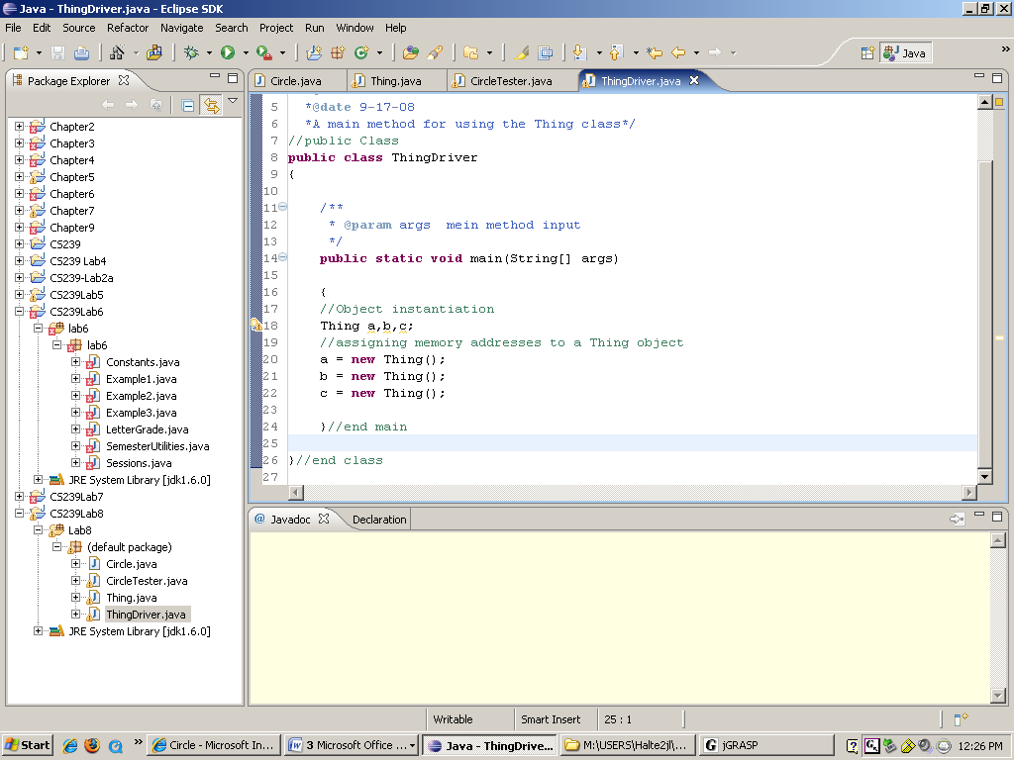

4.10 How many separate instances of the x member exist?
3

4.11 How many separate instances of the y member exist?
3

  - How many separate instances of the z member exist?
1

4.16 What was output?
