Homework #14
assigned November 8, 2005
due November 10, 2005

Read Chapter 6 and write the answers to the following 2 questions

- What are the arguments for and against representing Boolean values as single bits in memory?

- Explain all of the differences between subtypes and derived types.

Second set of project questions which is also due Thursday is here.

The trees will appear later tonight... Here are two trees. Represent each of their structures as a Lisp list by placing the root of each tree between lists consisting of a left subtree and a right subtree each of which is a tree.

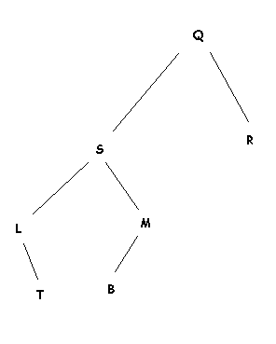 | 