Homework #14
assigned November 8, 2005
due November 10, 2005

Read Chapter 6 and write the answers to the following 2 questions

- What are the arguments for and against representing Boolean values as single bits in memory?
For: it saves space in memory (2 POINTS)
Against: it is hard to access a single bit of memory efficiently on many machines. (2 POINTS)

- Explain all of the differences between subtypes and derived types.
  - “ a subtype of a given type is a combination of the type, a constraint on values of the type, and certain attributes specific to the type.” Ada LRM.
  - A subtype inherits the operations and a subset of the values of its parent type. It is type compatible with its parent
  - A derived type of a given time is a new type which inherits the operations and a subset of the value of its parent type. It is NOT type compatible with its parent.

page 226 in our text.
“A derived type is a new type that is based on some previously defined type with which it is incompatible” (2 POINTS)
“An Ada sub-type is a possibly range-constrained version of an existing type. A subtype is compatible with its parent type.
(2 POINTS

Our book says a “a derived class is a subtype if it has an is-a relationship with its parent class” (p. 499)
“An is-a relationship guarantees that a variable of the derived class type could appear anywhere a variable of the parent class type was legal without causing a type error. The subtypes of Ada are examples of this simple form of inheritance.

Second set of project questions which is also due Thursday is here.

The trees will appear later tonight... Here are two trees. Represent each of their structures as a Lisp list by placing the root of each tree between lists consisting of a left subtree and a right subtree each of which is a tree.

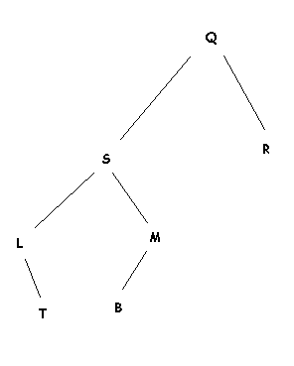 | 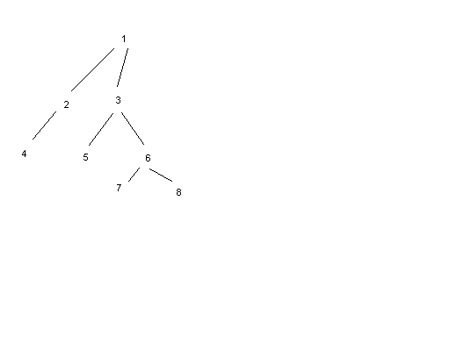

( (nil L (nil T nil)) S ( ( nil B nil ) M nil) Q(nil R nil)) 2 POINTS

(((nil 4 nil) 2 nil) 1 ((nil 5 nil)3 ((nil 7 nil)6(nil 8 nil)))) 2 POINTS

