Programming Language Project
Question Set #6
Due: November 23, 2004 at start of class
Answers MUST be keyed in before printing

Programming Language ____COBOL________

Note: For each of these question sets, you should look first in the reports you were given. You should then check the information on the Web or in a book. If the information is not in the report, you should say so and then find it on the Web or in a book.

1. Attach the source code for a short program that you have interpreted/compiled and run. The program does not have to achieve any meaningful task but must include statements illustrating 3 additional answers from question set #2 (the answers to questions 6,7, 8,9, and 10 that you didn't already illustrate in question set #4). It must include line by line comments identifying the type of statement AND the requirements for the statement. Circle the type of statements you are illustrating.
a. Assignment
b. Selection
c. Iteration
d. Input
e. Output

2. Capture the output produced by your program (screen capture). Print it and attach it also.
When the program compiled without any errors, this message is received. Otherwise a message with the line(s) containing the errors is displayed.
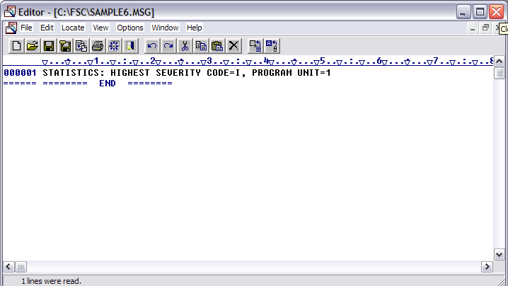

The output of running the program (SAMPLE6.EXE)
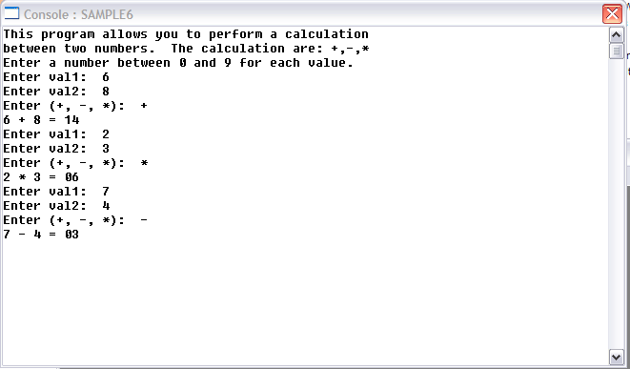

3. Does your language provide any exception handling mechanisms?
None found.

4. If it does, provide a description of what happens on erroneous input. If it doesn't, describe what happens when on erroneous input.
When the program expects an integer value and the user enters a character. The program issues an error message but assigns the expected variable the initial value that it was set to in the DATA DIVISION section of the program.

5. Can the user define their own exception handlers?
None found.

6. What types of subprograms does your language have (i.e. functions, procedures), if any?
Procedures

7. What is the parameter passing mechanism in your language?
Call by reference (Ada in out) and call by content (Ada in)

8. Does your programming language allow recursive calls?
No <http://home.swbell.net/mck9/cobol/tech/stack.html>
The code used in SAMPLE6.COB
000010* The IDENTIFICATION DIVISION is needed in every program.
000011* This is where information about the author, date written/compiled
000012* is given.
000013 IDENTIFICATION DIVISION.
000014
000015* The name given to the program is placed in the PROGRAM-ID, this name
000016* must match the name given to the file otherwise the Fujitsu compiler
000017* will issue an error message.
000020 PROGRAM-ID. SAMPLE6.
000030 AUTHOR. Temitope Akanni.
000040 INSTALLATION. Fujitsu COBOLV3.
000050
000051* The ENVIRONMENT DIVISION is also necessary in order for a program to
000052* compile.
000060 ENVIRONMENT DIVISION.
000070
000071* The third division in a COBOL program is the DATA DIVISION, it is necessary
000072* even if you are not declaring any variables in its sub section the WORKING-
000073* STORAGE SECTION.
000080 DATA DIVISION.
000090 WORKING-STORAGE SECTION.
000100* WORKING-STORAGE SECTION is where variables used in the program
000110* are declared and initialized as necessary.
000120 01 Val1 PIC 9 VALUE ZERO.
000130 01 Val2 PIC 9 VALUE ZEROS.
000140 01 Result PIC 99 VALUE ZEROS.
000150 01 Operator PIC X VALUE SPACE.
000170
000171
000180 PROCEDURE DIVISION.
000190* Sub procedures that are needed in the program are declared in the
000200* PROCEDURE DIVISION.
000210
000220* The sub procedure demonstrates the use of COBOL's selection and
000230* one of COBOL's iteration statements.
000231* SELECTION-PARAGRAPH is the name given to main procedure for the
000232* program. The name is arbitrary but must end in a period as with
000233* all the other statements.
000240 SELECTION-PARAGRAPH.
000241* DISPLAY is used to display information to the user. Statements are
000242* enclosed in double quotes and when done ends in a period.
000250 DISPLAY "This program allows you to perform a calculation".
000260 DISPLAY "between two numbers. The calculations are: +,-,*".
000270 DISPLAY "Enter a number between 0 and 9 for each value. ".
000280
000281* PERFORM n TIMES is one of the iteration statements in COBOL
000282* The loop runs 3 times before the program ends.
000290 PERFORM 3 TIMES
000291* WITH NO ADVANCING does not advance the line until the user
000292* enters a value and press enter.
000300 DISPLAY "Enter val1: " WITH NO ADVANCING
000310 ACCEPT Val1
000320 DISPLAY "Enter val2: " WITH NO ADVANCING
000330 ACCEPT Val2
000340 DISPLAY "Enter (+, -, *): " WITH NO ADVANCING
000350 ACCEPT Operator
000380
000390* The IF <condition> THEN <statements> END-IF is one of the
000400* selection statements in COBOL. It performs the same as using
000401* several non-nested if statements in Java or Pascal or Ada.
000402* The if statements check to see what operator the user entered.
000403
000404* When using the PERFORM...END-PERFORM. verb, statements inside
000405* the iteration should not end with a period. The END-PERFORM
000406* statement is the only statement that should end in a period.
000410 IF Operator = "+" THEN
000420 COMPUTE Result = Val1 + Val2
000430 END-IF
000431
000440 IF Operator = "-" THEN
000450 SUBTRACT Val1 FROM Val2 GIVING Result
000460 END-IF
000461
000470 IF Operator = "*" THEN
000480 MULTIPLY Val1 BY Val2 GIVING Result
000490 END-IF
000491
000501* Displaying the values and operator entered and the result
000530 DISPLAY Val1, " ", Operator, " ", Val2, " = ", Result
000540 END-PERFORM.
000550* Every program must have has it last executable statement, STOP RUN.
000551 STOP RUN.
000560* END PROGRAM SAMPLE6.

