Download Data Files from World Wide Web
Discussion: In this exercise, you will download data files from the Web and have a chance to explore our Web Site. You will open a self-extracting Zip file and store the data files on a diskette or in a hard drive folder of your choice.
We assume that you know how to use a Web Browser and are somewhat comfortable in navigating the Web. If not, have someone who is proficient help you with this exercise.
The sample figures were done with Microsoft Explorer. Your browser may give you some slightly different windows and perhaps different messages.
  - Find the COBOL Web Site
The first step is to find the COBOL Web Site. This site is http://www.prenhall.com/grauer_cobol/. (Note: there is an “_” between the words “grauer” and “cobol”.) If your computer shows the previous URL as a hyperlink and you are connected to the Internet, you can click on the hyperlink and be directly connected to the web site. Otherwise, log on to the Web and enter the URL, you should arrive at the screen shown in Figure 2.1.
Figure 2.1 Welcome Screen for COBOL Web Site.
  - Explore the Main Content Page
Once you have located the web site, click on the Enter circle and you will then find the main content page as in Figure 2.2. You should explore these options and may want to mark this page as a “Favorite.”
Figure 2.2 Main Content Screen of Web Site
Click on the bulleted item “Download the Data Disk to proceed.
  - Download the Data Files
The page shown in Figure 2.3 provides two options:
- COBOL Data Disk (COBOLDAT.EXE)
- ReadMe (README.txt)
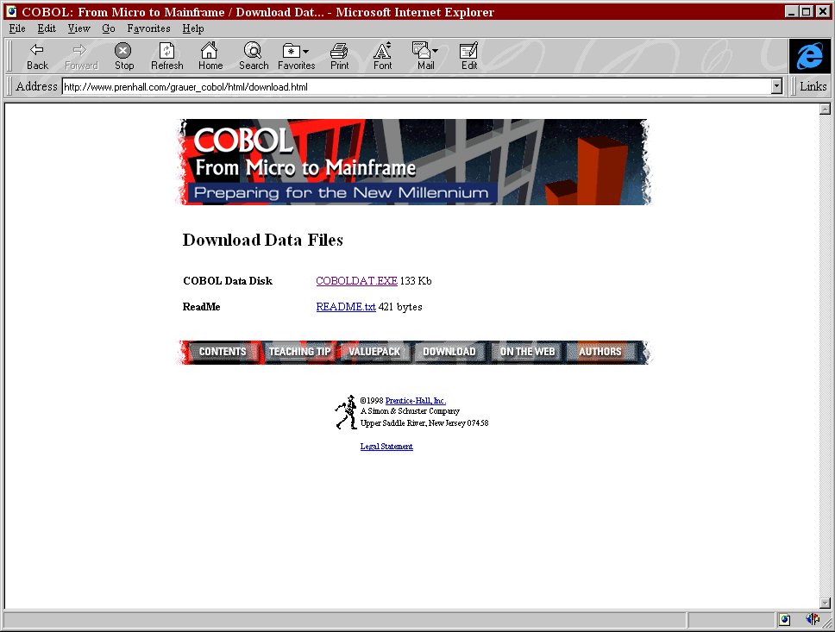
The COBOL Data Disk entry will allow you to download the data files and store them on a diskette or hard disk. The Readme file is our greeting to you and gives a brief explanation of downloading. Click on COBOLDAT.EXE.
Click Here
Figure 2.3 Download Data Disk
  - Process Warning Messages
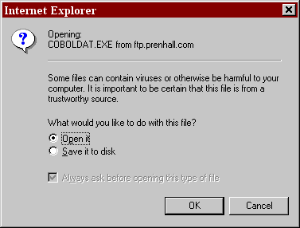
You may receive a message similar to that in Figure 2.3. Click on the Open it radio-button to have the files directly installed on your disk device. Save it to disk will save the file and then you would have to run it later. If your Internet Browser does not offer the Open it option, and only saves the file be sure you know where the COBOLDAT.EXE file is stored. You will need to run the program outside of the browser.
Figure 2.4 Open File Message
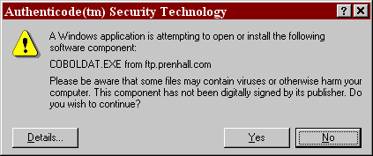
Click on OK to start the process. However, you may also receive the message in Figure 2.5:
Figure 2.5 Virus Warning Message
In this case, you can select Yes to continue the process.
  - Run the Self-Extracting File
If you have saved the self-extracting file, you need to open the folder where it was saved. Click on the icon to start the process.
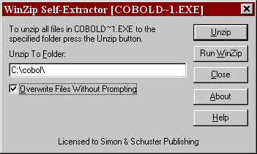
The next window is the Self-Extractor message. To save time and space we have compressed all of the files into a Zip format. COBOLDAT.EXE contains both the compressed data files and a program to uncompress them. The default location for the restored files is “A:\” the diskette drive. For demonstration purposes, we have chosen to store the files on a hard drive.
Save to Hard Drive.
Figure 2.6 Self-Extractor Window
Click on Unzip to store the restored files on your machine. If you chose to store the data files on a diskette, be sure that you have an empty, formatted diskette in your diskette drive.
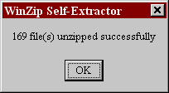
When the Self-Extracting program has completed its work, you should see the window in Figure 2.7
Figure 2.7 Completion

