Installing Fujitsu COBOL 85
Discussion: This exercise leads through the installation of Fujitsu COBOL 85. Before starting, you should take note of the system requirements on the CD jacket. Be sure your computer can handle the specifications. Record the Serial Number provided on the jacket in a safe place. This number will be necessary if you need to reinstall the compiler.
This exercise covers the Windows 95 installation. The processing is similar in Windows 3.1 and Windows NT. This installation is like most Windows installations and experienced Windows users should have little difficulty. However, you should be aware that the setup on the CD is not in the root folder. Windows 95 and Windows NT users will find the setup program in COBOL32 while Windows 3.1 users will find it in COBOL16.
  - Begin Installation
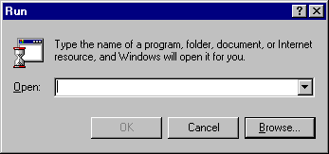
To begin the process, click on Run in the Start Menu. The Run Dialog Box appears and then click on Browse.
Figure 1.1 Run Dialog Box

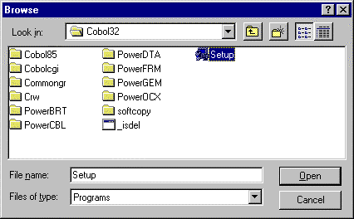You will need to go to the COBOL32 folder and select Setup. Click Open; the Run Dialog Box reappears with the proper file name.
Figure 1.2 Open Dialog Box with Setup Highlighted
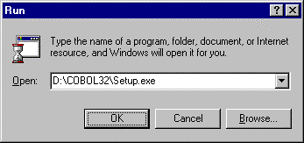Click on OK and the installation process begins.
Figure 1.3 Run Dialog Box with Setup

  - Prepare the System for Installation
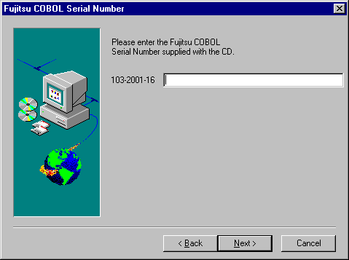
The system asks for the Serial Number supplied with the CD. Make sure that you have this number and have it saved for future reference. Enter the dashes as well as the numbers.
Figure 1.4 Serial Number Window
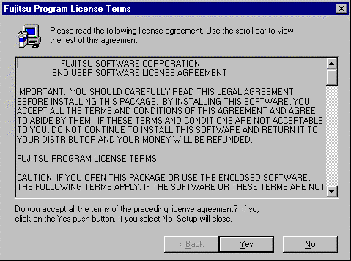After the system has accepted the serial number, it displays the software license agreement. Read the agreement and then press Yes to continue.
Figure 1.5 License Terms Window
The system then asks what components you want installed. We recommend the Starter Set and the Common Ground ProViewer at a minimum. The other two products would not be used with text and can be omitted 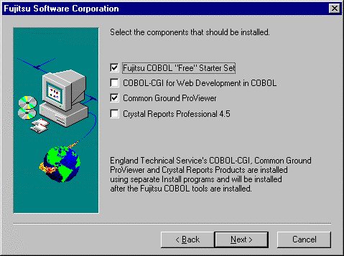particularly if disk space is limited.
Press Next to continue.
Figure 1.6 Installation Screen
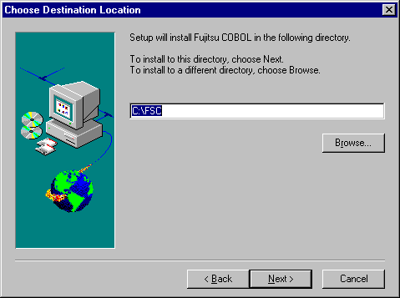
In this screen, the system suggests a location for data to be stored. You should accept this location, unless there is a good reason to store the data in another folder. If you do change the default folder, make sure that you write it down so you can find it.

Figure 1.7 Folder Selection Window
The system then suggests a Program Folder to use for starting COBOL 85. Click on Next to accept the default.
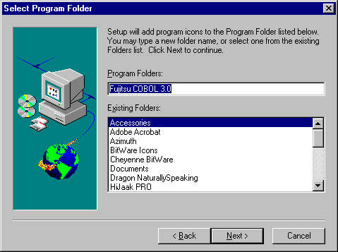
Figure 1.8 Select Program Folder Window

The next window allows you to decide what portions of the product to install. The minimum would be to install the “Free” Starter Set. This set contains all of the features needed for programs in the book. You may want also to install either “Install Softcopy Books” or “View Softcopy from CD.” These options allow you to read the full documentation manuals on line. If you have enough hard disk space, “Install Softcopy Books” allows faster access to the documentation and does not require you to have a CD with you to look up something.
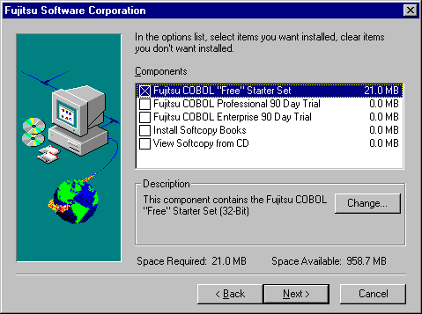
Once you have determined your options, select Next to continue.
Figure 1.9 Select Installation Options Window

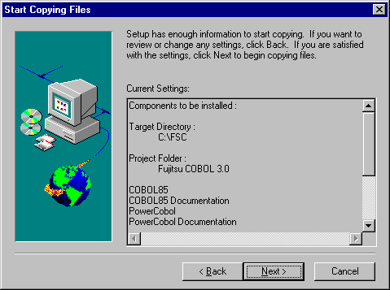
The final window before installation actually begins gives you a list of what will be installed. Review the list for any changes you might want to make. Clicking Back allows you to return to previous screens. Clicking Next starts the actual installation.
Figure 1.10 Installation Settings

  - System Copies Files and Installs Programs.
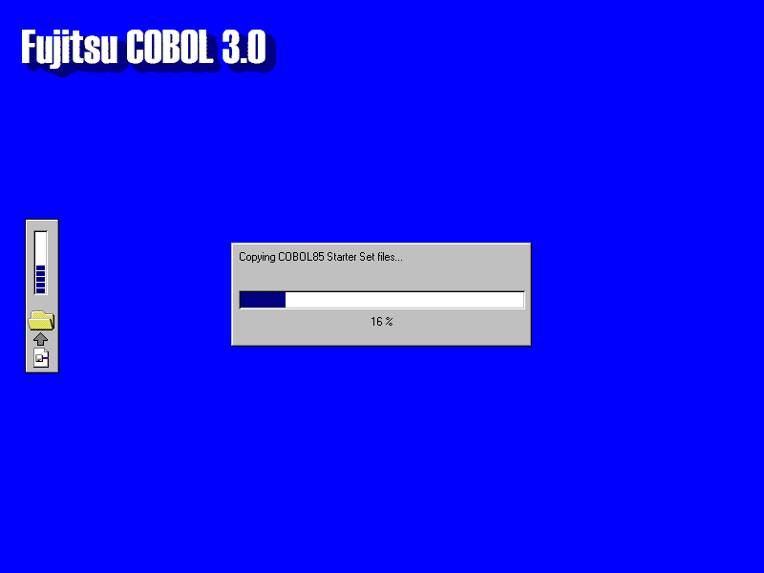
While the system is copying files and installing programs, you will see several screens similar to that below.
Figure 1.11 Sample Installation Screen
  - Register With Fujitsu
After installing the programs, the system requests information for registration. This material is optional for students. Registration can be done on-line or printed out depending on your choice.
Figure 1.12 Fujitsu Registration Screen
If you choose to register, fill out all of the appropriate fields. The serial number field is automatically filled.
XX-XXXXX-XXXXX
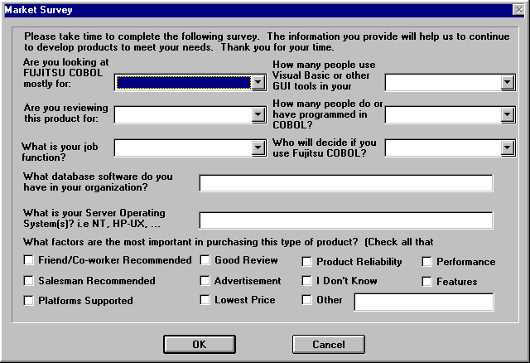
If you choose to continue with registration, Fujitsu requests some marketing information from you. Again, this information is optional.
Figure 1.12 Marketing Information
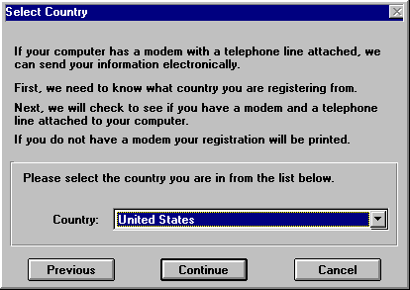
If you continue with registration, the system first attempts to connect you by modem and then by Internet. In the interest of space, we are only showing the first of these screens. You can cancel at any point.
Figure 1.13 Registration by Modem Screen

  - Restart the Computer
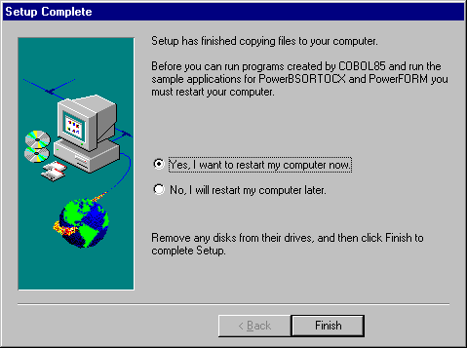
Upon completion, the system asks if you want to restart the computer or not. Normally, you should restart the computer. Click Finish to complete the installation and restart your computer.
Figure 1.14 Final Installation Window

