Editors on Raven

Pico: The Unix Notepad
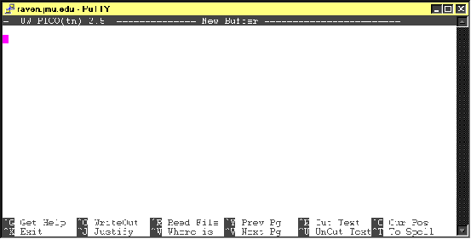 The first and easiest to learn editor on raven is Pico, and it is equivalent (almost) to a windows style notepad. It doesn’t have the feature set of something like edit, lsedit, vi or vim, but this does make it easier to use. Bellow is a screenshot of an empty Pico editor window. Notice the command list at the bottom, including the “Get Help” command, bound to Control(^)-G. Also notice the exit command, so that if, for some reason, you mistakenly get into Pico, you can still get out.
Pico editing is about as simple as it gets. There are no modes, so if you type, it will appear on screen. Saving a file is easy as well. Simply press Control-O (remember this as OutputFile, not WriteOut as Pico says) type in a file name, and hit return. Your file is now saved. Opening a file is just as easy: just press Control-R, type in a file name, and hit return. If Pico finds the file, it will load it up and you’re ready to go.
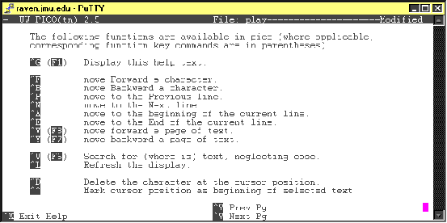 Other, more advanced features of Pico include Justification, searching (the Where is command), spell checking, getting the current line position, line marking, and inserting files. If you’d like more information on any one of these features, try these sites, or try the Get Help command. (see screenshot below). One very important feature is the “Set Mark” feature, something that allows you to select text, much like you do when dragging the mouse in Microsoft Word. This allows you to then perform commands on large amounts of text, including cuts (^K), and pastes (^U aka “Uncut”).

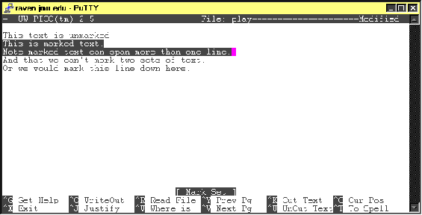 To start a mark the key is ^^, which is misleading. It is not “Control-Control,” it’s really Control-6. See the screenshot below for an example of selected (marked) text.
Other useful keys in Pico – Control-E (end of line), Control-A (beginning of line)

Edit: A VAX Relic?
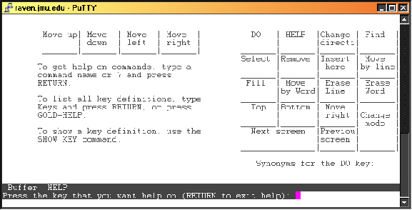 Edit is probably the most confusing editor on Raven. It defines keys that were probably on old VAX terminals, but are no longer on standard computers. When you boot up edit, you are given what looks just like a standard editor. Like so:

Unfortunately, it’s hard to learn how to quit edit. So this may be about as far as you get. The exit key (if you really don’t want to work in edit) is Control-Z. Edit is, however, a powerful editor, if not unwieldy. The first order of business is to look at the keypad definitions. Here they are:
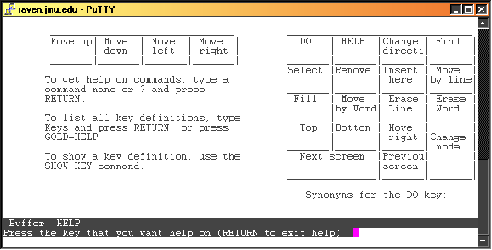This probably makes no sense. However, what you’re looking at on the right side is a diagram of the keypad on your computer. So, the DO command (the command that brings up a type of command prompt) is the Num Lock key, the HELP command is mapped to the forward slash on the keypad, and so on down to the Next Screen key being the Zero key, the previous screen key being the . key and the change mode key being Enter on the key pad.
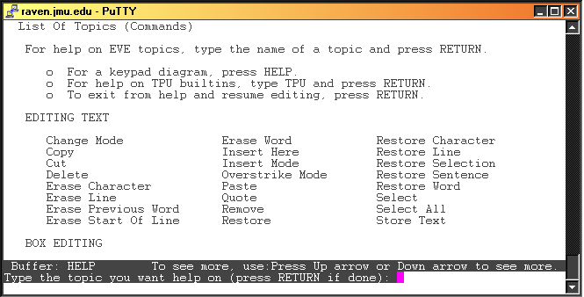 Unfortunately, these keys are useless unless you have a list of other bound keys, and a list of commands that can be run in Edit. To get a list of commands in Edit, you can simply press the “Do” command (the Num Lock key) and type help. This will give you general help and the following screen:
(Note, from here, you can get to the previous keypad diagram by typing “keypad,” or from the main window you can simply press the “help” key.)
This list is rather large, and if there’s something you want to do, it is probably in here. I won’t bother going through everything. Do note, however, the key definitions section. Edit does allow you to set up your own key definitions, including setting a special key called the “Gold Key.” The Gold Key has its own special command called “Set Gold” which will allow you to set the Gold Key to any key on the keyboard (minus typing keys, alt, and keys already bound).
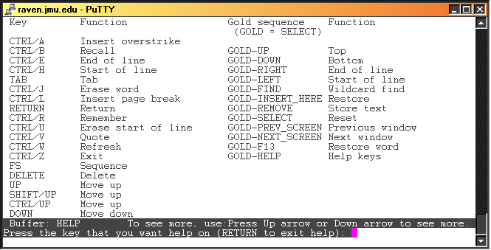 The last thing of note is the key definitions. These can be reached by first entering the keypad definition then typing “Keys.” The above screen will appear. This help page is several pages long, but most of what you will need to know is on this first page. Notice the special gold keys in the right hand column. Remember, these can not be used until you set a gold key.
The last command of note is the write command. There is no key bound to this command, but it is what writes your file to drive. Simply press the “DO” key and (once again, the Num Lock key) and type “write” to save you work. Control-Z once again exits.

LSEdit : Another Edit
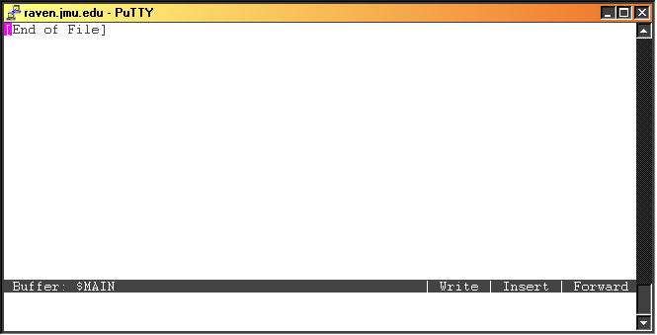For those of you used to UNIX and its variants, you probably accidentally entered lsedit when trying to get a directory listing. LSEdit is another version of edit and, at first glance, looks exactly like it. However, there are some important differences that need to be addressed. First of all, there is no “DO” key (thankfully). To enter the command prompt for LSEdit, the bound key is Control-Z. This will also get you out of the command prompt. From here you can type “exit” to leave the program or “help” to get more information on this editor. The first few pages explain what the help command does, and then gets to a list of valid commands in LSEdit. As you can see, this is a much-simplified version of what we had in edit. However, the commands are potentially a lot more powerful, though also potentially more confusing.
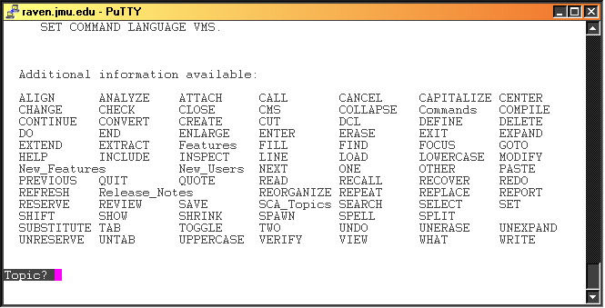 The two most useful help topics are New_Users, which explains what LSEdit is, and Features, which explains some of the things LSEdit can do. Also of note is the DEFINE command, which allows you to define key bindings to specific commands. The last command to keep in mind is the WRITE command, which will save your work.

