Answer Key for Written assignment #9
Exercises 1.4
31
C(x) – x is a computer science student
W(x,y) – x works harder than y
S(x,y) – x gets less sleep than y
m – maria

(∀x) (C(x) →(∃y) W(x,y)) ∩ (∀ x) (∀y) (W(x,y) → S(x,y)) ∩ C(m) → (∃y)(S(m,y))

1. (∀x) (C(x) →(∃y) W(x,y)) hyp
2. (C(m) →(∃y) W(m,y) 1 u.i
3. C(m) hyp (deductive method)
4 (∃y) W(m,y) 2,3 M.P.
5. W(m,a) 4, e.i.
6. (∀ x) (∀y) (W(x,y) → S(x,y)) hyp
7. (∀y) (W(m,y) → S(m,y)) 6, u.i.
8. W(m,a) → S (m,a) 7. u.i.
9. S(m,a) 8,5 M.P.
10. (∃y)(S(m,y)) 9, e.g

Exercises 3.1
39b
the elements of S are : ∅ , a, {a}, {{a}}, {a. {a}}
the elements of C are: a
the elements of C’ are: ∅ , {a} , {{a}}, {a. {a}}
the elements of B are: ∅ , {a}, {a, {a}}
answer: { ∅,{a}, {a. {a}} }

41c
cat is a word that appears after canary in an English language dictionary so it’s an element of set B
cat is not a word of more than four letters so it’s not an element of C
therefore it cat is an element of B ∩ C’

43.
a. A’
b. A ∩B
c. A ∩ B’ or A - B

50a
12

Exercises 3.2
12
2 choices for 1st digit, 4 choices for 2nd digit , 4 choices for 3rd digit = 2 * 4 * 4 = 32
23
10 exterior colors * 7 interior colors * 3 transmissions * 2 air * 2 power steering * 2 option =
10 * 7 * 3 * 2 * 2 * 2 = 1680
28
20 down to 10 is 11 times (not 10)
5 up to 10 is 6 times (not 5)
11*6*2 = 132
Trace would be too tedious
result | 0 | 2 | 4 | 6 | 8 | 10 | 12
index | 20 |  |  |  |  |  | 19
inner | 5 | 6 | 7 | 8 | 9 | 10 | 5 | 6 | 7 | 5 | 6 | 7 | 8 | 9 | 10

40
There are only 8 places where the 1 zero can be put – no choices for the other spots once that is chosen
therefore the answer is 8.

Exercises 3.3
1

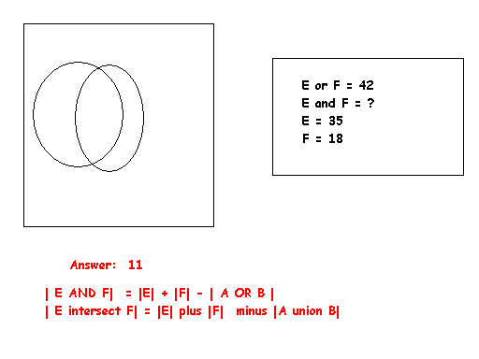
3
Using equation (3) on page 203
A = Paint B = Packaging C = Electonics X = the answer

| A union B union C| = |A| + |B| + |C| - |A intersect B| - |A intersect C | - |B intersect C| + | A intersect B intersect C|
40 = 28 + 17 + 13 - 6 - 7 - 10 + X
40 = 58 - 23 + X
40 = 35 + X
40 – 35 = X
5 = X

10
Using equation (3) on page 203
A = Odor B = Lather C = Natural
| A union B union C| = |A| + |B| + |C| - |A intersect B| - |A intersect C | - |B intersect C| + | A intersect B intersect C|
?
450 = 425 + 397 + 340 – 284 – 314 - 219 + 147
450 ≠ 491
No you should not. The figures say 491 people were surveyed but there were only 450 in the group.

Exercises 3.4
1c
P(6,4) = 6! / (6-4)! = 6*5*4*3*2*1 = 6*5*4*3 = 360
2*1

4
There are 8 letters in computer so the answer is to the first half of the question is 8!
You have 3 choices for the last letter and 7! choices for the other 7 letters so the answer is 7! * 3

Note:
2! = 2 3! = 6 4! = 24 5! = 120 6! = 720 7! = 5040 8! = 40,320
7! * 3 = 15,120

8a
Assuming that we are not distinguishing between upper and lower case letters and that letters can be repeated
26 * 26* 26 = 26³ = 17,576

8b
Assuming that we are not distinguishing between upper and lower case letters and that letters can not be repeated
26*25*24 = 15,600

24
Q Q Q Q __
48 cards left to choose from for 4th card
1*1*1*1*C(48,1) OR 1*1*1*1*48

45
want number of ways of choosing all dimes plus number of ways of choosing all quarters
number of ways of choosing all quarters is C(7,4) = 7! = 35
4!3!
number of ways of choosing all dimes is C(5,4) 5! = 5
4!1!

answer = 40

65 had intended 3.2 not 3.4 - done in class using formula and reasoning in example 57
12 books on the shelf so 12! total permutations possible
if we can’t distinguish between the various books with the same titles then answer is
12! = 12*11*10*9*8*7*6*5*4*3*2*1 = 12*11*10*9*8*7*6 = 11*10*9*8*7 = 27,720
5!3!4! 5*4*3*2*1 * 3*2*1 * 4*3*2*1 3*2*1 *4*3*2*1 2
pink anwer is adequate

69 had intended 3.2 not 3.4 - if you noted that this problem is like Example 58, you would use the formula there

r = # objects to choose = 48 sales
n = # distinct objects to choose from = 34 kinds of cheese
C( r + n – 1, r) = C( 48 + 34 -1, 48) = C(82-1, 48) = C(81, 48) = 81!
48!(81-48)!

Note: the table at the top of page 217 would be a useful one to study. It summarizes the counting techniques.

