=Homework #18
Turn this in at or before the exam. If you come by my office with it done, you can check your answers.

Study for test on Monday, November 21st.
Chapter 7 – Relations
Chapter 8 – Graphs
Sequential circuits & flip-flops
Glance at Logic proofs

- Study Algorithm 1 and Example 25 on page 526, and Figures 9 and 11 on page 527. The use the methods to perform a topological sort on the diagram in problem 27 on page 534.
One solution:
Find recipe - Buy seafood – buy groceries – steam rice – wash vegetables – cut ginger and garlic – wash shellfish – clean fish – make garnishes – chop water chestnuts – cut fish –cook in wok – arrange in platters – serve

- Problem 4 on page 528 - tell why it is or is not a partial order.
being a partial order requires: reflexive, antisymmetric and transitive. This is not a partial order because it is not transitive. c is related to d and d is related to be but c is not related to b.

- Problem 16b on page 532.
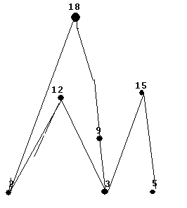
- Problem 20 on page 529.
{ (a,a), (a,b), (a,c), (a,d), (a,e), (b,b), (b,d), (b,e), (c,c), (c,d), (d,d), (e,e)}
- Problem 4 on page 544.
multigraph
- Problem 14 on page 544.

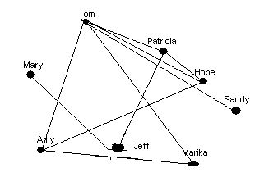

- Problem 8 on page 554.
vertices 4
edges 8
indegree: a-2, b-3, c-2, d-1
outdegree: a-2, b-4, c-1, d-1

- Problem 26 on page 555
it has 7 edges (by the handshaking theorem the sum of the degrees of the vertices is 2 times the number of edges in an undirected graph even if multiple edges and loops are present).

It also asked you to draw the graph…
- Problem 17 on page 620
This problem tells you which classes do NOT conflict. In order to determine the chromatic number you need to know which conflict.
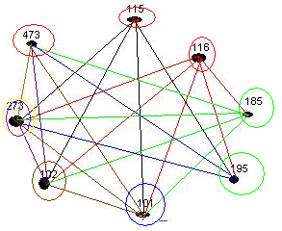

 | 115 | 116 | 185 | 195 | 101 | 102 | 273 | 473
115 | 0 | 0 | 0 |  |  |  |  | 0
116 | 0 | 0 |  |  |  |  |  | 0
185 | 0 |  | 0 | 0
195 |  |  | 0 | 0 | 0 | 0
101 |  |  |  | 0 | 0
102 |  |  |  | 0 |  | 0
273 |  |  |  |  |  |  | 0
473 | 0 | 0 |  |  |  |  |  | 0

A solution: (red circles) 115, 473, 116
(green circles) 185, 195
(blue circle) 101
(brown circle) 102
(lavender circle) 273
5 different time slots are needed !!!

- Problem 2 on page 563.

Vertex | Adjacent vertices
a | b,d
b | a,d,e
c | d,e
d | a,b,c
e | b,c

- Problem 22 on page 564.
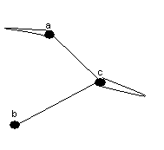

- Look at figures 1 and 2 on page 578. They show the Konigsberg Bridge problem

