Homework #20 KEY - from the Handout (not from our text)
due Monday December 5fh
Practice 19
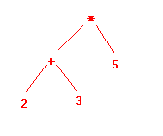
Practice 20 a
 | Left Child | Right Child
1 | 0 | 2
2 | 3 | 4
3 | 0 | 5
4 | 0 | 0
5 | 0 | 0
b.
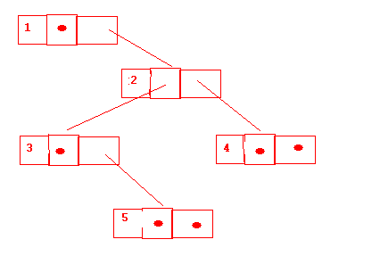

Practice 21 preorder: abefcdgih
inorder : ebfacigdh
postorder: efbcighda

Practice 22

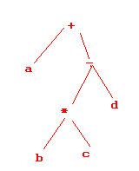

preorder: +a-*bcd
inorder : a+b*c-d
postorder: abc*d-+

Page 384 #17
preorder: a b d g e c f h
inorder: g d b e a h f c
postorder: g d e b h f c a

Page 385 #28

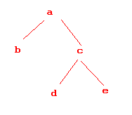

Practice 25

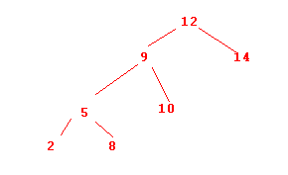
Page 394 #7
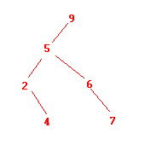
depth 3

Practice 27 a. ppca?
b. cagak
c, ?kac?

Practice 28

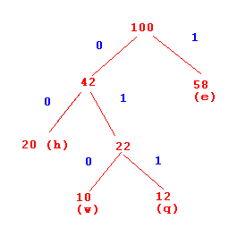

Practice 29 e = 1
h = 00
w = 010
q = 011

