Name ___________________ Possible Points this page 15 Earned Points this Page __

Tree Traversals and Expressions

1, Show the following traversals of the tree below: (2 points each)

Preorder:

InOrder:

PostOrder:

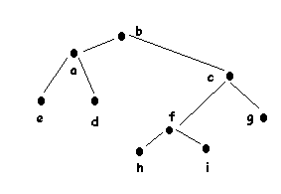

2. Write the expression tree for a + (b * c - d) (5 points)

3. Write the expression you drew the tree for in (2 points each)

prefix notation:

postix notation:

