Name ___________________ Possible Points this page ___ Earned Points this Page __

Partial Ordering and Topological Sort

1. What properties does a binary relation on a set have if the relation is a partial ordering? (3)

2. The diagram below represents a partial ordering on the set S. Find a topological sort of the partial ordering in the diagram. (4)

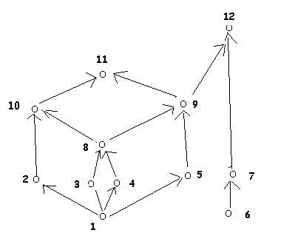

3. If a binary relation on a set is an equivalence relation, what properties does it have? (3)

