Name ___________________ Possible Points this page 14 Earned Points this Page __

Euler and Hamilton Circuits and Paths

1. What is the difference between a path and a circuit in an undirected graph? (2 points)

2. Does the connected multigraph below have an Euler circuit? ____ If it does, tell what it is

3. Does the connected multigraph below have an Euler path? ____ If it does, tell what it is

4. Does the connected multigraph below have a Hamilton circuit? ____ If it does, tell what it is.

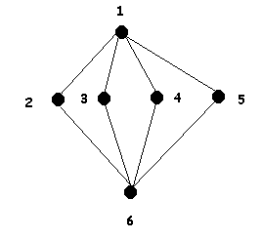
5. Does the connected multigraph below have an Euler circuit? ____ If it does, tell what it is

6. Does the connected multigraph below have an Euler path? ____ If it does, tell what it is

7. Does the connected multigraph below have a Hamilton circuit? ____ If it does, tell
what it is.

