Name ___________________ Possible Points this page 16 Earned Points this Page __

Adjacency matrix and adjacency relation

1. Show the adjacency matrix and adjacency relation for the graph below (4 points each)

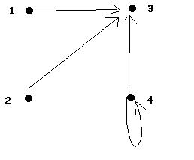

2. Copy the graph from Question 1 below and add any edges necessary to make the binary relation represented by the graph reflexive. (3 points)

3. Copy the graph from Question 2 below and add any edges necessary to make the binary relation represented by the graph symmetric. (3 points)

4. Does the graph you drew in Question 3 represent an equivalence relation? _____ Why or why not? (2 points)

