CS 228 Exam 2 – November 21, 2005

Name ______________________

- 1. List the ordered pairs in the relation R from A = {1, 3, 5, 7} to B = {2,4,6} where (a,b) ∈ R if and only if a > b. (5 points)

R = { (3,2), (5,2), (5,4), (7,2) , (7,4), (7,6)}

- Given the following relations on the set { 1,2,3,4}, fill in the table below placing a check in the appropriate column if the relation has that property. (6 points)

Relations | reflexive | symmetric | transitive | irreflexive | anti-symmetric
{(1,1), (1,2), (2,1), (2,2), (3,3), (4,4)}
{(2,4), (4,2)}
{(1,3), (1,4), (2,3), (2,4), (3,1), (3,4)}

- Given the following sets and relations (8 points)
A = {2,4,5}
B = {2,4,5,8}
R1 = { (2,2), (4,4), (5,5)}
R2 = {(2,2), (2,4), (2,5), (2,8)}

Complete the table below
R1 ∩ R2
R1 Ụ R2
R1 – R2
R2 – R1

- The 5-tuples in a 5-ary relation represent these attributes of all people in the United States: name, Social Security number, street address, city, state. Why is Social Security number the only reasonable primary key? (5 points)

- What do you obtain when you apply the selection operator S_{C}, where C is the condition (Project = 2) ∧ (Quantity >= 12) to the database below. (5 points)

Part-Number | Project | Quantity | Color-Code
1001 | 1 | 14 | 8
1092 | 1 | 2 | 2
1101 | 3 | 1 | 1
3477 | 2 | 25 | 2
4975 | 3 | 6 | 2
6984 | 4 | 10 | 1
9048 | 4 | 12 | 2
9191 | 2 | 80 | 4

- Under what conditions is a relation on a set A called an equivalence relation?
(6 points)

- Given the relation below on the set {1,2,3,4}

{(1,2), (1,3), (1,4), (2,1), (2,3), (2,4), (3,1), (3,2), (3,4), (4,1), (4,2), (4,3)}

  - draw the directed graph that represents it (5 points)

  - represent it with a zero-one matrix. (5 points)

- Draw the Hasse diagram for the "greater than or equal to" relation on the set { 2, 4, 6, 8, 10} (5 points)

- Given the Hasse diagram below representing a partial ordering
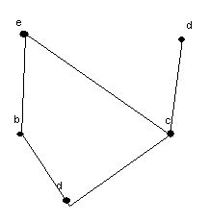
  - list all the ordered pairs in the partial ordering with the accompanying Hasse diagram (5 points)

  - provide a topologial sort. (5 points)

- Suppose that you are responsible for scheduling the final exams for seven finals. The courses are numbered 1 through 7. Suppose that the following pairs of courses have common students: 1 and 2, 1 and 3, 1 and 4, 1 and 7, 2 and 3, 2 and 4, 2 and 5, 2 and 7, 3 and 4, 3 and 6, 3 and 7, 4 and 5, 4 and 6, 5 and 6, 5 and 7, and 6 and 7.
  - draw the graph model (5 points)

  - determine the number of time periods needed to avoid scheduling conflicts. (5 points)

- For each of the graphs below, indicate whether the graph has and indicate the path or the circuit if it has either one. (5 points each)
 | an euler circuit | an euler path | path or circuit shown here if one exists
a
b

a.
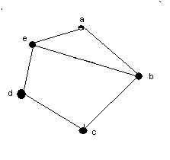

b.
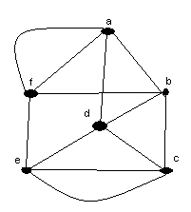
12. Given the graph below
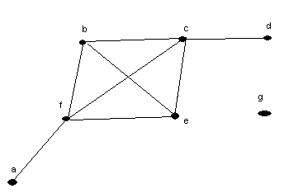
  - identify each of the following (5 points)
isolated vertex
pendant vertex
maximum valence
number of edges
number of vertices

b. is the graph above connected? ________ Why or why not? (5 points)

- Add the edges to the graph below that would be needed to turn it into a complete graph? (5 points)
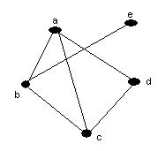

Give the state table for the finite-state machine shown below

- Show the state table or diagram (your choice) for a finite-state machine for a toll machine that opens a gate after 25 cents in nickels, dimes, or quarters has been deposited. No change is given for overpayment and no credit is given to the next driver when more than 25 cents has been deposited. (10 points)

