CS 228 Exam 2 – November 21, 2005

Name ______________________

- 1. List the ordered pairs in the relation R from A = {1, 3, 5, 7} to B = {2,4,6} where (a,b) ∈ R if and only if a > b. (5 points)

R = { (3,2), (5,2), (5,4), (7,2) , (7,4), (7,6)}

- Given the following relations on the set { 1,2,3,4}, fill in the table below placing a check in the appropriate column if the relation has that property. (6 points)

Relations | reflexive | symmetric | transitive | irreflexive | anti-symmetric
{(1,1), (1,2), (2,1), (2,2), (3,3), (4,4)} | xx | xxx | xx
{(2,4), (4,2)} |  | xxx |  | xxx
{(1,3), (1,4), (2,3), (2,4), (3,1), (3,4)} |  |  |  | xxx

- Given the following sets and relations (8 points)
A = {2,4,5}
B = {2,4,5,8}
R1 = { (2,2), (4,4), (5,5)}
R2 = {(2,2), (2,4), (2,5), (2,8)}

Complete the table below
R1 ∩ R2 | {(2.2)}
R1 Ụ R2 | {(2,2), (2,4),(2,5), (2,8), (5,5), (4,4)}
R1 – R2 | { (4,4), (5,5)}
R2 – R1 | { (2.4), (2,5), (2,8)}

- The 5-tuples in a 5-ary relation represent these attributes of all people in the United States: name, Social Security number, street address, city, state. Why is Social Security number the only reasonable primary key? (5 points)

because it is the only attribute that is guaranteed to be unique. People can have the same name, the same street address, live in the same city and the same state.

- What do you obtain when you apply the selection operator S_{C}, where C is the condition (Project = 2) ∧ (Quantity >= 12) to the database below. (5 points)

Part-Number | Project | Quantity | Color-Code
1001 | 1 | 14 | 8
1092 | 1 | 2 | 2
1101 | 3 | 1 | 1
3477 | 2 | 25 | 2
4975 | 3 | 6 | 2
6984 | 4 | 10 | 1
9048 | 4 | 12 | 2
9191 | 2 | 80 | 4
3477 | 2 | 25 | 2
9191 | 2 | 80 | 4

- Under what conditions is a relation on a set A called an equivalence relation?
(6 points)

A relation on a set A is called an equivalence relation if it is reflexive, symmetric and transitive

- Given the relation below on the set {1,2,3,4}

{(1,2), (1,3), (1,4), (2,1), (2,3), (2,4), (3,1), (3,2), (3,4), (4,1), (4,2), (4,3)}

  - draw the directed graph that represents it (5 points)
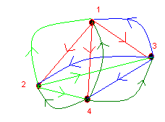
  - represent it with a zero-one matrix. (5 points)

 | 1 | 2 | 3 | 4
1 | 0 | 1 | 1 | 1
2 | 1 | 0 | 1 | 1
3 | 1 | 1 | 0 | 1
4 | 1 | 1 | 1 | 0

- Draw the Hasse diagram for the "greater than or equal to" relation on the set { 2, 4, 6, 8, 10} (5 points)

2
|
4
|
6
|
8
|
10

- Given the Hasse diagram below representing a partial ordering
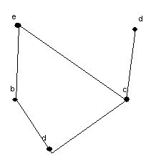
  - list all the ordered pairs in the partial ordering with the accompanying Hasse diagram (5 points)

{ (a,a), (b,b), (c,c), (d,d), (e,e), (a,b), (a,c), (a,e), (a,d), (b,e), (c,d), (c,e)}

  - provide a topologial sort. (5 points)

any of the following: a b c d e a c d b e a c b e d a b c e d

- Suppose that you are responsible for scheduling the final exams for seven finals. The courses are numbered 1 through 7. Suppose that the following pairs of courses have common students: 1 and 2, 1 and 3, 1 and 4, 1 and 7, 2 and 3, 2 and 4, 2 and 5, 2 and 7, 3 and 4, 3 and 6, 3 and 7, 4 and 5, 4 and 6, 5 and 6, 5 and 7, and 6 and 7.
  - draw the graph model (5 points)
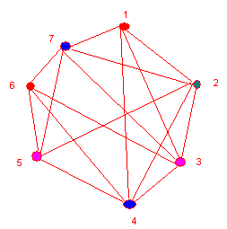
  - determine the number of time periods needed to avoid scheduling conflicts. (5 points)
4 time periods are needed. A possible schedule would pair: 1 and 5, 2 and 6, 4 and 7, and have 3 by itself.
- For each of the graphs below, indicate whether the graph has and indicate the path or the circuit if it has either one. (5 points each)
 | an euler circuit | an euler path | path or circuit shown here if one exists
a |  | yes | beabcde, ebcdeab, ebaedcb, bedcbae,  baebcde, bcdeabe are all Euler paths
b | yes |  | dbafadefbcecd, abcedcefadbfa,  fafbadbcecdef,fabfececbcdaf,  abcecdefafbda, cedcbdabfafec,  afecbdcedafba , afabcdbfeceda  are all Euler circuits

a.
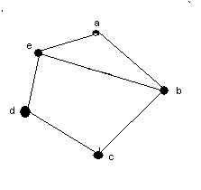

b.
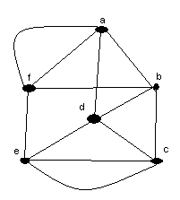
12. Given the graph below
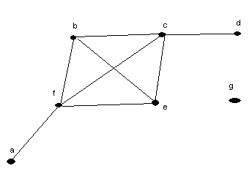
  - identify each of the following (5 points)
isolated vertex | g
pendant vertex | d or a
maximum valence | 4
number of edges | 8
number of vertices | 7

b. is the graph above connected? _No_______ Why or why not? (5 points)

No it is not connected. There is no path from any vertex to g.

- Add the edges to the graph below that would be needed to turn it into a complete graph? (5 points)
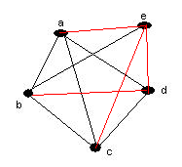

- Show the state table or diagram (your choice) for a finite-state machine for a toll machine that opens a gate after 25 cents in nickels, dimes, or quarters has been deposited. No change is given for overpayment and no credit is given to the next driver when more than 25 cents has been deposited. (10 points)

Current State | Input | Next State | Gate
S0 | 5 | S5 | 0
S0 | 10 | S10 | 0
S0 | 25 | S0 | 1
S5 | 5 | S10 | 0
S5 | 10 | S15 | 0
S5 | 25 | S0 | 1
S10 | 5 | S15 | 0
S10 | 10 | S20 | 0
S10 | 25 | S0 | 1
S15 | 5 | S20 | 0
S15 | 10 | S0 | 1
S15 | 25 | S0 | 1
S20 | 5 | S0 | 1
S20 | 10 | S0 | 1
S20 | 25 | S0 | 1

