02/26/09, Thursday, Notes taken by Ammad Shami

∆ **EXAM ON THURSDAY, March 5th!**

For HW # 11, each group will critique what the other group did (if you did back-up/restore files, you will critique the import/export group’s steps and vice versa).

Discussion question of the day:

Why do we back-up/restore files?

* Accidents (drop*?)
* In case of power failure
* For archiving data in case you want to go back and make changes on the old version
* To perform beta testing
* People working together each need a copy of the database without depending on one person to be responsible for it. (Master copy 🡪 Other copies)

What’s covered on the exam..?

Ch.1, 2, 3, 4, 5, 9 & relational algebra

Here’s a guideline on what you need to study as discussed by Dr. Adams.

* Know why file processing isn’t good.
* Be able to tell the # of users, functional dependencies of attributes to one another and size of a database.
* Know the different components of databases (who talks to who?)
  + User 🡪 Application 🡪 DBMS 🡪 Database
  + Know the relational algebra associated with it such as SELECT, PROJECT, and the different variations of a JOIN procedure.
* Look through all the previous notes from students to review what we’ve covered so far!
* **Chapter 2, read through**
  + All terminology
  + What’s a schema?
  + Know how to create queries and reports
* **Chapter 3, The E-R model**
  + Know how to design a solution using the E-R model and know its characteristics
  + Review slides in designing with this type of model
  + Look at Pg.67-71 (Jefferson & Sailboat Charters models)
    - We might get questions referring to these!
* **Chapter 4, The Semantic Data Model**
  + All terminology
  + Review slides in designing with this type of model
  + Only need to understand the first 3 kinds of objects (This is what Dr. Adams said!)
* **Chapter 5, Normalization**
  + Know the forms all the way up to Third Normal Form and the types of modification anomalies that exist.
    - Remember,
    - Any table of data in general that meets the definition of a relation is said to be in **first normal form**.
    - A relation in which all its non-key attributes are dependent on all of the key is said to be in **second normal form**.
    - A relation which is in second normal form BUT has no transitive dependencies is said to be in **third normal form**.
  + But, still look over what 4th normal form and Boyce Cott normal forms are.
* **Chapter 9, Structured Query Language (SQL)**
  + All terminology
  + Review slides on working the SQL language
  + KNOW THE DIFFERENCES BETWEEN SQL SERVER AND ACCESS!
  + The expressions (%, -) belong to SQL while the expressions (?, *) belong to MS Access.
  + ****How did we get the query MDC.sql which we went over in class?****
    - Open SQL server
    - Right click on the database (i.e. we used Northwind)
    - Click on all tasks
    - Click on generate SQL scripts
    - Click on Show All
    - Pick the object or objects to script and click the ADD>> button
    - Click ok
    - Save as <whatever>*.sql
    - Now, click on the database you want to put it into (i.e. we used silly)
    - Click tools
    - Click SQL query analyzer
    - Go to file, open and chose the .sql file that you created/saved earlier.
    - Run the file by clicking on the green ‘play’ button
    - Now, go to user tables of where you specified to put it (i.e. silly) OR a faster way to get there would be using the scroll down option above the query window and changing to that database.
  + Remember, queries generated by SQL use “fully qualified” references. We don’t need to use those references however in writing queries by ourselves.
  + How do we use a query to delete a table?
    - If we want to delete the Customers table in Northwind, go to Query and write the SQL statement: drop table dbo.customers;
* Chapter 6 & 7 WILL NOT be covered on the midterm exam.

**Chapter 7** – SQL for Database Construction & Application Processing

* Refer to the slides corresponding to this topic. The following are notes to guide you through the ppt slides,
* SQL can be used for Constructing & Destructing tables (as we saw in the above example by using drop/create table function)
* Besides drop/create table, a new option is alter table.
* Why use SQL?
  + It is faster
  + Portable, most database management systems use SQL
  + It’s a universal language
* Observe tables from View Ridge Database design in Chapter 6.
  + The table design on this page comes from the software called ER-Win (try it out! – said Dr. Adams). Just pointing out that the designs are not E-R or Semantic Models so don’t get confused. 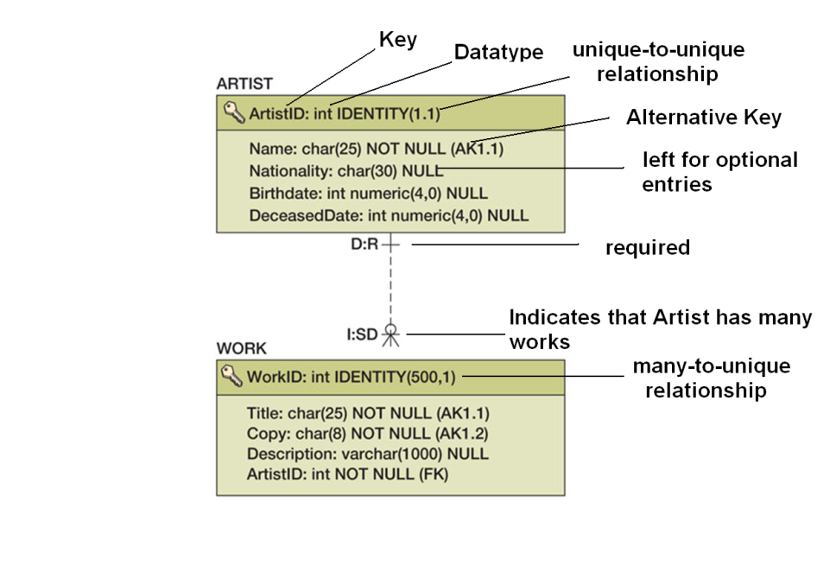

SQL code to create the above relation,

Create table artist (

artistID int not null, myname nchar(25) not null, nationality nchar(30)

Constraint ArtistPK Primary Key (Artist ))

Table Creation and Deletion Order (slide),

* The thing to know in this slide is, delete the record that has the foreign key BEFORE deleting the record that has the primary key.