NAME PRINTED LEGIBLY________________________________

Note: This exam is worth 136 points. It is VERY LONG. Go through it doing what you can do immediately and then go back over what you weren't sure of. For each question page, use the back of the previous page if you need more room.

Page # |  | Points  Possible | Points  Earned
2 | Short Answer/Multiple Choice | 18
3 | Relational algebra page | 21
4 | Cereal Semantic Object page | 24
5 | Matching questions page | 15
6 | Functional dependency/Normal form page | 22
7 | Entity Relationship Diagram page | 16
8 | SQL page | 20
 | TOTALS | 136

BONUS: if you want, you can go over your test and attempt to determine how many points
you earned ( out of the 136, write a number not a per cent) and write it here _____
If you are within 5 points of your actual earned score, I will add an additional 3 points to your grade.

Total Points earned: _____________________

Name ______________________ Points Possible 18 Points Earned ____

Circle the correct answer for multiple choice and true/false questions

- In a file processing system: (2)
  - the user interacts with the application
  - the user accesses the file data
  - the application accesses the database data
  - a and b
  - a and c

- Which of the following would not be stored in system tables? (2)
  - uer data
  - keys
  - stored procedures
  - lists of indexes
  - length of fields

- The ___________ description of a domain indicates the meaning of the data (2)

- Which keyword is used to specify the names the conditions for a join? (2)
  - FROM
  - HAVING
  - JOIN
  - SELECT
  - WHERE

- Which of the following is known to be true from the functional dependency shown as (A) ) → (X,Y)? (2)
  - X is functionally dependent on A
  - A determines Y
  - A is a determinant
  - X and Y are functionally dependent on A
  - All of the above

- What are the components of a database application? (4)

- Who is the man responsible for “coming up with” the idea of normalization? (2)

- The term data integrity is used to describe data which represents the user’s data in a truthful way TRUE FALSE (2)
Name: ___________________________ Points Possible 21 Points Earned ________
Name __________________________Points Possible 21 Points Earned ______

SALESPERSON CUSTOMER
Name | Salary |  | Name | City | Industry Type
A | $600 |  | AC | Willow | canning
C | $420 |  | ML | Chester | Pecans
J | $980 |  | TCB | NY | Film
M | $770 |  | AH | LA | Film
Z | $360

ORDER STUDENT
Number | CustName | SellerName | Amount |  |  | Name | Rent
100 | AC | Z | $560 |  |  | A | $600
200 | AC | J | $1800 |  |  | B | $650
300 | ML | A | $480 |  |  | K | $1000
400 | AH | A | $2500
500 | AC | M | $6000
600 | TCB | A | $700
700 | ML | J | $150

What does it mean for two relations to be union compatible? (3)

If you performed the relational algebra project operation SALESPERSON[Name], what
would the result be? (3)

If you performed the relational algebra select operation CUSTOMER WHERE
Name = ‘ML’ what would the result be? (3)

Can the result of performing a relational algebra operation on one or more tables ever
result in duplicate tuples? YES NO (1) How do you know? (2)

What is the union of SALESPERSON and STUDENT? (3)

What is the difference of SALESPERSON and STUDENT? (3)

What is the equi-join of STUDENT AND SALESPERSON where Name = Name? (3)

Name: ___________________________ Points Possible 24 Points Earned ________
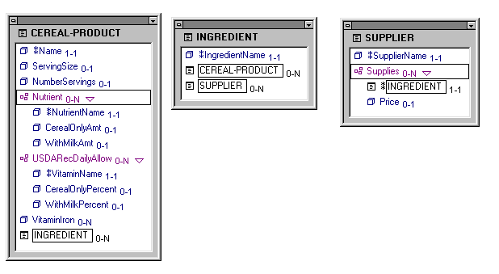
What type of object is the Semantic Object SUPPLIER? (2)

What type of object is the Semantic Object CEREAL-PRODUCT? (2)

What type of object is the Semantic Object INGREDIENT? (2)

Three different types of relationships between compound objects are all represented by inserting foreign keys into the database. How is it done for each of the relationships shown below? Assume that the object on the left is A and the one on the right is B in each of the relationships below.

one-to-one (2)

one-to-many (2)

On the back of the previous page, show the relations that would be created from the model above for the semantic object CEREAL-PRODUCT. Use initials instead of writing the entire name of the attributes. Add _FK to foreign key attributes and underline keys (14)

Name: ___________________________ Points Possible 15 Points Earned ________

The numbers in column C are associated with the definitions in column D. Write the number from column C that defines the term in column B in the blanks in column A.

A | B | C | D
 | database management system | 1 | attribute that identifies a unique instance of a group within a semantic object or another group
 | DDL | 2 | cannot exist in db unless another type of entity also exists in db
 | domain | 3
  process of evaluating a relation to determine whether it is
  in a specified normal form and if necessary, converting it
  to relations in that form
 | domain key/normal form | 4 | column with an index
 | data dictionary | 5 | composite of other attributes
 | multi-value attribute | 7 | consists of 2 or more attributes
 | normalization | 8 | contains only single-value, simple or group attributes
 | database | 9 | description of database structure
 | object instance | 10 | in a relation, the situation in which the removal of one row of a table deletes facts about two or more themes
 | physical key | 11 | is a unique system-supplied identifier used as the primary key of a relation
 | referential integrity constraint | 12 | language used to describe the database structure
 | relational schema | 13 | logical and physical descriptions of an attributes allowed values
 | simple object | 14 | maximum cardinality is greater than one
 | surrogate key | 15 | occurrence of a particular semantic object
 | weak entity | 16 | relation in which all constraints are logical consequences of domains and keys
 |  | 17 | relationship constraint on foreign key values
 |  | 18 | self describing collection of integrated records
 |  | 19 | set of programs used to define, administer and process the database and its applications
 |  | 20 | state of a database in which all constraints are fulfilled
 |  | 21 | structure of a relation along with the constraints on its allowable values

Name: ___________________________ Points Possible 22 Points Earned ________

A state development office wants you to design a database which describes parcels of land for sale in various counties of a state. Each piece of property has an identification number and a lot number. Lot numbers are only unique within each county but property numbers are unique across counties for the entire state. The tax rate is fixed for a given county (i.e. it does not vary lot by lot within the same county. The price of a lot is determined by its area regardless of which county it is in.
A student working in the state office identified the following 6 attributes that needed to be included in the database: identification number , county, lot number, tax rate, price, and area.
The student came up with the following initial design.
You have just been hired and know a little more than this student so you should be able to answer the following questions.
LOTS
Property_ID# | County_Name | Lot# | Area | Price | Tax_Rate
1123 | Charles | 26 | 1.5 | $10,500 | .074
4124 | Howard | 26 | 3 | $30,000 | .085
2157 | Albemarle | 43 | 1.5 | $10,500 | .069
1487 | Calvert | 15 | 2.7 | $27,000 | .057
5274 | Charles | 31 | 2.1 | $21,000 | 0.74

The student told you his design was in 2nd normal form. You say it isn’t. Why isn’t it? (2)

From the problem description, what functional dependencies are in this table? (4)

Can Property ID# be a key of this table? YES NO (1) Why? (2)

Can Lot# be a key of this table? YES NO (1)
Why>? (2)

What is the definition of a composite key? (2)
What candidate composite key could you select to be the primary key (2)

On the back of the previous page, show the tables you would form to put your design into 2nd normal form. (show the tables without the data) (3)

Is your design in any higher normal form? YES NO (1)
Why? (2)

Name ________________________ Possible Points: 16 Earned Points: __________

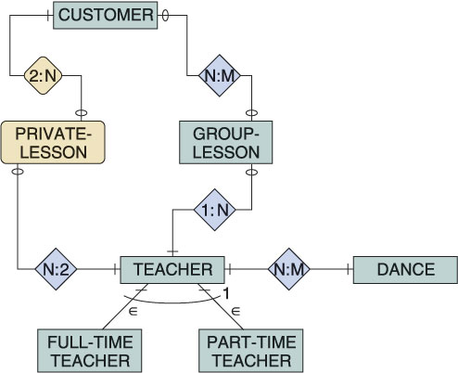

(1

1. What is the relationship between TEACHER and PART-TIME TEACHER? (1)

- Which is the weak entity in this ER diagram? (1)

- What does the 2:N relationship between CUSTOMER and PRIVATE-LESSON mean? (2)

- Who provides a GROUP-LESSON to a CUSTOMER? (2)

- Can a CUSTOMER receive more than one GROUP-LESSON? YES NO (1)
How do you know? (2)

- Does an CUSTOMER have to have a PRIVATE-LESSON? YES NO (1)
How do you know? (2)

- What information has been omitted from this diagram? (2)

- What do the | and | marks between TEACHER and DANCE tell us? (2)

Name: ___________________________ Points Possible 20 Points Earned ________

All of the questions on this page relate to the following three tables and require you to write standard SQL statements (not Access versions).

SALESPERSON CUSTOMER
Name | PercetOfQuota | Salary |  | Name | City | IndustryType
Abel | 63 | 120,000 |  | Abernathy Construction | Willow | B
Baker | 38 | 42,000 |  | Manchester Lumber | Manchester | F
Jones | 26 | 36,000 |  | Tri-City Builders | Memphis | B
Murphy | 42 | 50,000 |  | Amalgamated Housing | Memphis | B
Zemith | 59 | 118,000
Lpbad | 27 | 36.000

ORDER
Number | CustName | SalesPersonName | Amount
100 | Abernathy Construction | Zenith | 560
200 | Abernathy Construction | Jones | 1800
300 | Manchester Lumber | Abel | 480
400 | Amalgamated Housing | Abel | 2500
500 | Abernathy Construction | Murphy | 6000
600 | Tri-City Builders | Abel | 700
700 | Manchester Lumber | Jones | 150

- Write the SQL statement that will show the salaries of all salespeople but omit duplicates. (3)

- Write the SQL statement that will show the names of all salespeople who earn more than $49,999 and less than $100,000. (3)

- Write the SQL statement that will show the names of customers who are located in a City ending with the letter S. (3)

- Write the SQL statement that will computer the number of orders for each salesperson. (3)

- Write the SQL statement that will show the quota percentages of salespeople who have an order with a customer in Memphis (use a join). (5)

- Write the SQL statement that will show the total salaries of all of the salespeople. (3)

