NAME PRINTED LEGIBLY ________________________________

Note: This exam is worth 136 points. It is VERY LONG. Go through it doing what you can do immediately and then go back over what you weren't sure of. For each question page, use the back of the previous page if you need more room.

Page # |  | Points  Possible | Points  Earned
2 | Short Answer/Multiple Choice | 18
3 | Relational algebra page | 21
4 | Cereal Semantic Object page | 24
5 | Matching questions page | 15
6 | Functional dependency/Normal form page | 22
7 | Entity Relationship Diagram page | 16
8 | SQL page | 20
 | TOTALS | 136

BONUS: if you want, you can go over your test and attempt to determine how many points
you earned ( out of the 136, write a number not a per cent) and write it here _____
If you are within 5 points of your actual earned score, I will add an additional 3 points to your grade.

Please sign the honor pledge below before turning in your exam.

This work complies with the JMU Honor Code. _______________________
Signature

Name _____________________ Points Possible: 18 Points Earned

Circle the correct answer for multiple choice and true/false questions

- In a database application processing system: (2)
  - the database application(s) interact with the DBMS
  - the database application(s) access the database data
  - the DBMS accesses the database data
  - a and b
  - a and c

- A database is a model of: (2)
  - the actual business
  - the user’s model of the business
  - the programmers’ view of the business
  - reality as it relates to the business
  - all of the above

- The ___________ description of a domain indicates the type of data and the length of the data. (2)

- Which keyword is used to specify the names of tables to be joined? (2)
  - FROM
  - HAVING
  - JOIN
  - SELECT
  - WHERE

- Which of the following is known to be true from the functional dependency shown as (A,B) → (C,D)? (2)
  - A is the determinant of C
  - A and B together are determined by C and D together
  - A and B together determine D
  - C and D together determine A
  - A determines B

- What are the four main DML statements? (4)

- Who is the man responsible for “coming up with” the idea of normalization? (2)

- A database schema defines a database’s structure, its tables, relationships, domains and business rules. TRUE FALSE (2)

Name: ___________________________ Points Possible 21 Points Earned ________

SALESPERSON CUSTOMER
Name | Salary |  | Name | City | Industry Type
A | $600 |  | AC | Willow | Canning
C | $420 |  | ML | Chester | Pecans
J | $980 |  | TCB | NY | Film
M | $770 |  | AH | LA | Film
Z | $360

ORDER STUDENT
Number | CustName | SellerName | Amount |  | Name | Rent
100 | AC | Z | $560 |  | A | $600
200 | AC | J | $1800 |  | B | $650
300 | ML | A | $480 |  | K | $1000
400 | AH | A | $2500
500 | AC | M | $6000
600 | TCB | A | $700
700 | ML | J | $150

- Are any of the relations above union compatible? YES NO (1)
- Why or why not? (2)

- If you performed the relational algebra project operation ORDER[CustName], what would the result be? (3)

- If you performed the relational algebra select operation CUSTOMER WHERE City = ‘NY’, what would the result be? (3)

- Why doesn’t the result of performing the relational algebra project operation on ORDER[CustName] result in 7 tuples? (3)

- What is the intersection of SALESPERSON and STUDENT? (3)

- What is the difference of STUDENT and SALESPERSON ? (3)

- What is the natural join of STUDENT AND SALESPERSON where Name = Name? (3)

Name: ___________________________ Points Possible 24 Points Earned ________
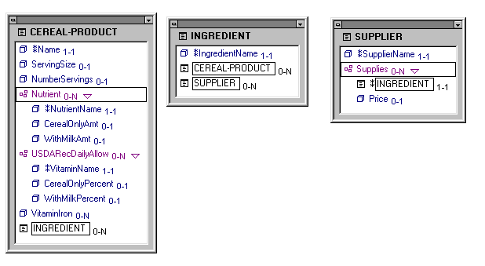
- What type of object is the Semantic Object CEREAL-PRODUCT? (2)

- What type of object is the Semantic Object INGREDIENT? (2)

- What type of object is the Semantic Object SUPPLIER? (2)

- Three different types of relationships between compound objects are all represented by inserting foreign keys into the database. How is it done for each of the relationships shown below? Assume that the object on the left is C and the one on the right is D in each of the relationships below.

one-to-one (2)

many-to-many (2)

- On the back of the previous page, show the relations that would be created from the model above for the semantic object CEREAL-PRODUCT. Use initials instead of writing the entire name of the attributes. Add _FK to foreign key attributes and underline keys (14)

Name: ___________________________ Points Possible 15 Points Earned ________

The numbers in column C are associated with the definitions in column D. Write the number from column C that defines the term in column B in the blanks in column A.
A | B | C | D
 | child | 1 | any table of data that meets the definition  of a relation
 | compound object | 2 | attribute or group of attributes that identifies  a unique row in a relation.
 | data manipulation language | 3 | attribute in which only one determines the other,  A->B, B not ->A
 | data structure diagram | 4 | an object containing a multi-value group that contains at least one object attribute
 | database | 5 | contains at least one object attribute
 | deletion anomaly | 6
  either a referential integrity constraint or a relationship
  cardinality constraint
 | Cartesian product | 7 | graphical display of tables and their relationships
 | intersection relation | 8 | has no non-key data
 | logical key | 9 | in a relation, the situation in which the removal of  one row of a table deletes facts about two or more  themes
 | one-to-many attribute | 10 | language used to describe the processing  of a database
 | metadata | 11 | maximum cardinality is 1
 | paired attributes | 12 | A relational operation on two relations producing a third relation which contains the concatenation of every row in the first relation with every row in the second relation
 | relationship constraint | 13 | relationship between two entities or objects  of the same logical type
 | single-value attribute | 14 | relationship between two entities or objects  that are of different logical types
 | union compatible | 15 | row, record or node on the one side of a  one-to-many relationship
 |  | 16 | row, record, or node on the many side of a  one-to-many relationship
 |  | 17 | self describing collection of integrated records
 |  | 18 | semantic objects having relationships with  each other
 |  | 19 | simple or group attribute
 |  | 20 | system tables

Name: ___________________________ Points Possible 22 Points Earned ________

A state development office wants you to design a database which describes parcels of land for sale in various counties of a state. Each piece of property has an identification number and a lot number. Lot numbers are only unique within each county but property numbers are unique across counties for the entire state. The tax rate is fixed for a given county (i.e. it does not vary lot by lot within the same county). The price of a lot is determined by its area regardless of which county it is in.
A student working in the state office identified the following 6 attributes that needed to be included in the database: identification number, county, lot number, tax rate, price, and area.
The student came up with the following initial design and entered some of the data.
You have just been hired and know a little more than this student so you should be able to answer the following questions.

LOTS
Property_ID# | County_Name | Lot# | Area | Price | Tax_Rate
1123 | Charles | 26 | 1.5 | $10,500 | .074
4124 | Howard | 26 | 3 | $30,000 | .085
2157 | Albemarle | 43 | 1.5 | $10,500 | .069
1487 | Calvert | 15 | 2.7 | $27,000 | .057
5274 | Charles | 31 | 2.1 | $21,000 | 0.74

- What functional dependencies are in this table? (4)

- What normal form is the initial design in? ________ (2)
What are the characteristics of this normal form? (4)

- Is there any single attribute that can serve as a key of this table? YES NO (1)
Justify your answer by explaining why or why not. (2)

- Are there any other candidate keys? YES NO (1)
(If YES, what? If NO, why not?) (2)

- Use the back of the previous page to describe modification anomalies you seen in this table. (2)

- On the back of the previous page, show how you would modify the design to eliminate the modification anomalies (show the tables without the data) (4)

- What normal form is your answer to the previous question (question 6) in? (2)

Name ________________________ Possible Points: 16 Earned Points: __________

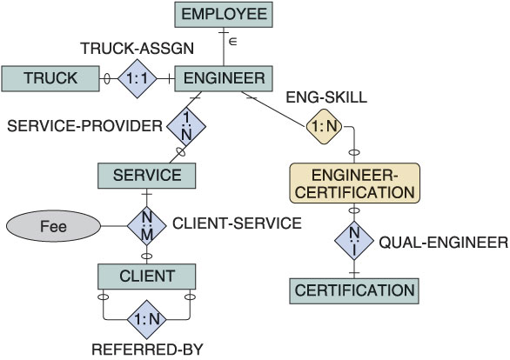

- What is the relationship between Employee and Engineer?

- What is the relationship between Employee and Engineer?

1. What is the relationship between EMPLOYEE and ENGINEER? (1)

- Which is the weak entity in this E-R diagram? (1)

- What does the 1:1 relationship between TRUCK and ENGINEER mean? (2)

- Who provides a SERVICE to a CLIENT? (2)

- Can a CLIENT receive more than one SERVICE? YES NO (1)
How do you know? (2)

- Does an ENGINEER have to have an ENGINEER-CERTIFICATION? YES NO (1)
How do you know? (2)

- Why is Fee an attribute of the CLIENT-SERVICE relationship? (2)

- What do the 0 and | marks between ENGINEER and SERVICE tell us? (2)

Name: ___________________________ Points Possible 20 Points Earned ________

All of the questions on this page relate to the following three tables and require you to write standard SQL statements (not Access versions).

SALESPERSON CUSTOMER
Name | PercetOfQuota | Salary |  | Name | City | IndustryType
Abel | 63 | 120,000 |  | Abernathy Construction | Willow | B
Baker | 38 | 42,000 |  | Manchester Lumber | Manchester | F
Jones | 26 | 36,000 |  | Tri-City Builders | Memphis | B
Murphy | 42 | 50,000 |  | Amalgamated Housing | Memphis | B
Zemith | 59 | 118,000
Lpbad | 27 | 36.000

ORDER
Number | CustName | SalesPersonName | Amount
100 | Abernathy Construction | Zenith | 560
200 | Abernathy Construction | Jones | 1800
300 | Manchester Lumber | Abel | 480
400 | Amalgamated Housing | Abel | 2500
500 | Abernathy Construction | Murphy | 6000
600 | Tri-City Builders | Abel | 700
700 | Manchester Lumber | Jones | 150

- Write the SQL statement that will show the salaries of all salespeople. (3)

- Write the SQL statement that will show the names of all salespeople with PercentOfQuota greater than 49 and less than 60 (3)

- Write the SQL statement that computes the number of orders. (3)

- Write the SQL statement that will compute the average percent of quota for salespeople. (3)

- Write the SQL statement that will show the names and quota percentages of salespeople who have an order with Abernathy Construction , in descending order of quota percentage (use a join). (5)

- Write the SQL statement that will show the names of salespeople who have two or more orders. (3)

