Name ______________________

Scenario
An automobile part (which consists of pnum, pname, price) contains at least one part. Moreover, an automobile part may also be contained in one or more parts. Choose the ER Diagram that best suits this scenario.

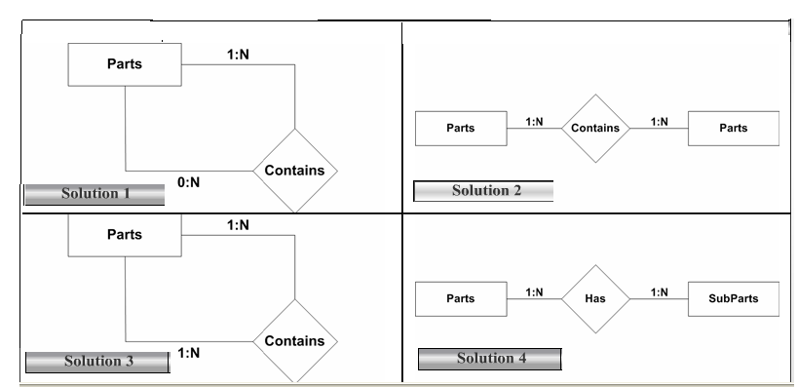

What are the entitites in the table below?

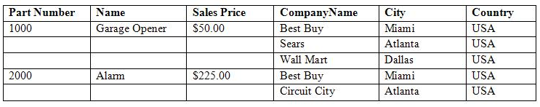

Draw an E-R diagram showing how they are related.
Name _________________

SCENARIO
A database system needs to be designed that will track medical prescriptions for patients. This database system should be able to show not only which drugs a patient has been prescribed, but also the name of the doctor who prescribed it. When designing this system, it should be noted that a doctor may issue several different prescriptions for any given patient. Similarly, a patient may have prescriptions from different doctors.

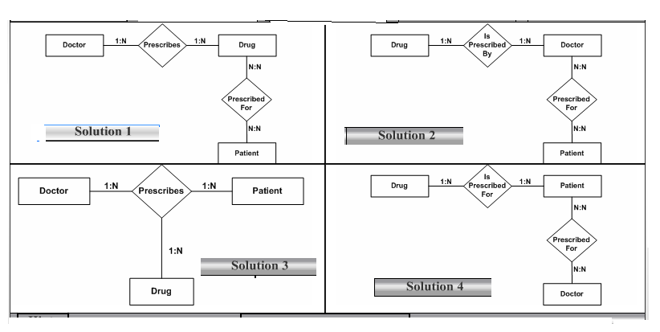

What are the entities in the form below?

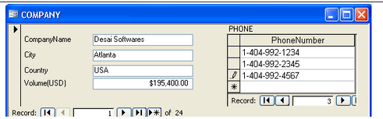

Draw an E-R diagram showing how they are related.

