Class Notes for Feb 24, 2009
The homework due Thursday Feb 26 is to make Semantic Object Models for Project A on Page 115.
There will be an exam next Thursday, March 5
Note that when you install table designer on Windows Vista, you might right click on the installer and click “Run as administrator” to install it.
- TableDesigner is very helpful in designing tables that can be imported into both Access and SQL Server. Note that it is used to design the tables, not fill them.
- Semantic Objects (Slide 1)
  - A semantic object is a named collection of attributes that sufficiently describes a distinct identity.
  - They are grouped into classes, which have names.
- Object Attributes (Slide 3)
  - A simple attribute is a single element, such as SalesTotal or StudentName.
  - Group attributes are composites of other attributes, such as an Address attribute, which is made of Street, City, State, and Zip Code
  - Semantic Object Attributes establish relationships between semantic objects, such as a Student object may have a Class attribute, which would like to another, separate Class object.
- Attribute Cardinality (Slide 5)
  - All attributes have a minimum cardinality, which is generally 0 or 1, but may be different, depending on the object. For example, a baseball team object would have a player attribute that would have a minimum cardinality of 9, since you have to have nine players to make up a baseball team.
  - Attributes have a max cardinality, which is usually 1 or N. This may also be different, depending on the object being described. For example, an NFL football team may not have more than 53 players, so its player attribute would have a maximum of 53.
  - An attribute with a max cardinality of 1 is called a single-value attribute.
  - An attribute with a max cardinality of greater than 1 is called a multi-value attribute.
  - The format to display minimum and maximum values for an attributes is m.n or min.max.

  - The following example is from page 82 of the book, and shows a department object, complete with attribute cardinalities.
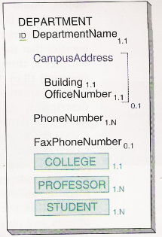
- An object identifier is one or more object attributes that are used to identify a unique instance of an object.
- Group identifiers are identifiers that involve two or more attributes.
- The domain of an attribute is a description of the attribute’s possible values. This is made up of both physical (data type) and a semantic (what it represents) descriptions.
- The portion of an object that is visible to an application is called the view.
- We covered three different types of objects: simple, composite, and compound.
  - Simple objects contain only single-value simple or group attributes.
  - An example of this is from page 95 of the book
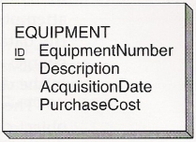
- Composite objects have one or more multi-value simple or group objects., but no object attributes.
- When transformed into tables, these will form two tables, each with what will be called Primary and Foreign keys (in a database) to enforce referential integrity between the two.
- An example of this is found on page 95 in the book, as well as on page 96 (to demonstrate multiple groups and nested groups).

- A compound object has at least one object attribute
  - These transform into two tables as well in database creation, and also have primary and foreign keys to enforce referential integrity at that point.

