Daniel Copeland
Yoshihiro Fujio
Ryan Selkregg
Kyle Heiman

Import/Export in SQL Server

Export

1.) Right click on the database to export and select Export Data
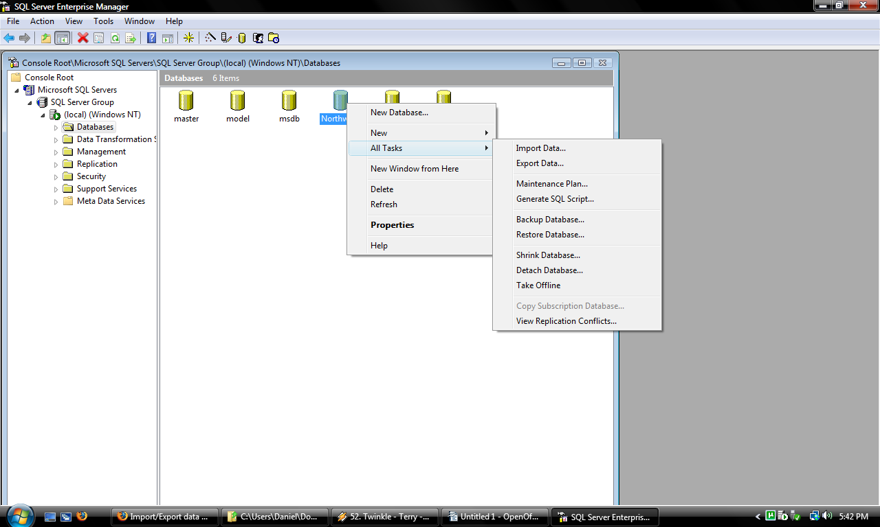
2.) This brings up the wizard. Click Next.

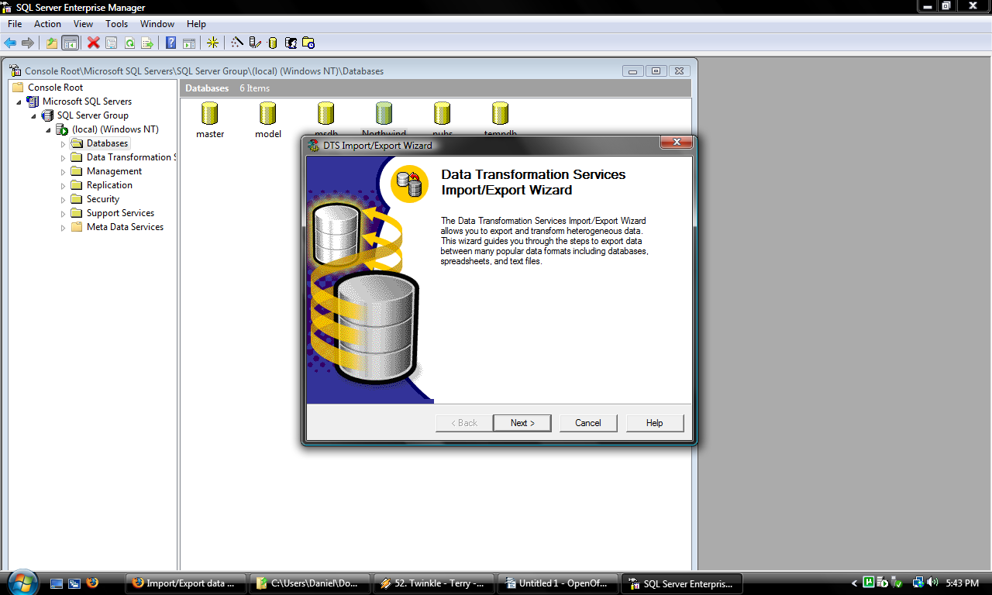
3.)Select data source and hit next.
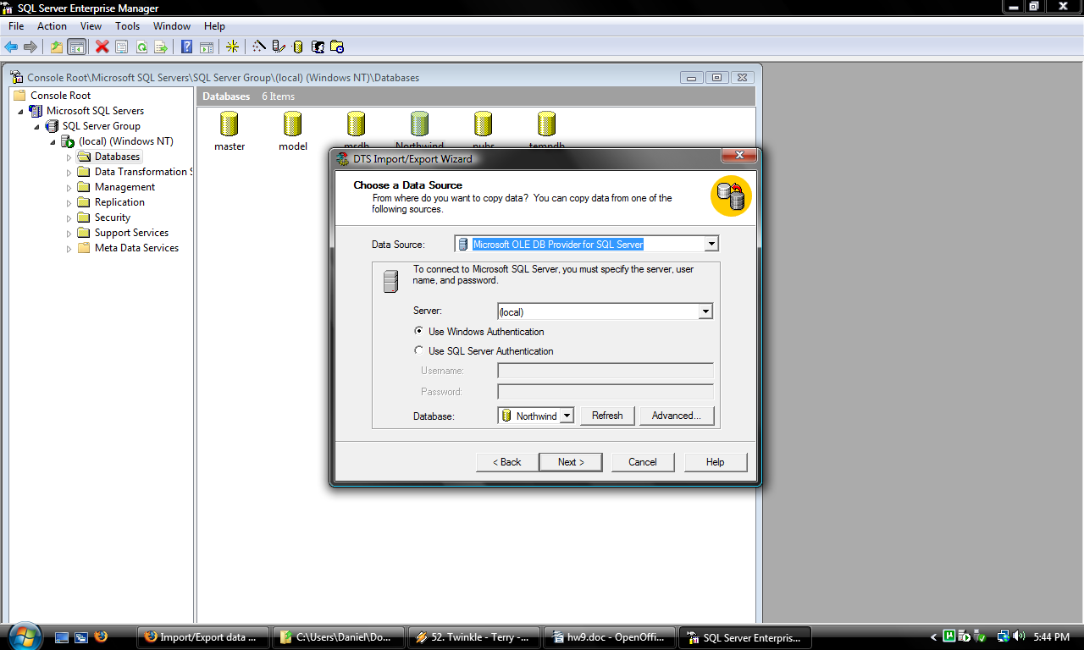
4.) Choose destination and hit next.
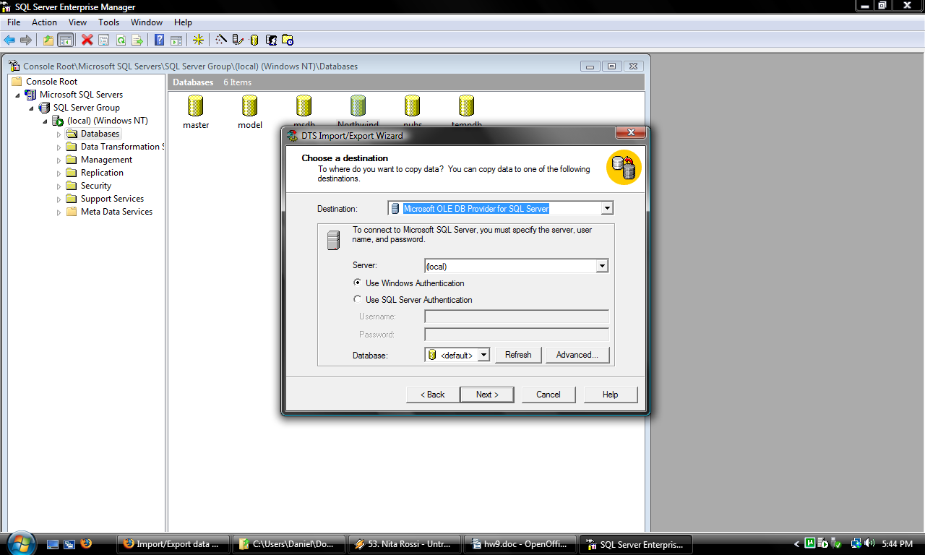

5.) Hit next.
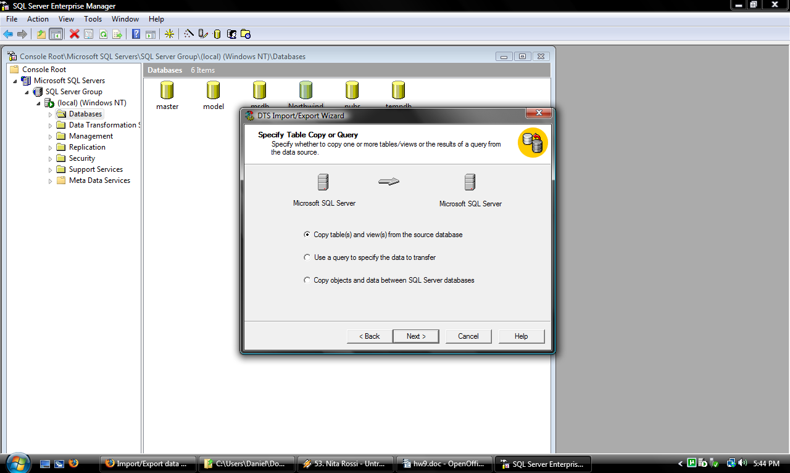
6.)Select tables to copy.

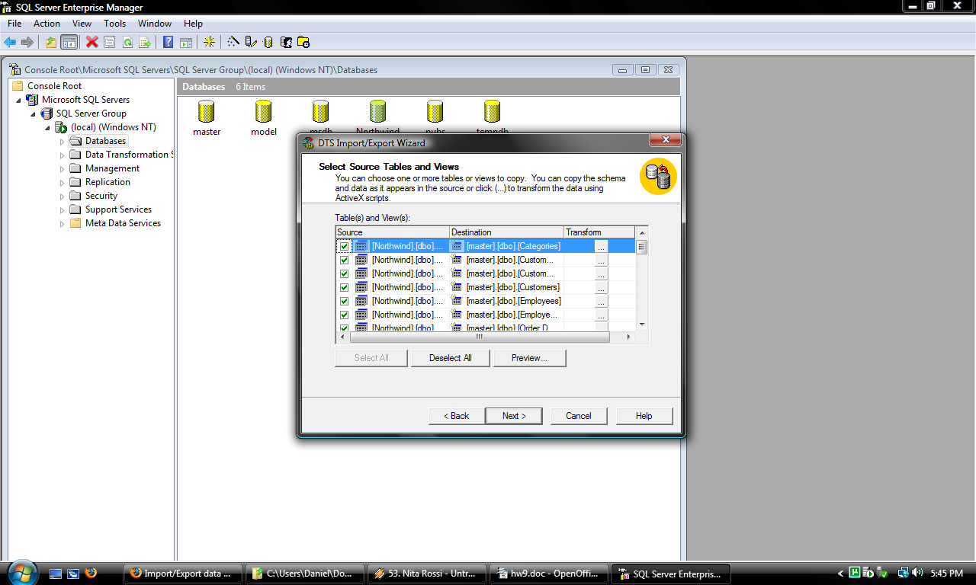
- Hit next.
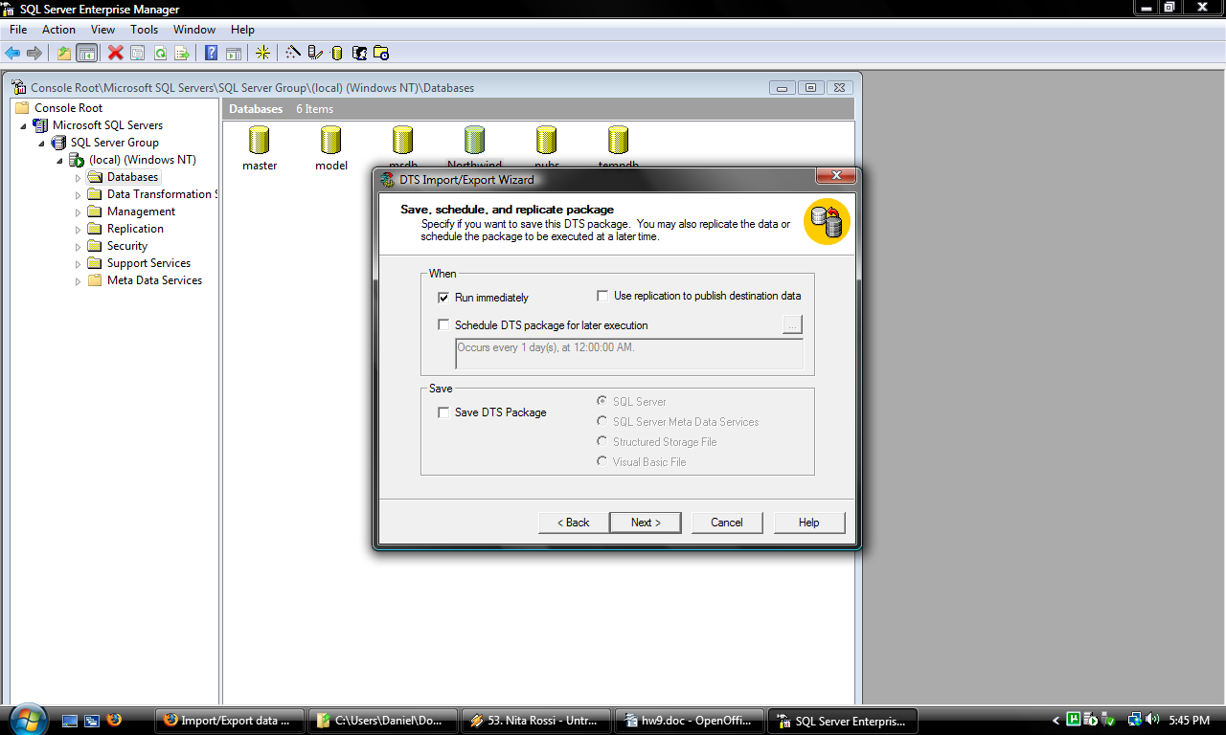
- Review summary and hit finish.
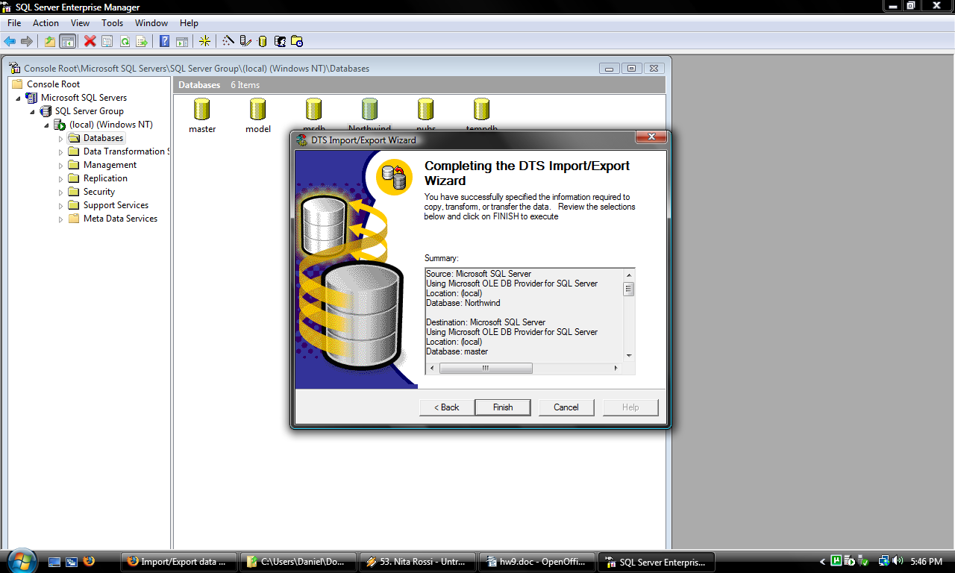

Import

- Right click on the database folder and select Import Data
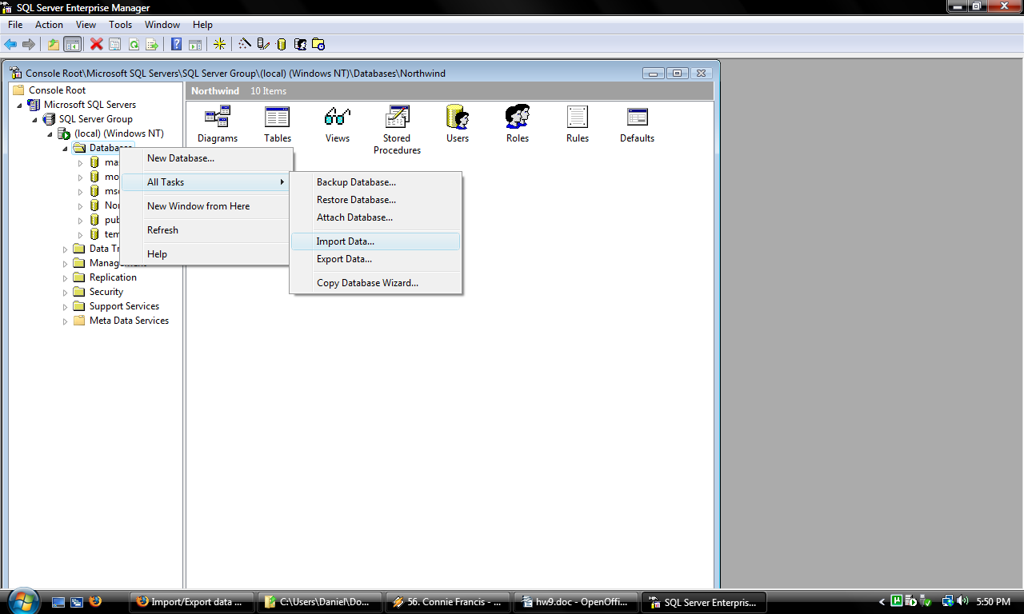
- Hit next.
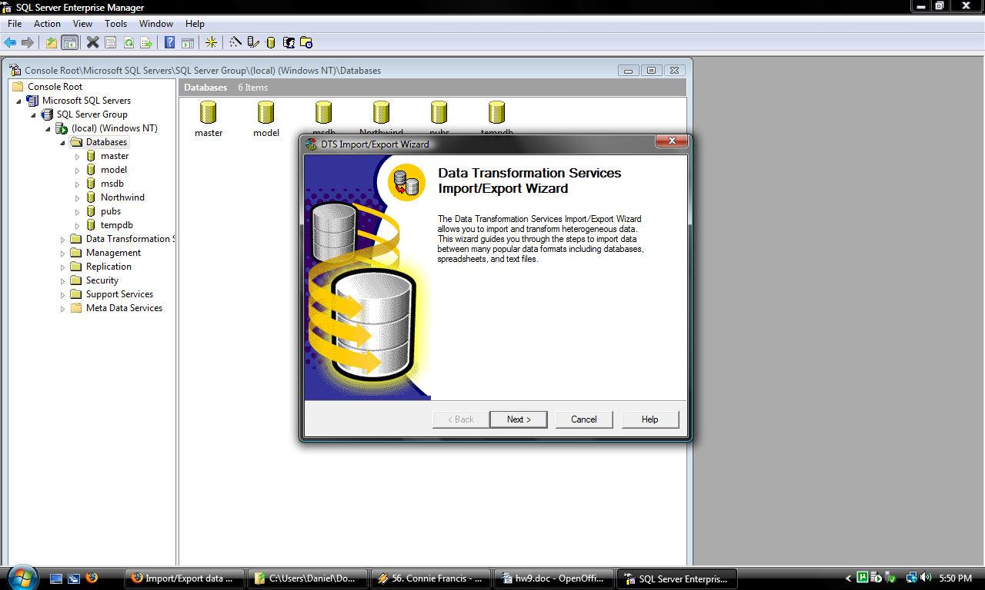
3.) Choose data source. Hit Next.
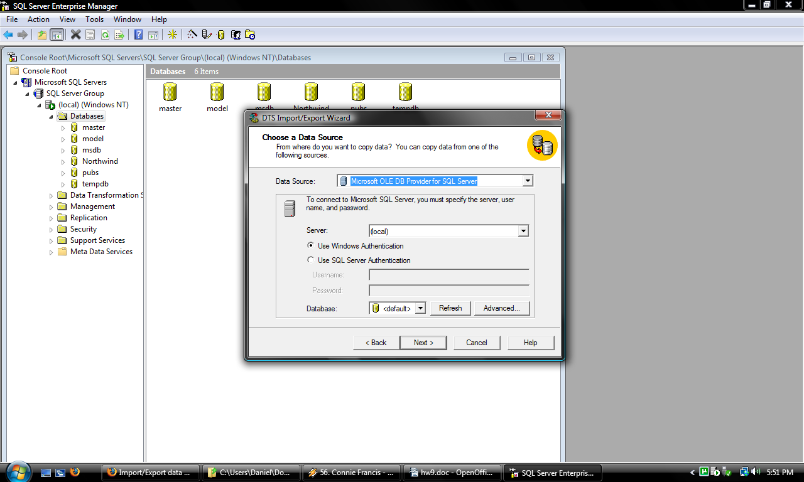

4.)Hit next.
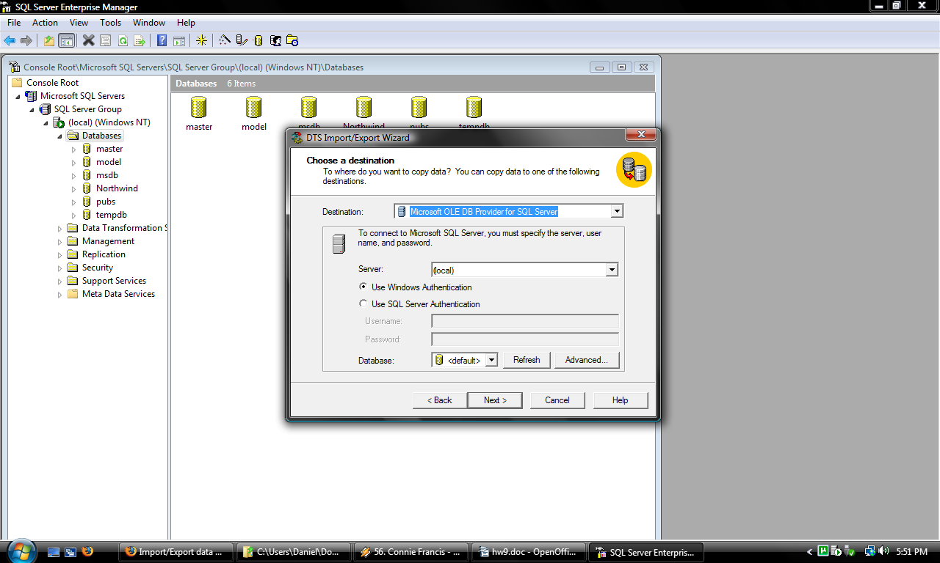
5.) Hit next.

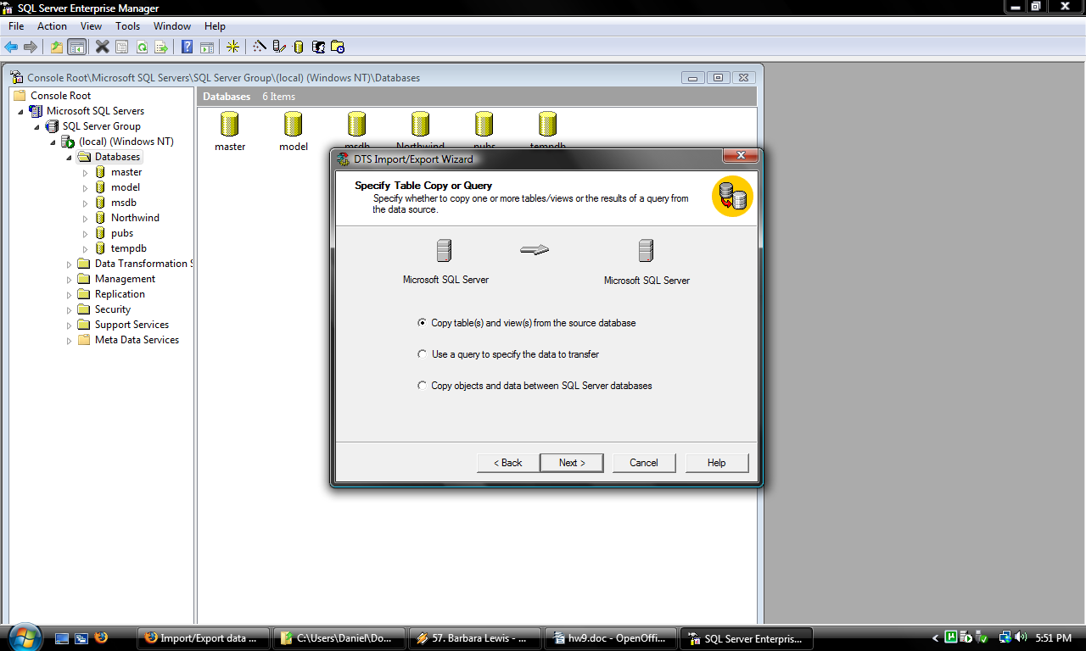
6.) Select tables to import. Hit next.
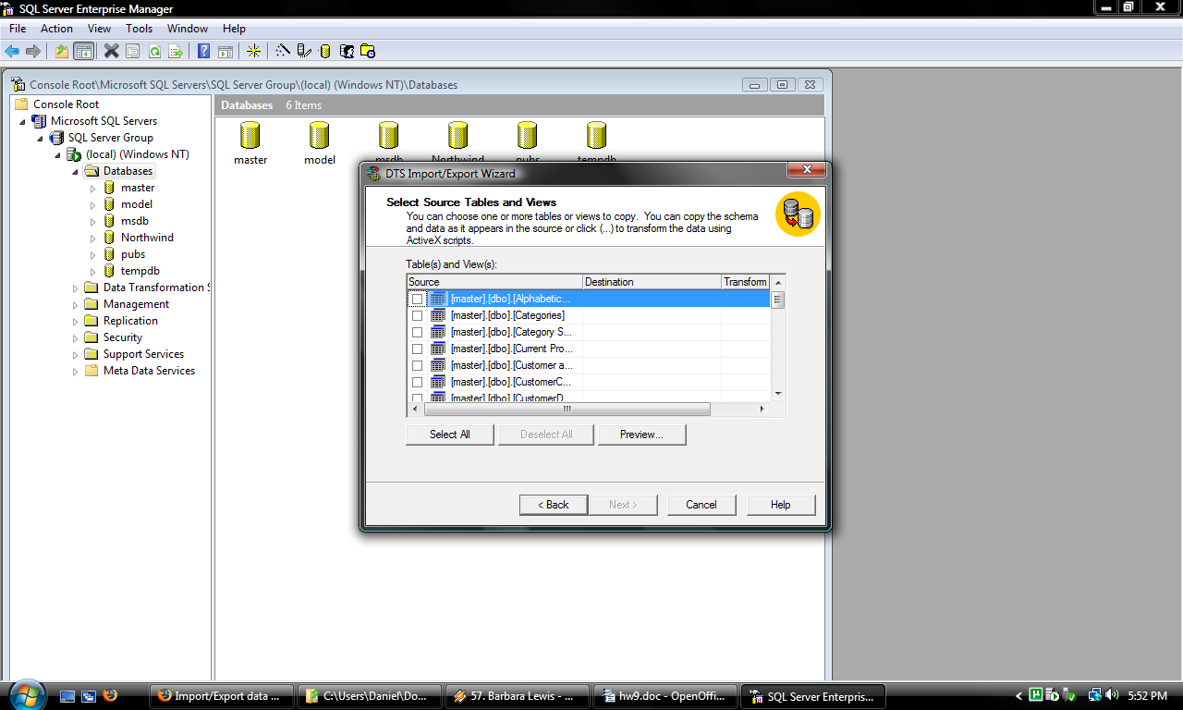
7.) Hit next.
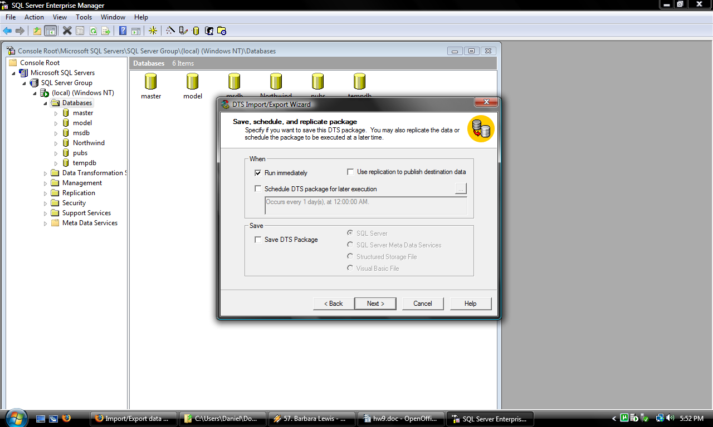

8.) Review selections and hit next.
