Homework 9
CS 474 Section 1
Marcus Lauber, Kevin Chilton, Jenny Sherman, Geoff Wellington

Problem 2 - how do you backup and restore a database in SQL Server

Backing up the database:

Step 1:
First, right click the database that you would like to back up in Microsoft SQL 2000’s Enterprise Manager. Then scroll over “All tasks…” and select the “Backup Database…” option.

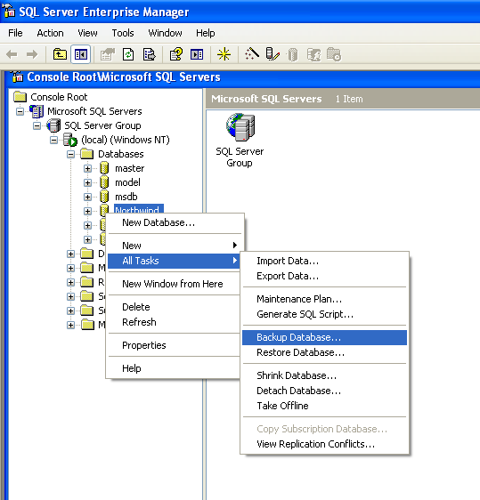

Step 2:
The SQL Server Backup window will open asking you which database you would like to backup and where you would like to save the file. To modify the location it will be saved to, click the “Add…” button under Destination. From here, the Select Backup Destination window will open, and you can select where you would like to save it to. Then click OK.

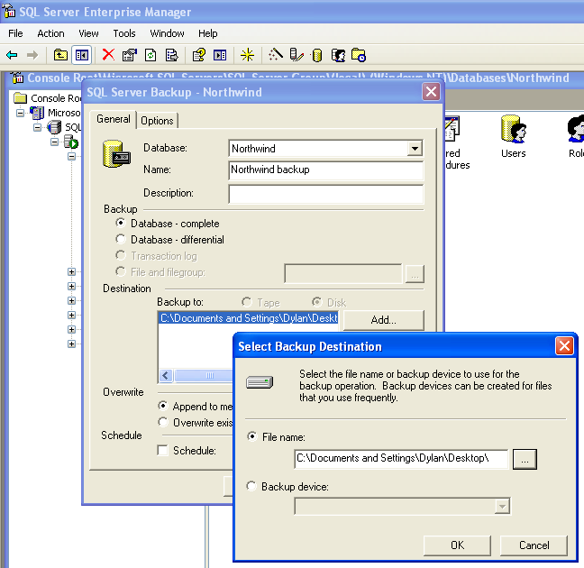

Step 3:

Type the name you would like the backup to be saved as in the “Name” text field. Click OK in the SQL Server Backup window to backup the database to the destination you chose in Step 2.

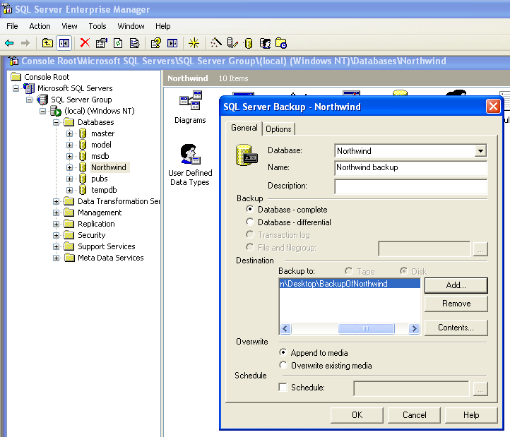

While it is backing up, a progress bar will appear.

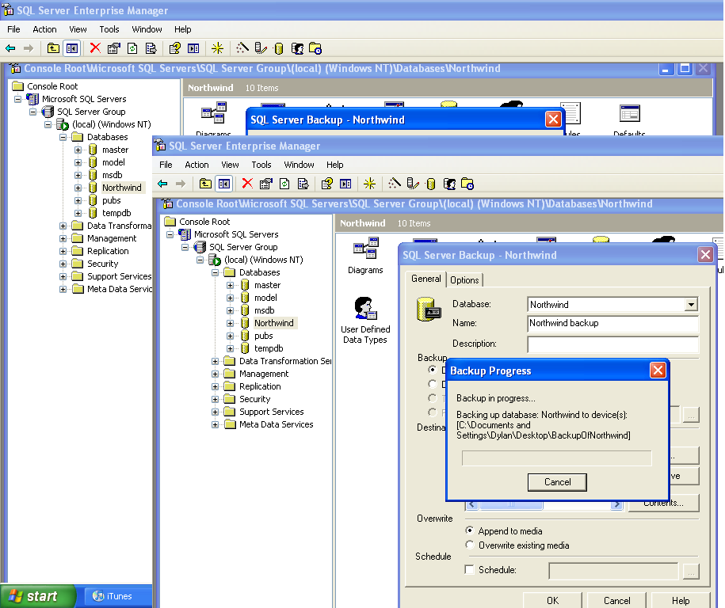

And finally, the backup file can be seen where you chose to save it.



Restore the database:

Step 1:
First, right click the database that you would like to restore in Microsoft SQL 2000’s Enterprise Manager. Then scroll over “All tasks…” and select the “Restore Database…” option.

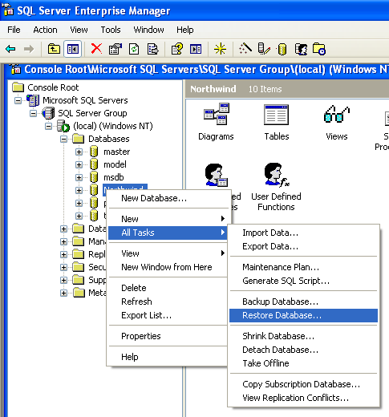

Step 2:
Select the backup file you would like to restore from. If it is not already present in the list, you can add a file by hitting the Properties button, the change button, then the add button.

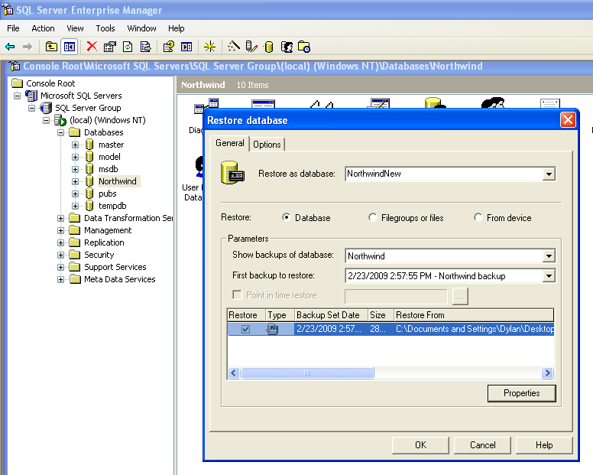

Step 3:
Type the name you would like to restore the database as into the Name text field and click OK in the “Restore Database” window. A bar will show up displaying the progress of the database restoration.

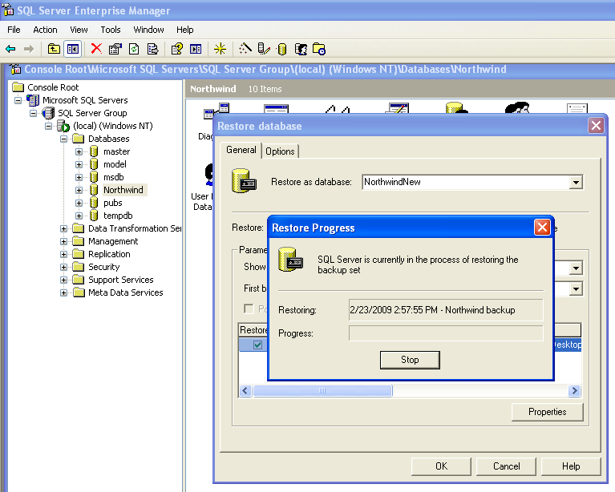

Finally, the restored database can be seen in the list of available databases.

